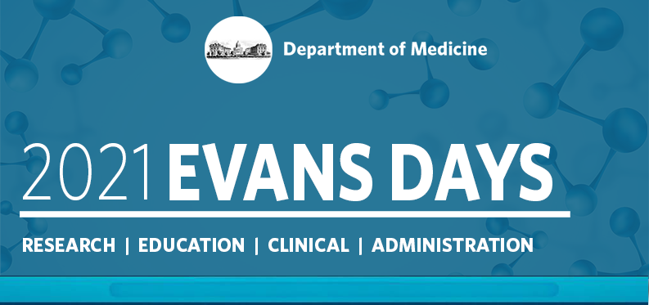

Abstract Submission Guidelines
October 7-8, 2021

Instructions for Completing the Online Abstracts Form
- In order to submit an abstract, we request some information about you. Please provide the following.
  - Your name
  - Section/Department
  - Your Mentor
  - Research Collaboration
  - Preferred email and phone number
  - Home mailing address
  - Recent Headshot
  - Include a brief bio of yourself (where did you go to school, research interest, etc.)
  - Is this research Basic Science or Clinical?
  - 3 Keywords
Once step one is complete and reviewed you will then be able to submit your abstract(s). Abstract must be submitted by Friday, July 30 by 11:59pm EST.
- Evaluation of abstracts will be based on the following considerations. You will be asked to address each of these items in separate text boxes. The total character limit is 1470 for the four boxes combined.
  - Objective: Clearly state the objective of the research project
  - Methods: Clearly state the methods used to obtain the results
  - Results: Clearly state the results of the research
  - Conclusions: Clearly state the conclusions of the research project
  - Image Size: No larger than 2in high x 4in wide for publication purposes.

- The abstracts receipt deadline Friday, July 30 by 11:59pm will remain firm and any abstracts received after the deadline will not be accepted.
Submission Rules
1. Abstracts may be submitted Thursday, July 1 and will not be accepted after Friday, July 30 at 11:59 PM, EST
2. Character Count: Abstracts are limited to 1470 characters, not including spaces. Image size should be no larger than 2in high x 4in wide for publication purposes.
3. Make abstracts as informative as possible, including a brief statement of the purpose of the study or why it was done, the methods used, the results observed, and the author(s)' conclusions based upon the results. Actual data should be summarized. It is inadequate to state "the results will be discussed" or "the data will be presented." Abstracts must be written in English.
4. You will be asked to partition your abstract into four section: Objective, Methods, Results and Conclusions. The total limit for all four sections combined is 1470 characters.
5. NO REVISIONS to abstracts will be allowed after the deadline.
6. Authorship on multiple abstracts permitted (1st authorship is permitted on one abstract only).
7. All Department of Medicine faculty, fellows, housestaff, post-docs and graduate students may submit abstracts.
8. Submissions are accepted from any BUMC member but ONLY DOM Trainees, Students, and Post docs will be eligible for competitive awards.
9. Work done at another institution can be accepted as long as It was done in collaboration with a DOM faculty member.
10. Upon completion of your submission you will receive an email confirmation from cOASIS Abstract System
11. Please be prepared to submit a poster in PDF or Powerpoint format to accompany your abstract. We will reach out to you once the abstract submission deadline has closed with more information on how to prepare your poster. The deadline for poster submissions will be September 3rd.

If you have any questions please feel free to reach out to Jennifer Visconti at Jennifer.visconti@bmc.org

