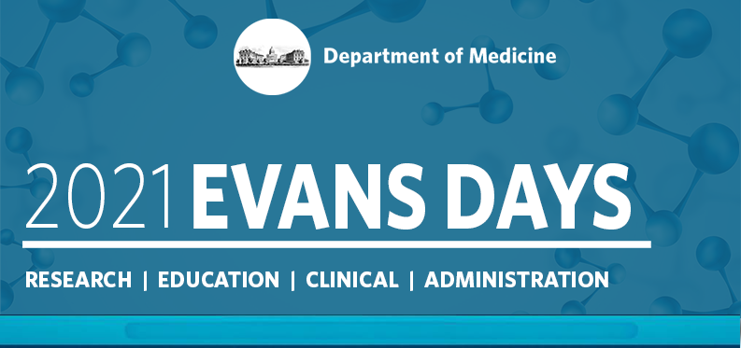

Abstract Submission Guidelines
October 7-8, 2021

Instructions for Completing the Online Abstracts Form
- In order to submit an abstract, we request some information about you. Please provide the following.
  - Your name
  - Section/Department
  - Your Mentor
  - Research Collaboration
  - Preferred email and phone number
  - Home mailing address
  - Recent Headshot
  - Include a brief bio of yourself (where did you go to school, research interest, etc.)
  - Is this research Basic Science or Clinical?
  - Synopsis of your research (2-3 sentence)
Once step one is complete and reviewed you will then be able to submit your abstract(s). Abstract must be submitted by Friday, July 30 by 11:59pm EST.
- Evaluation of abstracts will be based on the following considerations:
  - Objective: Clearly state the objective of the research project
  - Methods: Clearly state the methods used to obtain the results
  - Results: Clearly state the results of the research
  - Conclusions: Clearly state the conclusions of the research project
  - Image Size: No larger than 2in high x 4in wide for publication purposes.

- The abstracts receipt deadline Friday, July 30 by 11:59pm will remain firm and any abstracts received after the deadline will not be accepted.
Submission Rules
1. Abstracts may be submitted Thursday, July 1 and will not be accepted after Friday, July 30 at 11:59 PM, EST
2. Character Count: Abstracts are limited to 1470 characters, not including spaces. The abstract title, authors/institutions, body, and images count toward the character limit. Each image counts as 500 characters. Image size should be no larger than 2in high x 4in wide for publication purposes.
3. Make abstracts as informative as possible, including a brief statement of the purpose of the study or why it was done, the methods used, the results observed, and the author(s)' conclusions based upon the results. Actual data should be summarized. It is inadequate to state "the results will be discussed" or "the data will be presented." Abstracts must be written in English.
4. Do NOT use subtitles (e.g., Methods, Results) in the abstract body.
5. NO REVISIONS to abstracts will be allowed after the deadline.
6. Authorship on multiple abstracts permitted (1st authorship is permitted on one abstract only).
7. All Department of Medicine faculty, fellows, housestaff, post-docs and graduate students may submit abstracts.
8. Submissions are accepted from any BUMC member but ONLY DOM Trainees, Students, and Post docs will be eligible for competitive awards.
9. Upon completion of your submission you will receive an email confirmation from cOASIS Abstract System
10. Please be prepared to submit a poster to accompany your abstract in August. We will reach out to you once the abstract submission deadline has closed with more information on how to prepare your poster.

If you have any questions please feel free to reach out to Jennifer Visconti at Jennifer.visconti@bmc.org

