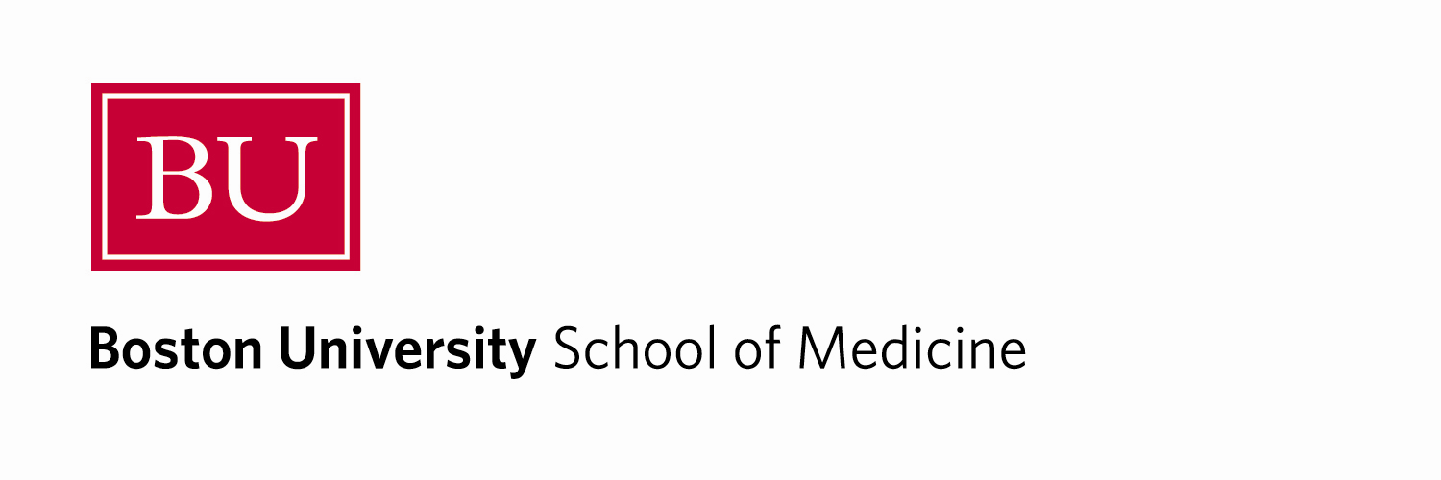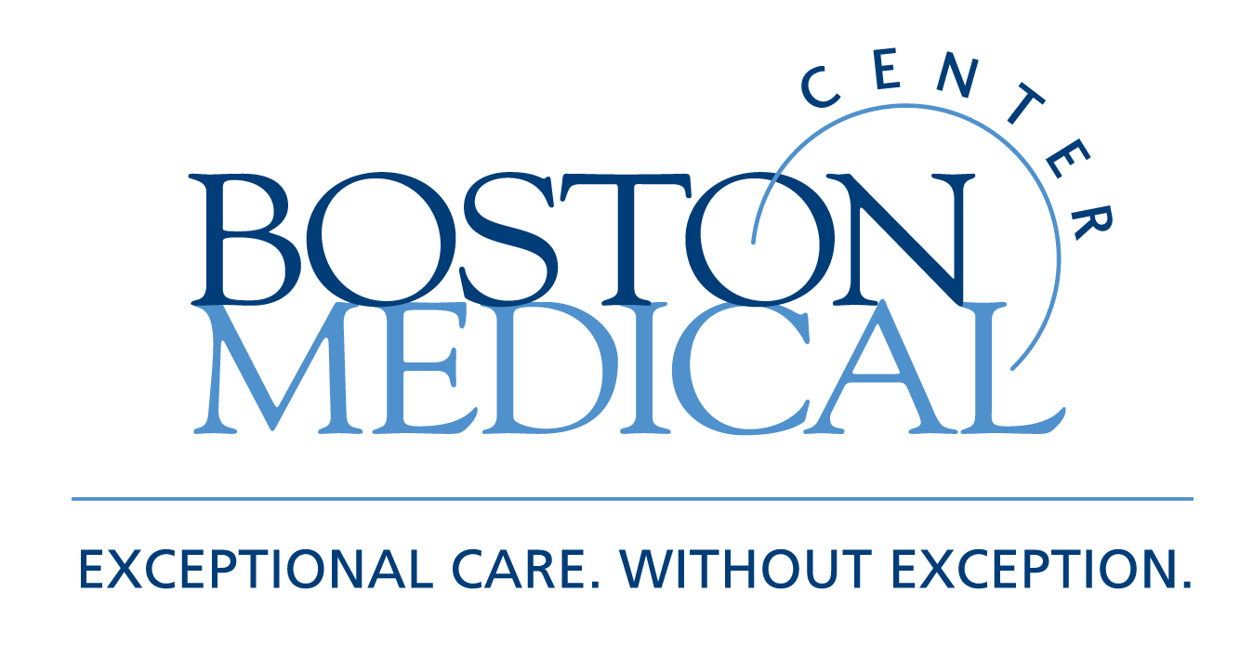

Department of Medicine
MEDICAL GRAND ROUNDS

NEUROCARDIOLOGY

Martin Samuels, M.D.
Professor of Neurology, Harvard Medical School
Chairman, Department of Neurology
Brigham and Women’s Hospital

Friday, January 14, 2011
12 PM – 1 PM
Keefer Auditorium

At the conclusion of this activity, participants will be able to:

- Recognize the cardiac manifestations of neurological disease
- Apply the appropriate measures to prevent neurogenic cardiac damage
- Treat neurogenic cardiac problems

Target Audience: Department of Medicine Faculty and House Staff and BUSM medical students

Course Director: Robert M. Levin, M.D.

Boston University School of Medicine is accredited by the Accreditation Council for Continuing Medical Education to provide continuing medical education for physicians.

Boston University School of Medicine designates this educational activity for a maximum of 1
AMA PRA Category 1 Credit(s)™. Physicians should only claim credit commensurate with the extent of their participation in the activity.

