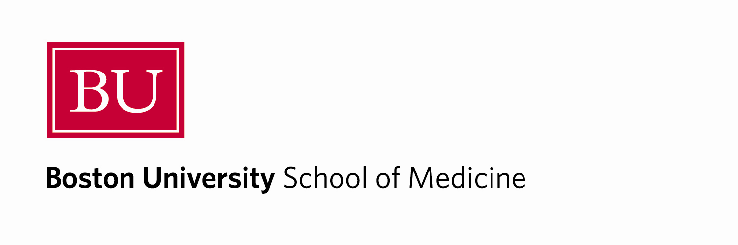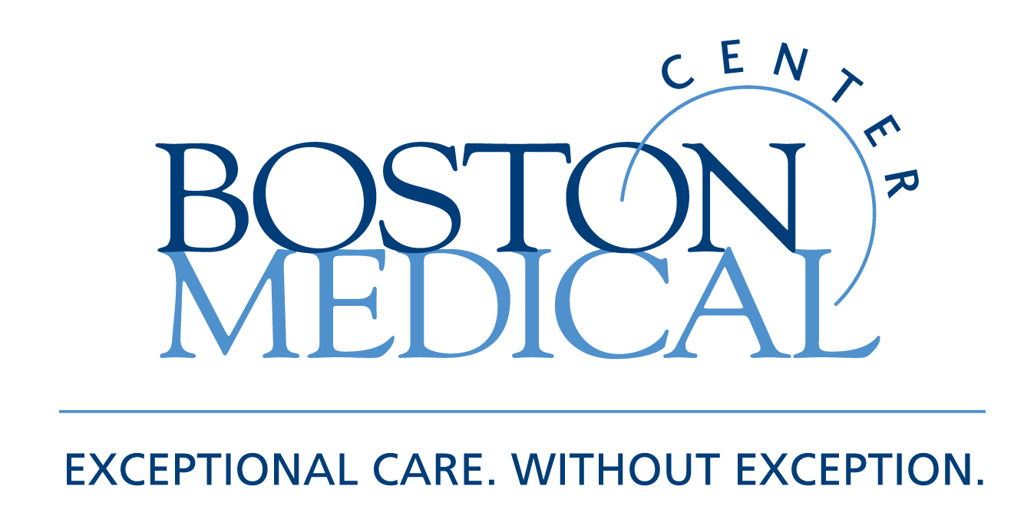

Department of Medicine
MEDICAL GRAND ROUNDS

Philip Kramer Visiting Professor

Screening and Surveillance for Colorectal Cancer

Douglas K. Rex, M.D.
Distinguished Professor of Medicine
Indiana University School of Medicine
Director of Endoscopy
Indiana University Hospital

Friday, February 25, 2011
12 PM – 1 PM
Keefer Auditorium

At the conclusion of this activity, participants will be able to:

- Know current guidelines for colorectal can cer screening
- Understand the quality movement in colonoscopy
- Know the rationales for converting from quaiac based fecal blood testing to fecal immunoclonnical testing

Target Audience: Department of Medicine Faculty and House Staff and BUSM medical students

Course Director: Robert M. Levin, M.D.

Boston University School of Medicine is accredited by the Accreditation Council for Continuing Medical Education to provide continuing medical education for physicians.

Boston University School of Medicine designates this educational activity for a maximum of 1
AMA PRA Category 1 Credit(s)™. Physicians should only claim credit commensurate with the extent of their participation in the activity.

