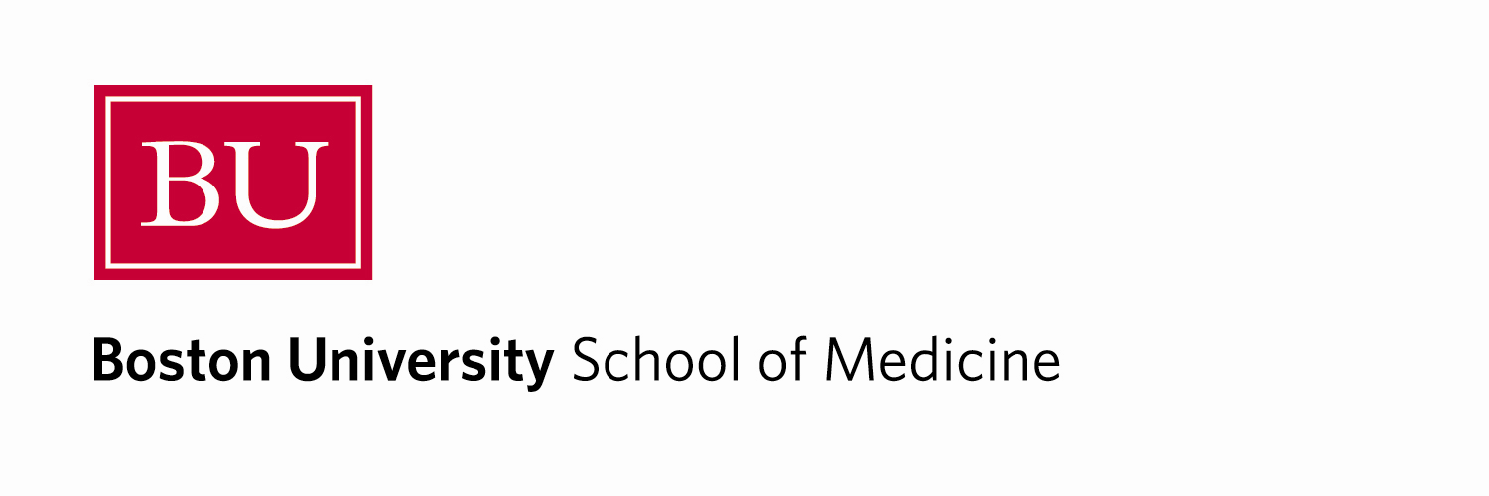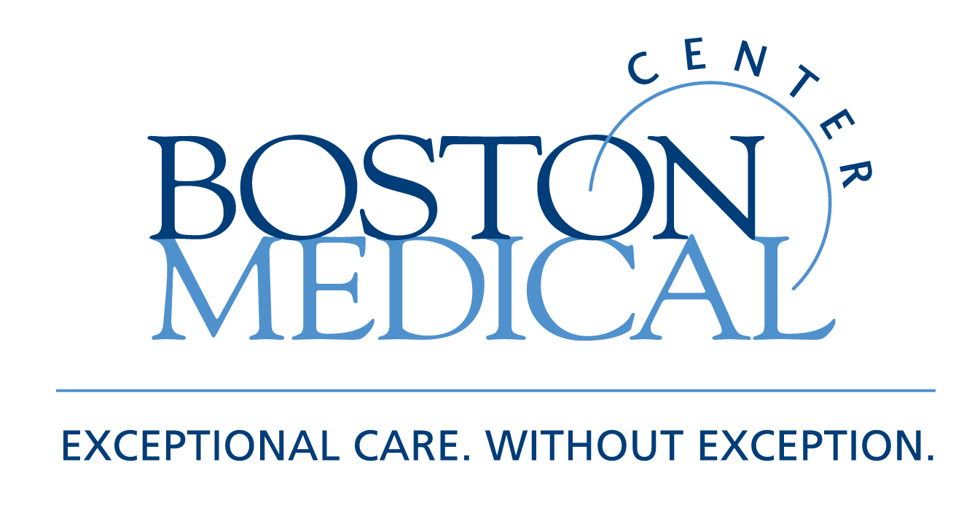

Department of Medicine
MEDICAL GRAND ROUNDS

Stem Cells and Regenerative Medicine:
A Primer for Clinicians

Darrell N. Kotton, M.D.
Associate Professor of Medicine and Pathology, BUSM
Co-Director, BU Center for Regenerative Medicine (CReM)

Friday, April 15, 2011
12 PM – 1 PM
Keefer Auditorium

At the conclusion of this activity, participants will be able to:

- List different kinds of stem cells with potential clinical applications
- Discuss controversies in stem cell research, such as barriers to the clinical application of pluripotent stem cells, such as embryonic stem cells
- Discuss how new technologies to derive “induced pluripotent stem cells” from patient skin fibroblasts allows novel approaches to disease modeling, drug discovery, and potential therapeutic cell therapies

Target Audience: Department of Medicine Faculty and House Staff and BUSM medical students

Course Director: Robert M. Levin, M.D.

Boston University School of Medicine is accredited by the Accreditation Council for Continuing Medical Education to provide continuing medical education for physicians.

Boston University School of Medicine designates this educational activity for a maximum of 1
AMA PRA Category 1 Credit(s)™. Physicians should only claim credit commensurate with the extent of their participation in the activity.

