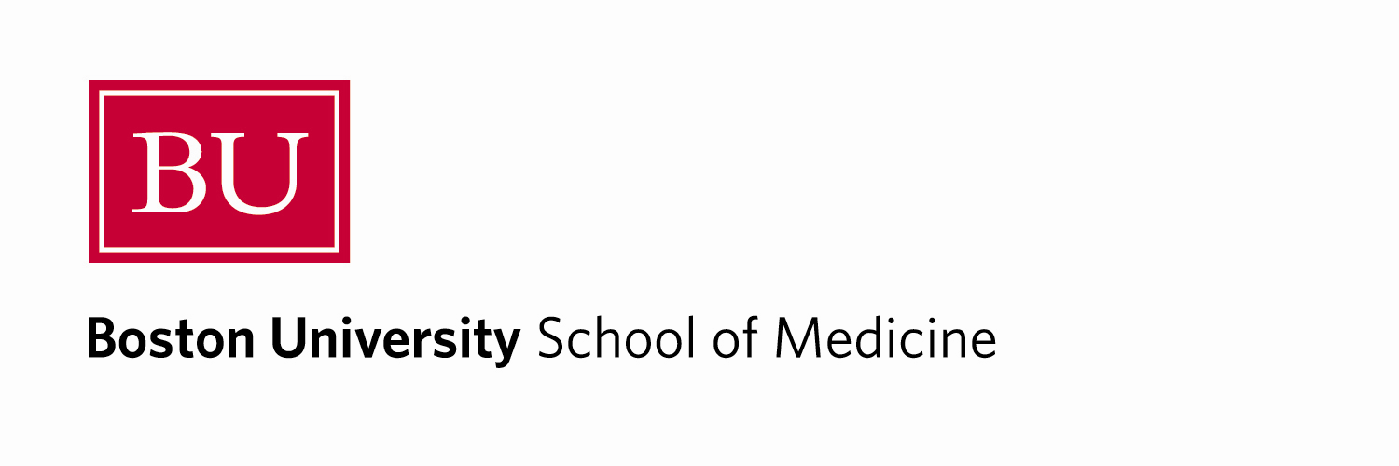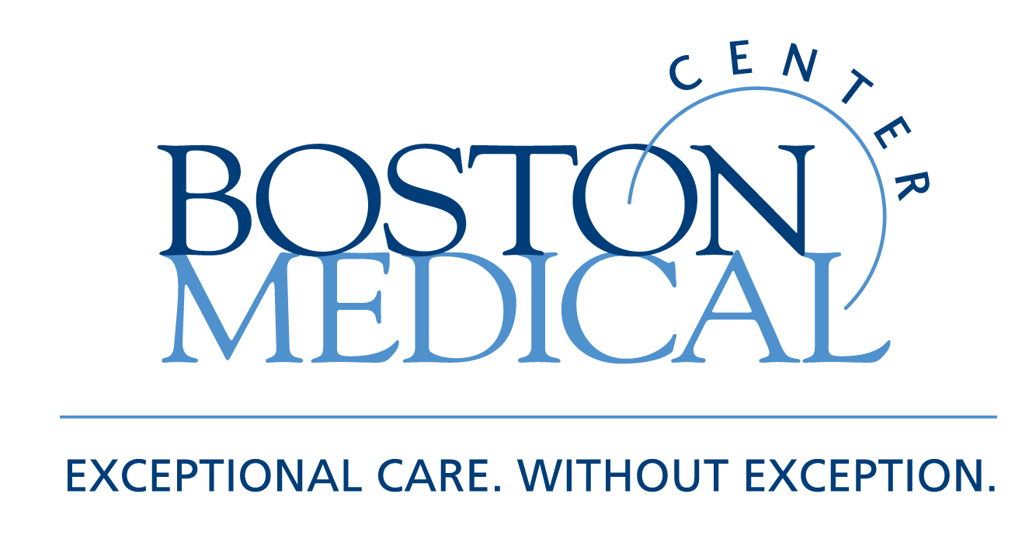

Department of Medicine
MEDICAL GRAND ROUNDS

Thyrotoxicosis: A Hidden Solution

Moderator: Lewis Braverman, M.D.
Professor of Medicine, BUSM
Physician, Endocrine Section

Presenter: Pornpoj Pramyothin, M.D.

Discussants: Angela Leung, M.D.
Elizabeth Pearce, M.D.

Friday, March 11, 2011
12 PM – 1 PM
Keefer Auditorium

At the conclusion of this activity, participants will be able to:

- Recognize the various causes of thyrotoxicosis
- Understand iodine physiology
- Learn how to treat the thyrotoxic patient

Target Audience: Department of Medicine Faculty and House Staff and BUSM medical students

Course Director: Robert M. Levin, M.D.

Boston University School of Medicine is accredited by the Accreditation Council for Continuing Medical Education to provide continuing medical education for physicians.

Boston University School of Medicine designates this educational activity for a maximum of 1
AMA PRA Category 1 Credit(s)™. Physicians should only claim credit commensurate with the extent of their participation in the activity.

