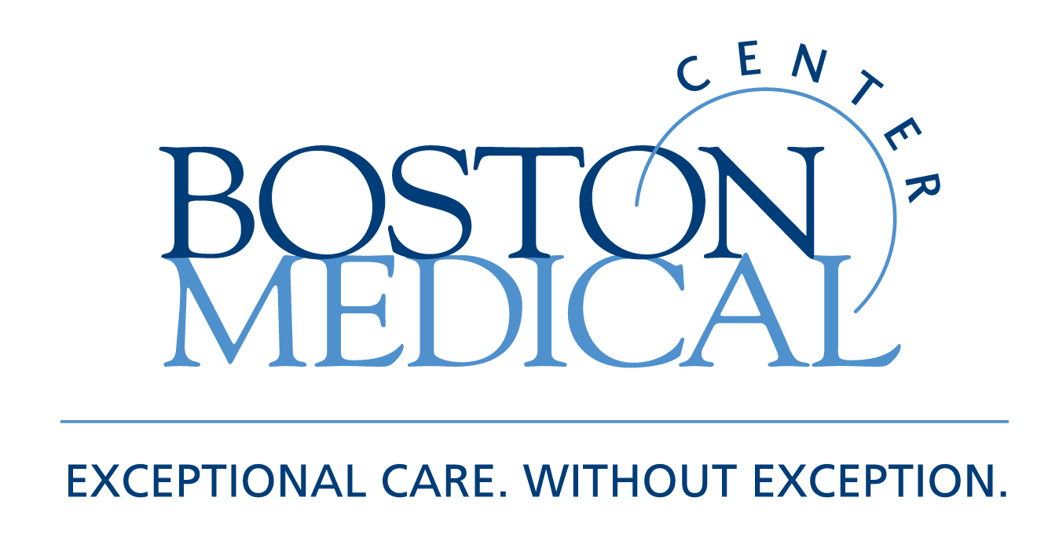

Department of Medicine
MEDICAL GRAND ROUNDS

Hepatitis C:
A New Diagnostic and Therapeutic Decade

Nezam Afdhal, M.D.
Associate Professor of Medicine
Harvard Medical School
Chief of Hepatology
Beth Israel-Deaconess Medical Center

Friday, April 15, 2011
12 PM – 1 PM
Keefer Auditorium

At the conclusion of this activity, participants will be able to:

- Understand the new genomic markers for HCV therapy
- Identify patients suitable for novel direct acting anti-virals
- Understand future therapies in development for hepatitis C

Target Audience: Department of Medicine Faculty and House Staff and BUSM medical students

Course Director: Robert M. Levin, M.D.

Boston University School of Medicine is accredited by the Accreditation Council for Continuing Medical Education to provide continuing medical education for physicians.

Boston University School of Medicine designates this educational activity for a maximum of 1
AMA PRA Category 1 Credit(s)™. Physicians should only claim credit commensurate with the extent of their participation in the activity.

