Standard Operating Procedure
Windows WLAN Profile Settings BU (802.1x)

Overview
This document describes the process to properly configure a Windows WLAN profile for use on BU (802.1x)

Prerequisites (optional)
N/A

Procedure
- Connect to BU (802.1x)
- Press the Windows logo key on the bottom left side of the keyboard and also press the R key. This should bring up the Run window. Type cmd in the Run window which will bring up the command prompt window.
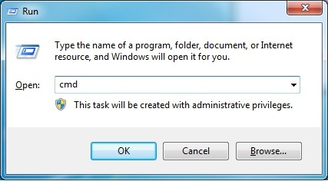
- Type netsh and press enter
Type wlan and press enter
Type delete profile name=”BU (802.1x)” and press enter
Close the command prompt window
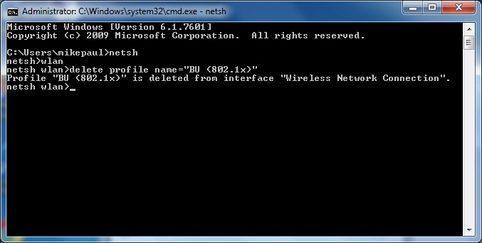
- Reconnect to BU (802.1x)
- Open Control Panel
- Click on Network and Sharing Center
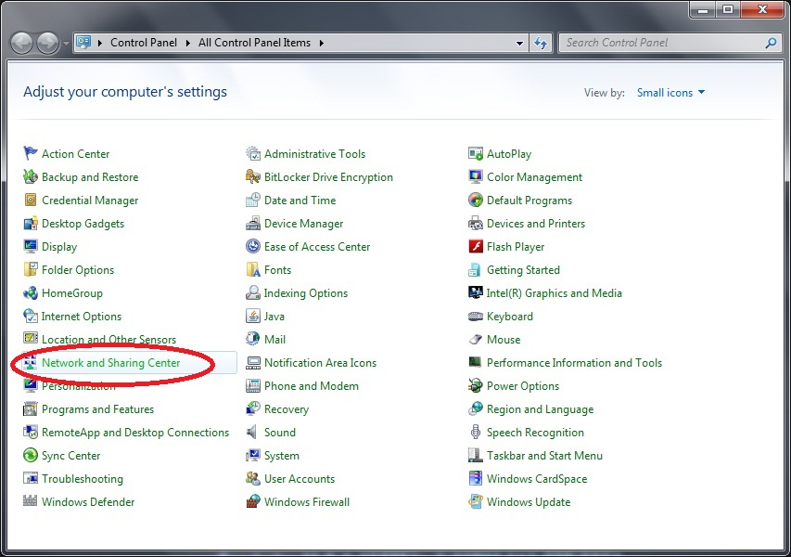

- Click on Wireless Network Connection BU (802.1x)
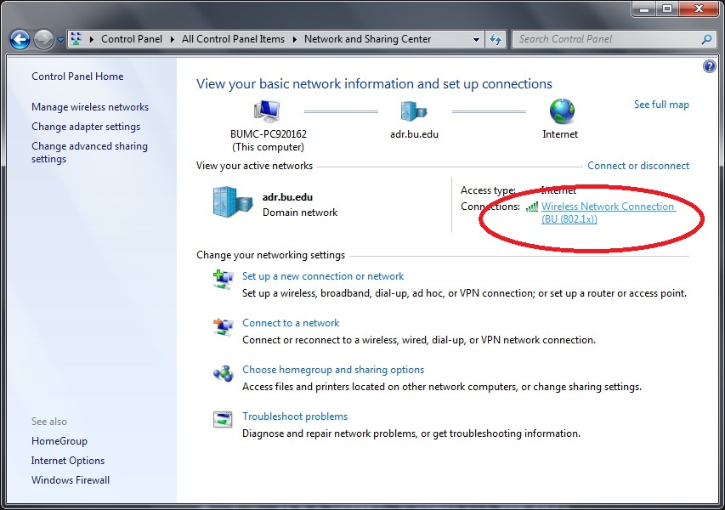
- Click Wireless Properties
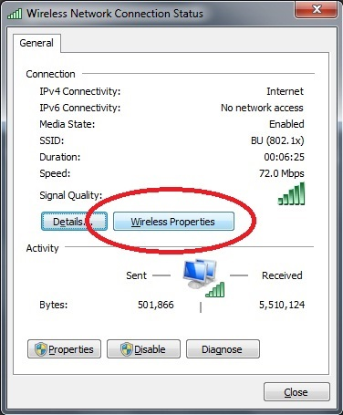
- Verify the box for “Connect automatically when network is in range” is checked and then click the Security tab
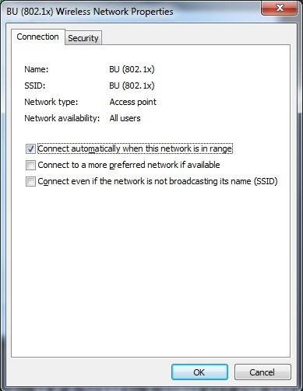

- Verify settings are as follows:
Security Type: WPA2-Enterprise
Encryption Type: AES
Network Authentication Method: Microsoft: Protected EAP (PEAP)
Box for Remember my credentials is checked
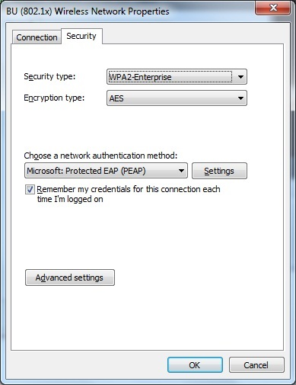
- Click on Settings next to Network Authentication Method which will bring up the Protected EAP Properties window
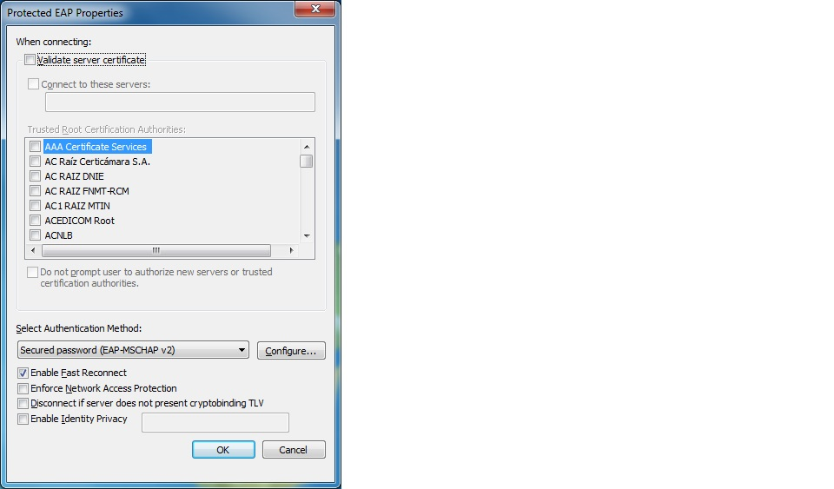

- Click on the Configure button next to Authentication Method. Verify that the box for “Automatically use my Windows logon name and password (and domain if any)” is checked.
Note – Only check this box if Windows logon for device is the same as your Kerberos credentials
Click OK when finished and click OK on Protected EAP Properties window
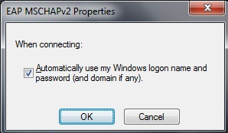
- Verify that the box for Specify authentication mode is checked and User authentication is checked
Click Save credentials and enter Kerberos username and password, be sure to put “ad\” (without quotes) before your username
Click OK
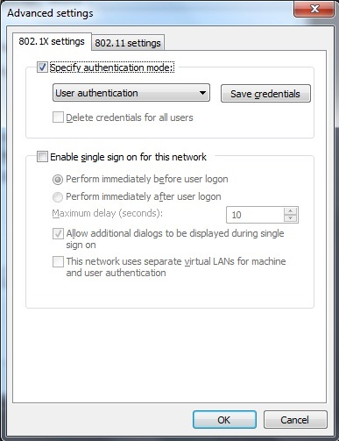

- Verify settings are as follows:
Box for Enable Pairwise Master Key (PMK) caching is checked
All other boxes are left unchecked
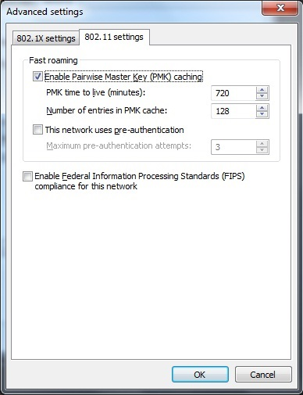
- Click OK on Advanced settings window

- Click OK on BU (802.1x) Wireless Network Properties window
This will disconnect you from the network, please reconnect to BU (802.1x).

Version History
Version | Date | Author | Summary of changes
1.0 | 06/03/2014 | Mike Harrison | Creation

