Verification Statement Required for Boston Medical Center
Home institutions must generate the following verification statement on behalf of a student accepted for an elective at Boston University Chobanian & Avedisian School of Medicine.

Steps to Complete the Verification Statement
Step 1:
Copy and paste the text from the verification statement on page 2 of this document into a new document that contains your institutional letterhead.

Step 2:
Complete all fields indicated in red: e.g. [ Home institution name ]

Step 3:
Verify statements #1 - #5 are accurate. See note below about item #5.

Step 4:
Choose one of the two options for statement #6. Delete the option not chosen. See note below about item #6 options.
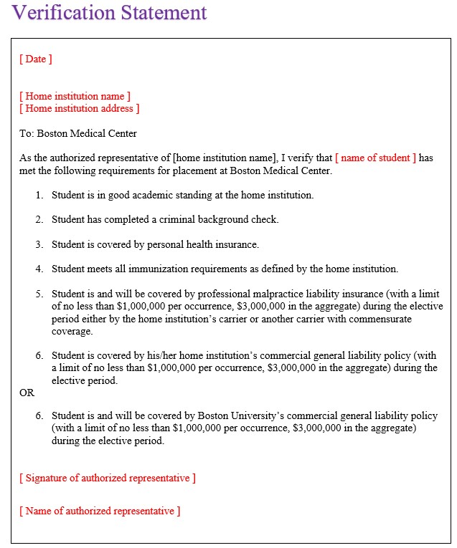

Note for item #5: if your home institution does not provide malpractice liability coverage at the level indicated, the student must show proof of commensurate coverage for you to complete this statement.
Note for item #6:
- Use the first statement if your institution has commercial general liability coverage and the student is covered by this policy.
- Use the second statement if your institution does not have commercial general liability coverage. Thus, the student will be covered by Boston University’s policy.
Verification Statement

[ Date ]

[ Home institution name ]
[ Home institution address ]

To: Boston Medical Center

As the authorized representative of [home institution name], I verify that [ name of student ] has met the following requirements for placement at Boston Medical Center.

- Student is in good academic standing at the home institution.
- Student has completed a criminal background check.
- Student is covered by personal health insurance.
- Student meets all immunization requirements as defined by the home institution.
- Student is and will be covered by professional malpractice liability insurance (with a limit of no less than $1,000,000 per occurrence, $3,000,000 in the aggregate) during the elective period either by the home institution’s carrier or another carrier with commensurate coverage.
- Student is covered by his/her home institution’s commercial general liability policy (with a limit of no less than $1,000,000 per occurrence, $3,000,000 in the aggregate) during the elective period.

OR

- Student is and will be covered by Boston University’s commercial general liability policy (with a limit of no less than $1,000,000 per occurrence, $3,000,000 in the aggregate) during the elective period.

[ Signature of authorized representative ]

[ Name of authorized representative ]

