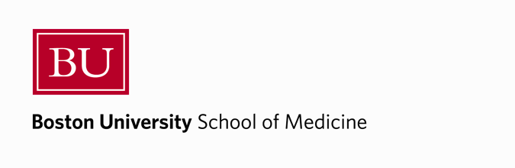 | Submit completed form to Program Administrator: Cassandra Kocek (ckocek@bu.edu) and Program Director: Matt Jones (mattj@bu.edu)
Program in Molecular and Translational Medicine

Student Name:

Dissertation Supervisor:

Date of Meeting:

Dissertation Advisory Committee Chair:

Committee Members Present:

Student Summary of current studies:

Student Summary of progress since last meeting and proposed future directions:

Committee Suggestions:

Chair summary and assessment of student progress:

On behalf of the dissertation advisory committee for the above listed student, I endorse the recommended thesis direction proposed at this meeting and the time frame of graduation discussed.

Signed:

Date:

