General information:
Website: https://mytotalcareer.org
Help: mytotalcareer@bu.edu

Bookmarks:
Topic 1 – Create an account
Topic 2 – Add an Event
Topic 3 – Searching Events/Calendar
Topic 4 – Editing and removing events

Topic 1 – Create an account

When you first enter the site you will land on the about page. We will be adding some additional information about the project on this page.
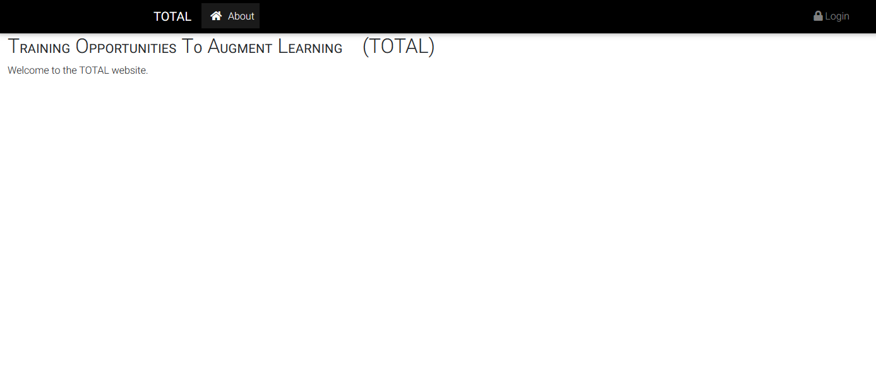

If you click the login button, you will be taken to this screen.
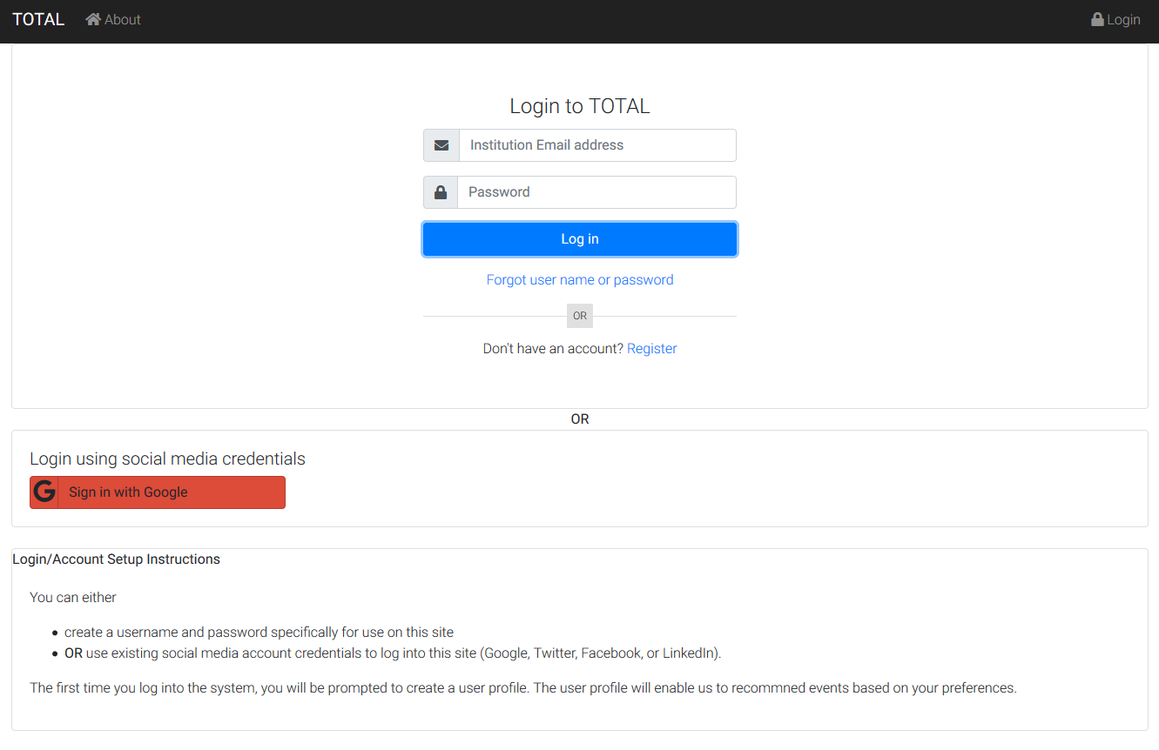

If it is your first time entering the site click Register, which will bring up the following screen. Enter an email address (must be from one of the participating institutions), password and password confirmation.

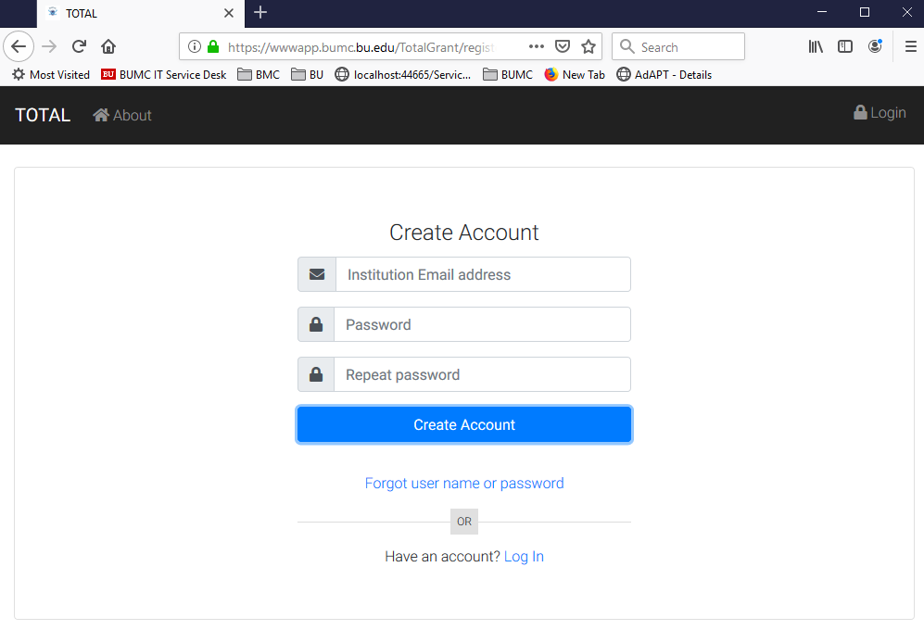

Upon clicking the “Create Account” button, you will be sent to this page.

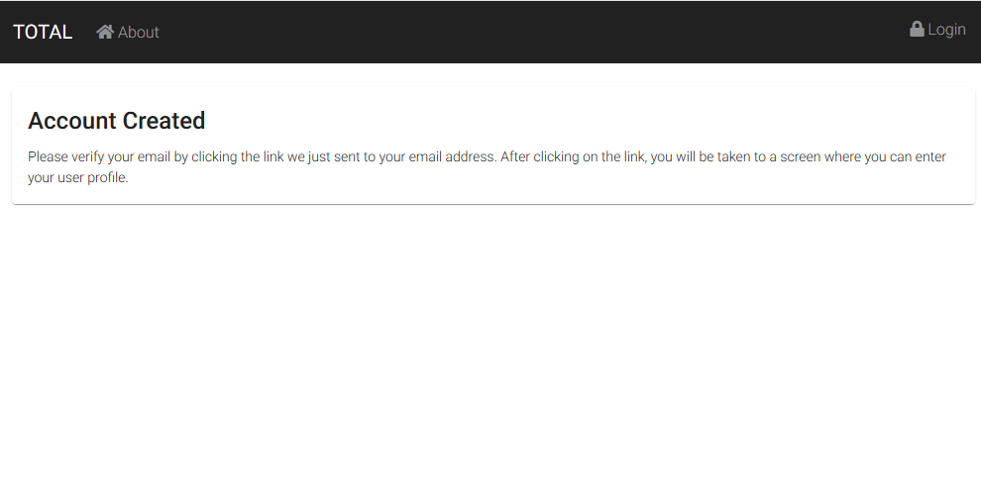

You should receive an email from mytotalcareer@bu.edu that looks like the following:
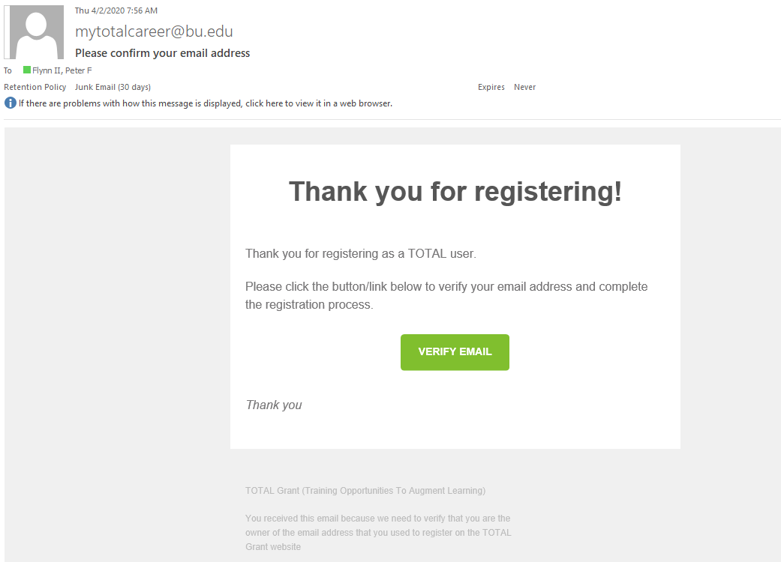

Click on the “Verify Email” button which will take you back into the total website to complete the account creation process.
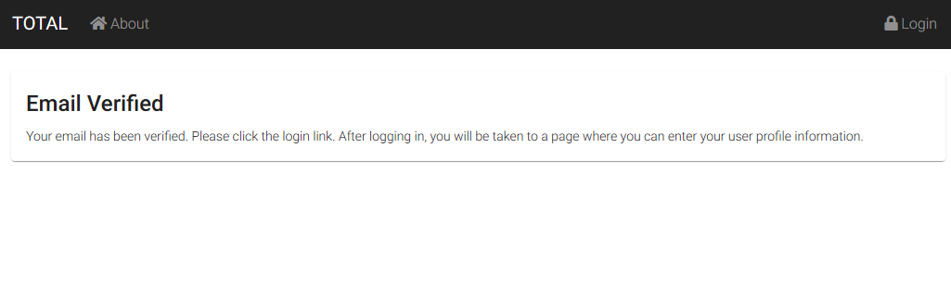

Login in using your newly created credentials
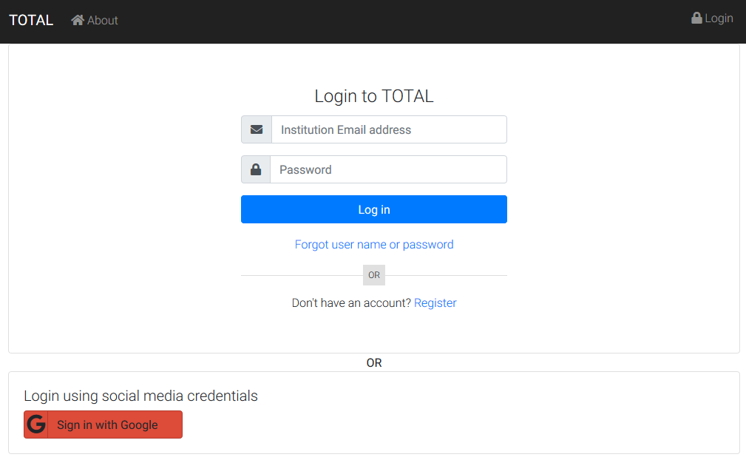

You will be taken to the Profile page. Enter your information and click the “Save” button.
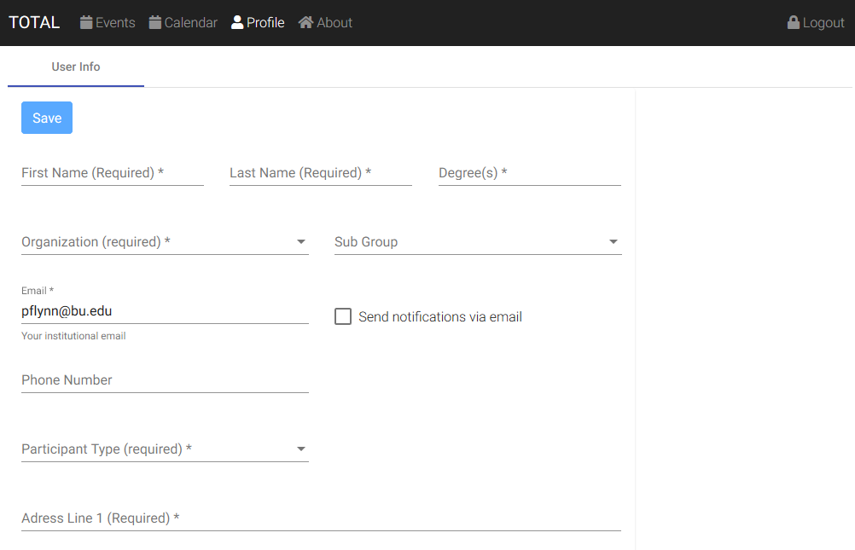

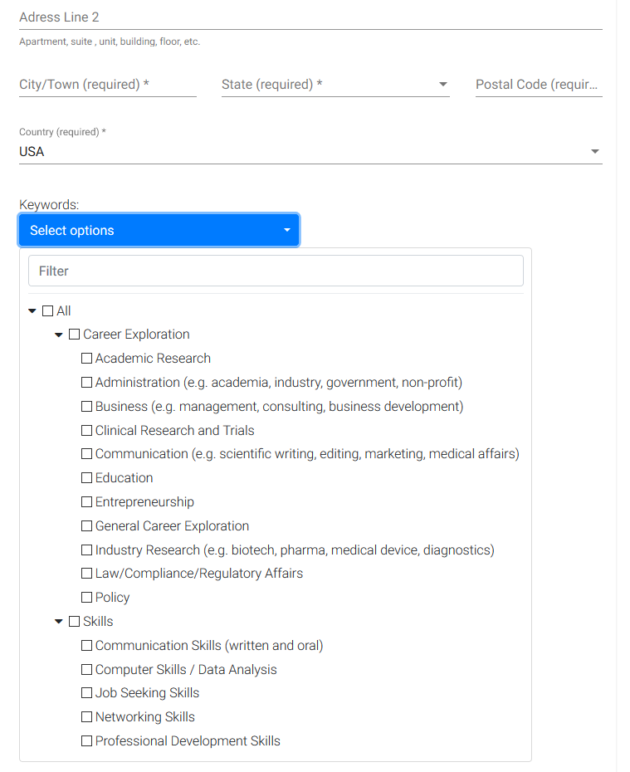
Notes on the Profile screen:

- Organization – one of the participating organizations.
- Sub Organization – show sub organizations for the selected organization. Events can be open to everyone or restricted by org and sub org (will explain later in the document).
- Send notifications via email – indicates if you would like to get email notifications when an event changes, e.g. new date/time or cancelled. You will only get notified for events that are marked as interested or attending (will explain this later in the document).
- Participant Type – One of Faculty, Postdoc, Masters Student, etc. This will allow us to make recommendations for events that you might be interested.
- Keywords - This will allow us to make recommendations for events that you might be interested.
- Clicking “Save” might take a minute to process (system is searching for events to recommend)

Topic 2 – Add an Event
Click on the “New Event” navigation item at the top of the page.
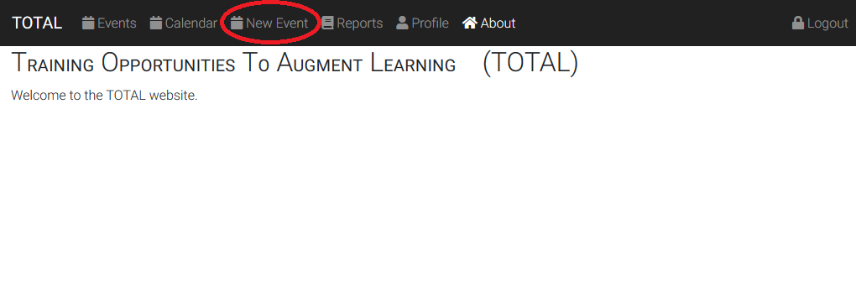

You will be taken to this page.
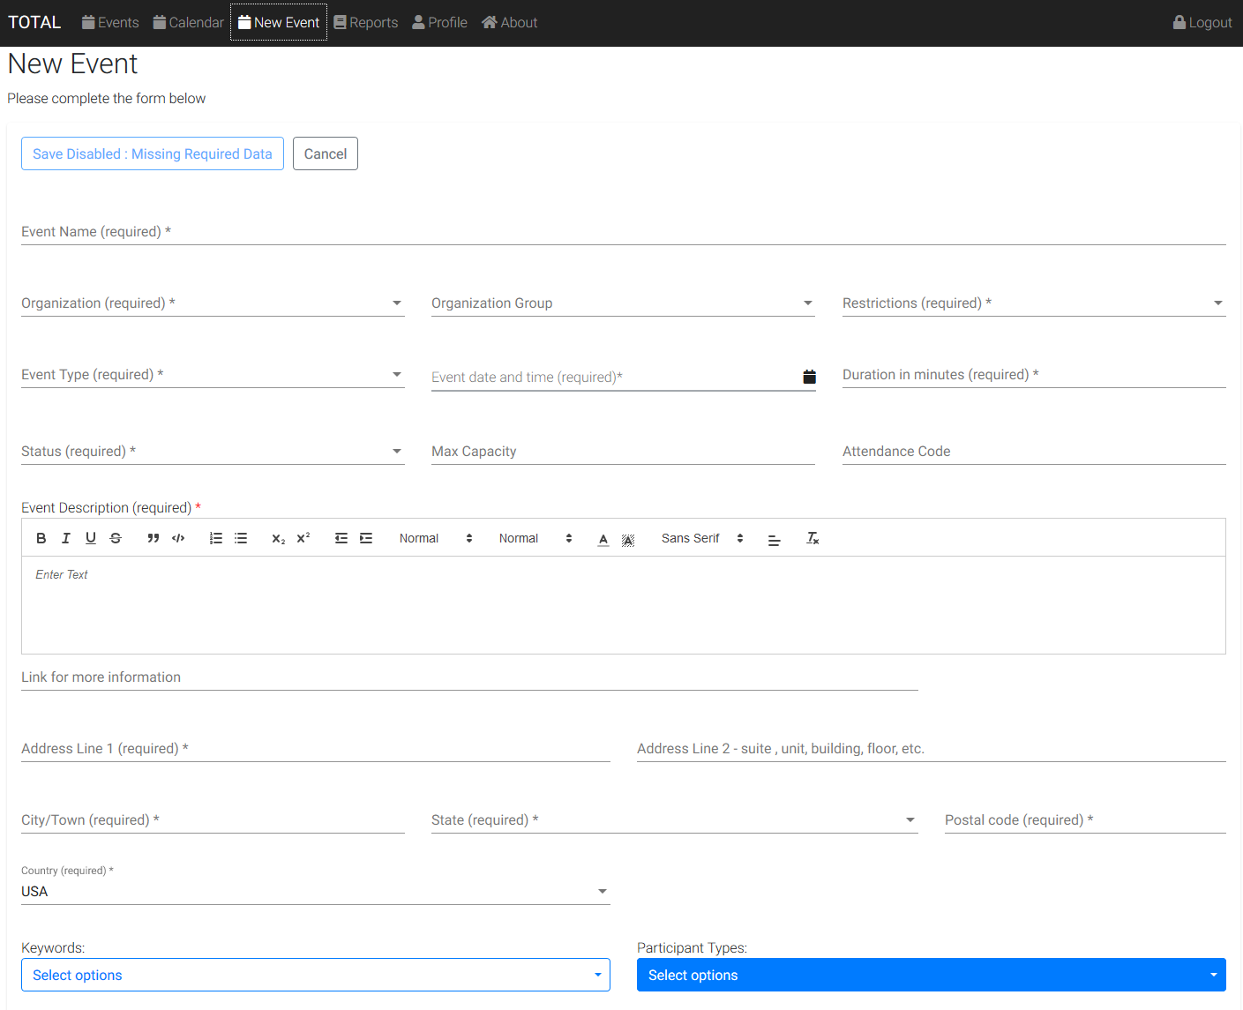
Notes on the create event page:
- Must specify which of the participating organizations is hosting the event.
- Can optionally specify a sub organization.
- Restrictions: one of “None (all users can see)”, “Open only to people in the organization”, or “Open only to people in the sub organization”
- Event Type: one of "Workshop", "Presentation", "Course", "Panel Discussion", "Online", "Informal Discussion", "Site Visit", "Seminar", "Networking", "Career Fair", "Case Competition"
- Event Date/Time and duration are required.
- Event Status: One of "Draft", "Open", "Cancelled", "Closed", "Completed", "At Capacity".
- Attendance Code: Admins can enter an attendance code which presenters can give to participants (for use in external systems). The only way the system knows that a participant attended is if the user indicates that they did by clicking an attended button.
- Description: allows some rich text formating colors, bullets, lists, etc.
- Link for more information: Link to an external page with more robust event description, registration, etc.
- Keywords: used to help make recommendations for users of events they might be interested in.
- Participant Types: used to help make recommendations for users of events they might be interested in.
- When you click “Save”, the system updates user recommendations for this event.

Topic 3 – Searching Events/Calendar

Clicking on the “Events” navigation button will bring you to the page below.
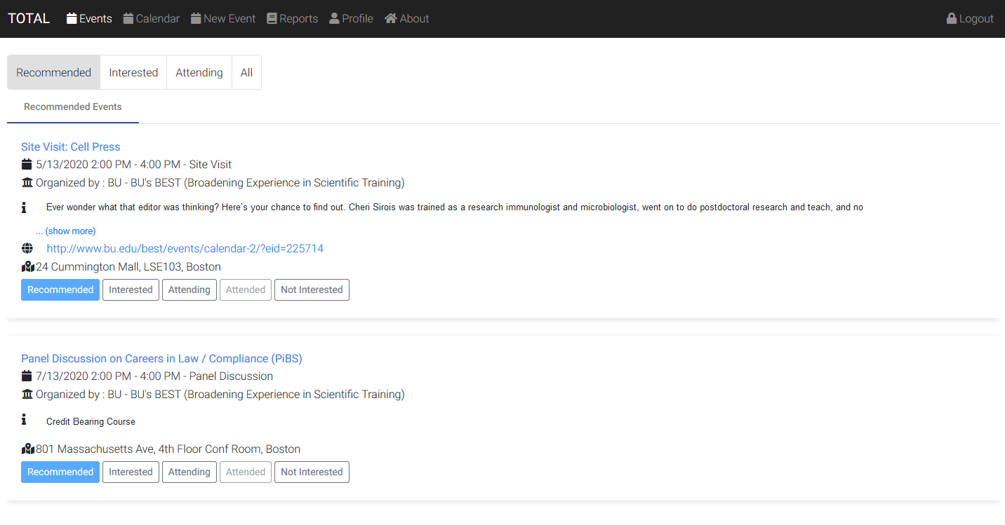
Notes:
- The “Recommended” tab will be selected by default.
- Clicking on the icon next to the address will make a map of the location appear
- Clicking on the “i” icon or clicking (show more) when applicable will expand the description.
- On this page as well as other pages that have the buttons you can mark an event as one that you are interested in, are attending, attended already, or are not interested in. Clicking will move the event into the appropriate tab.
- The “Attending” button is disabled for past events and “Attended” button is disabled for future events.
- The “Recommended” and “Interested” tabs only show future events.
- The “Attending” and “Attended” tabs show all events marked that way regardless of whether they are past or future.
- The “All” tab (shown below) will allow you to filter the events by a search term, the organization, the participant type, and the status (“Recommended”, “Interested”, etc.). It is the only tab that will allow you to see all past events.
- The application is designed to be responsive to te screen size.
- When accessing this website from a mobile device, you will have the option to install this site as a Progressive Web Site which will make it behave like a native application. If you enable that functionality, you will receive push notifications (even if the application is closed) when events you are marked as interested or attending are changed.

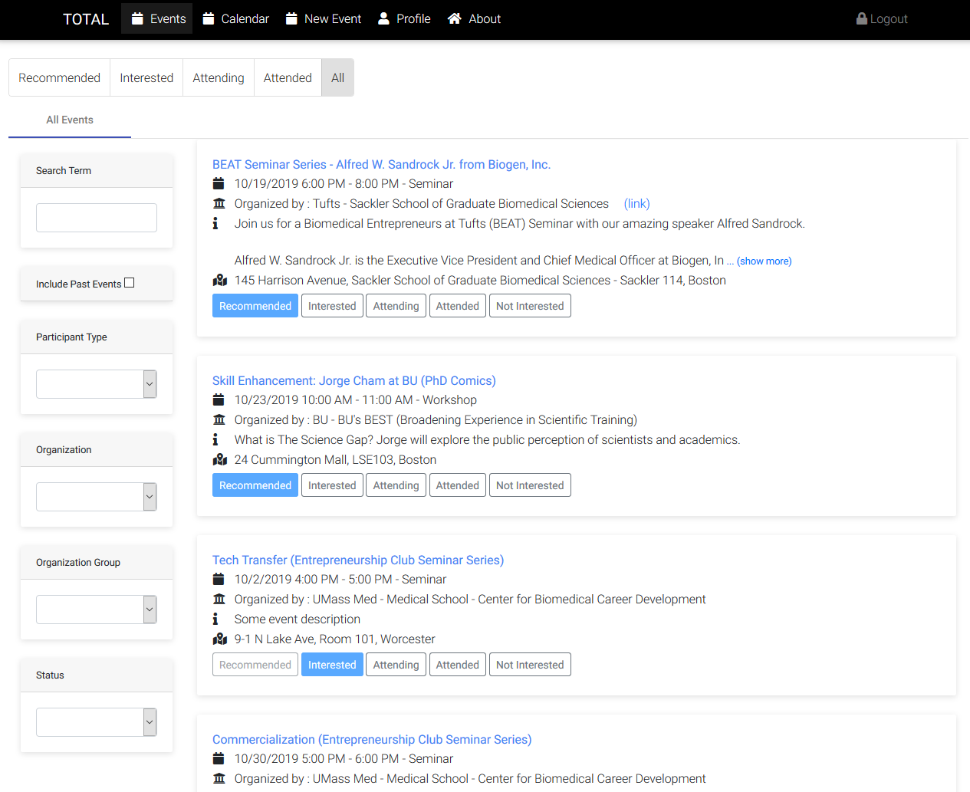

The calendar page defaults to the current month and shows the number of events (in a red circle) for each day of the month.
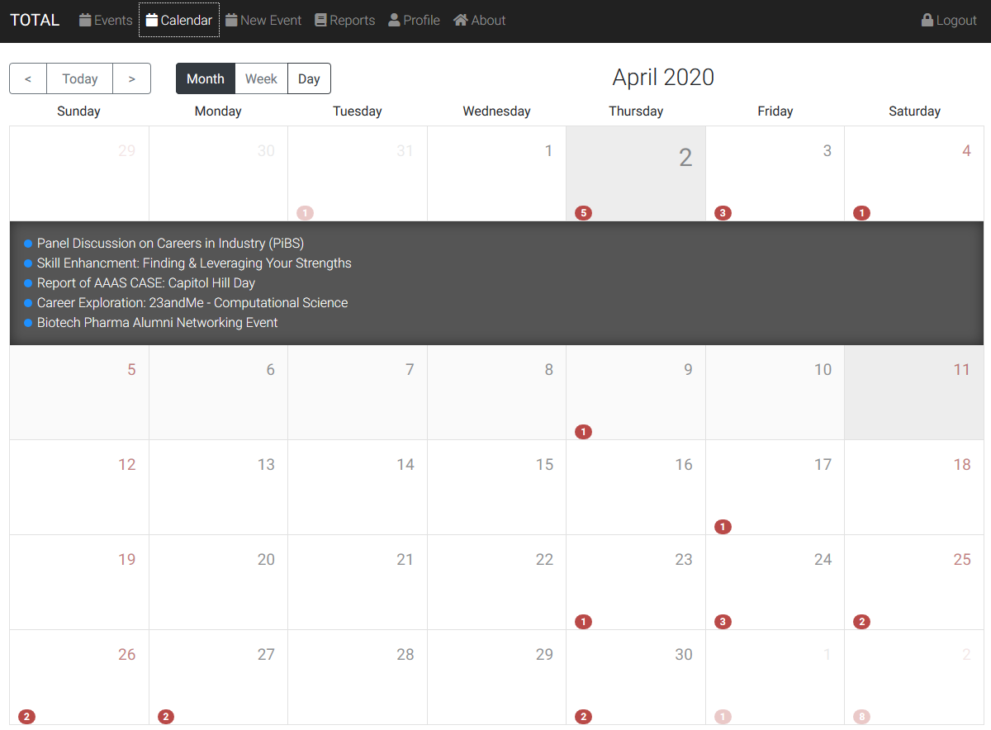

Clicking on a particular day of the month will expand a list of events happening on that day.
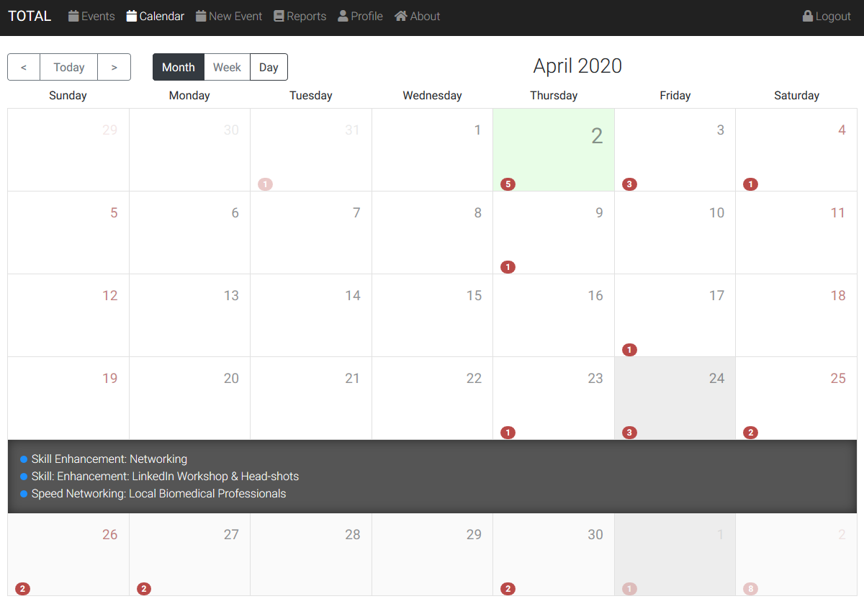

Clicking on a particular event in the expanded list will cause a details section for the event to appear at the top of the screen.
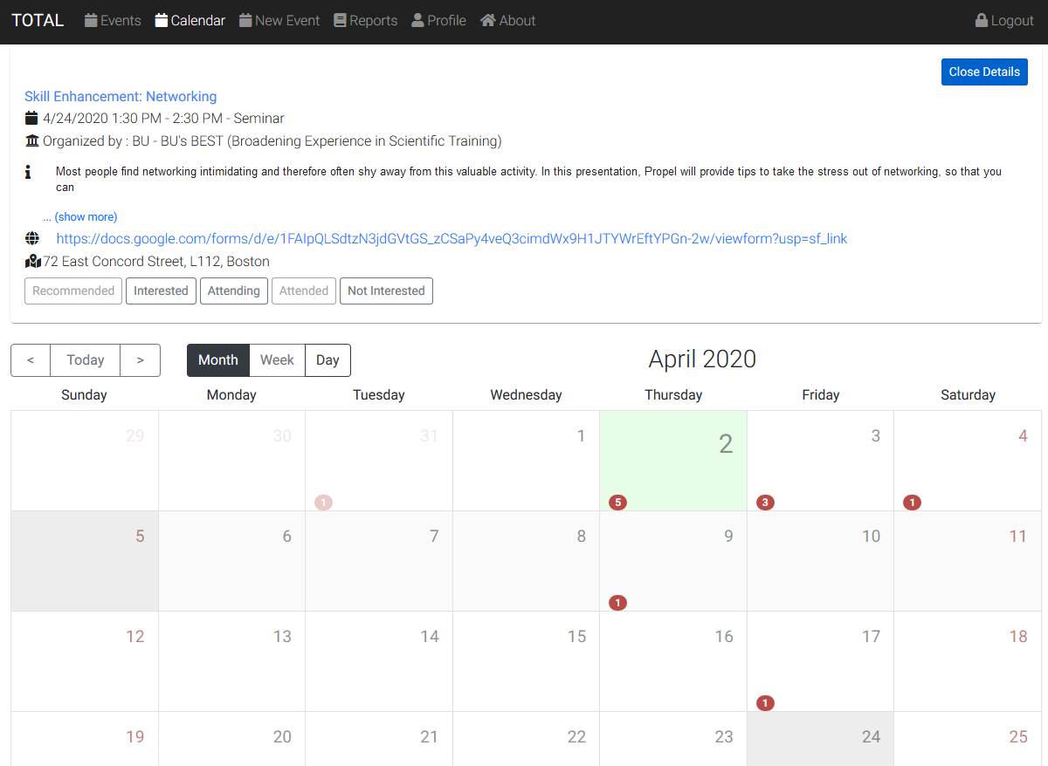

Topic 4 - Editing and removing events

From the events or calendar pages, clicking on the title of an event, will bring you to a details page.
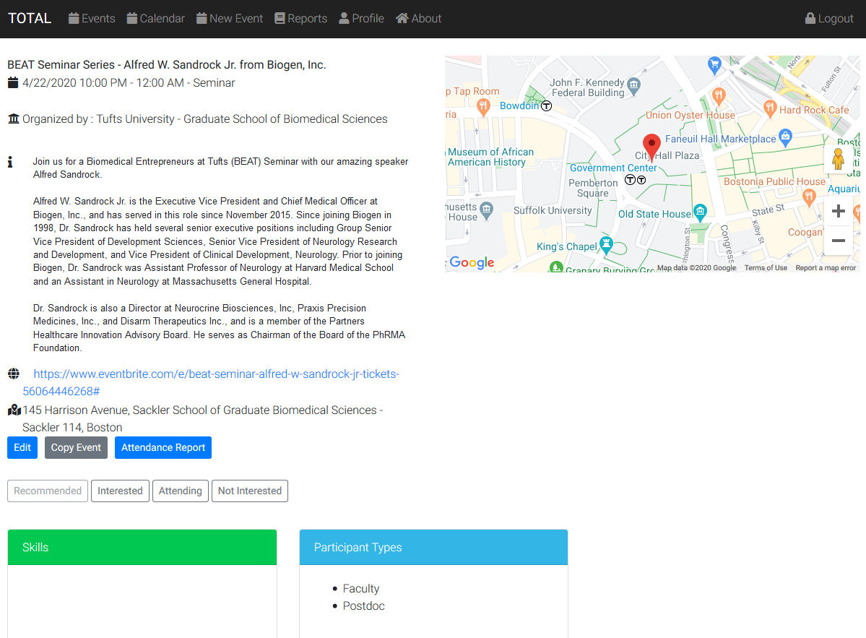

Administrators will have an a button to edit the event which will open the following page.
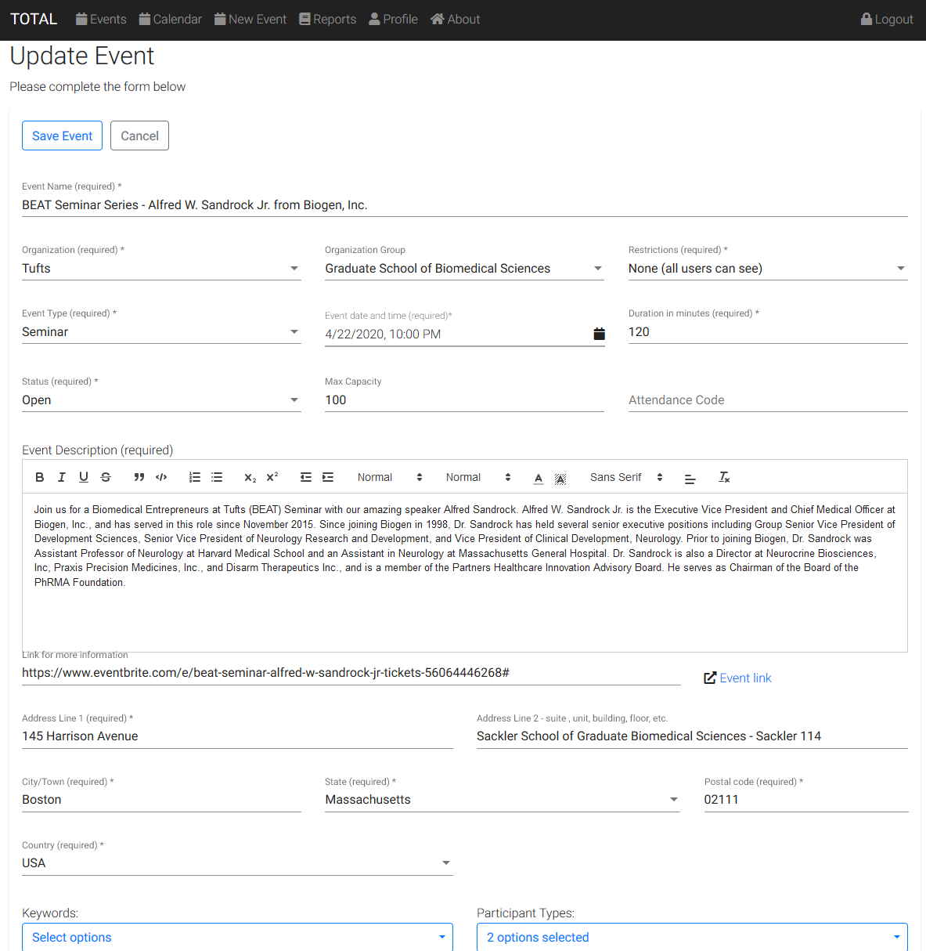

Notes on the edit event page:
- Event Date/Time and duration. Changes to these will trigger email (or mobile app notification)
- Keywords: changes to these will alter user recommendations.
- Participant Types: changes to these will alter user recommendations.
- When you click “Save”, the system updates user recommendations for this event.
- In addition to editing an event you can copy an event. Copying will default all the fields from the old event except the date and time.

