Name/Degree | Headshot | School/Dep | Track
Abigail Batchelder,  PhD MPH | 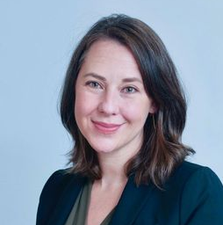 | CAMed  Psychiatry;  SPH | Clinician Scientist
Catherine S. Choi,  MD | 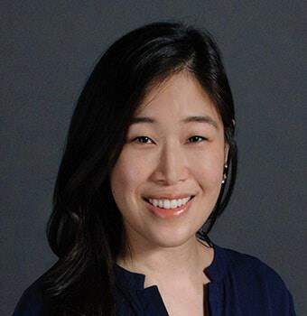 | CAMed/ Ophthalmology | Clinician Educator
Hilana Scott,  MSN | 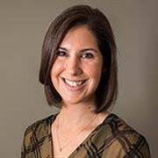 | CAMed/  Pediatrics | Clinician Educator
Jai Marathe,  MBBS MS | 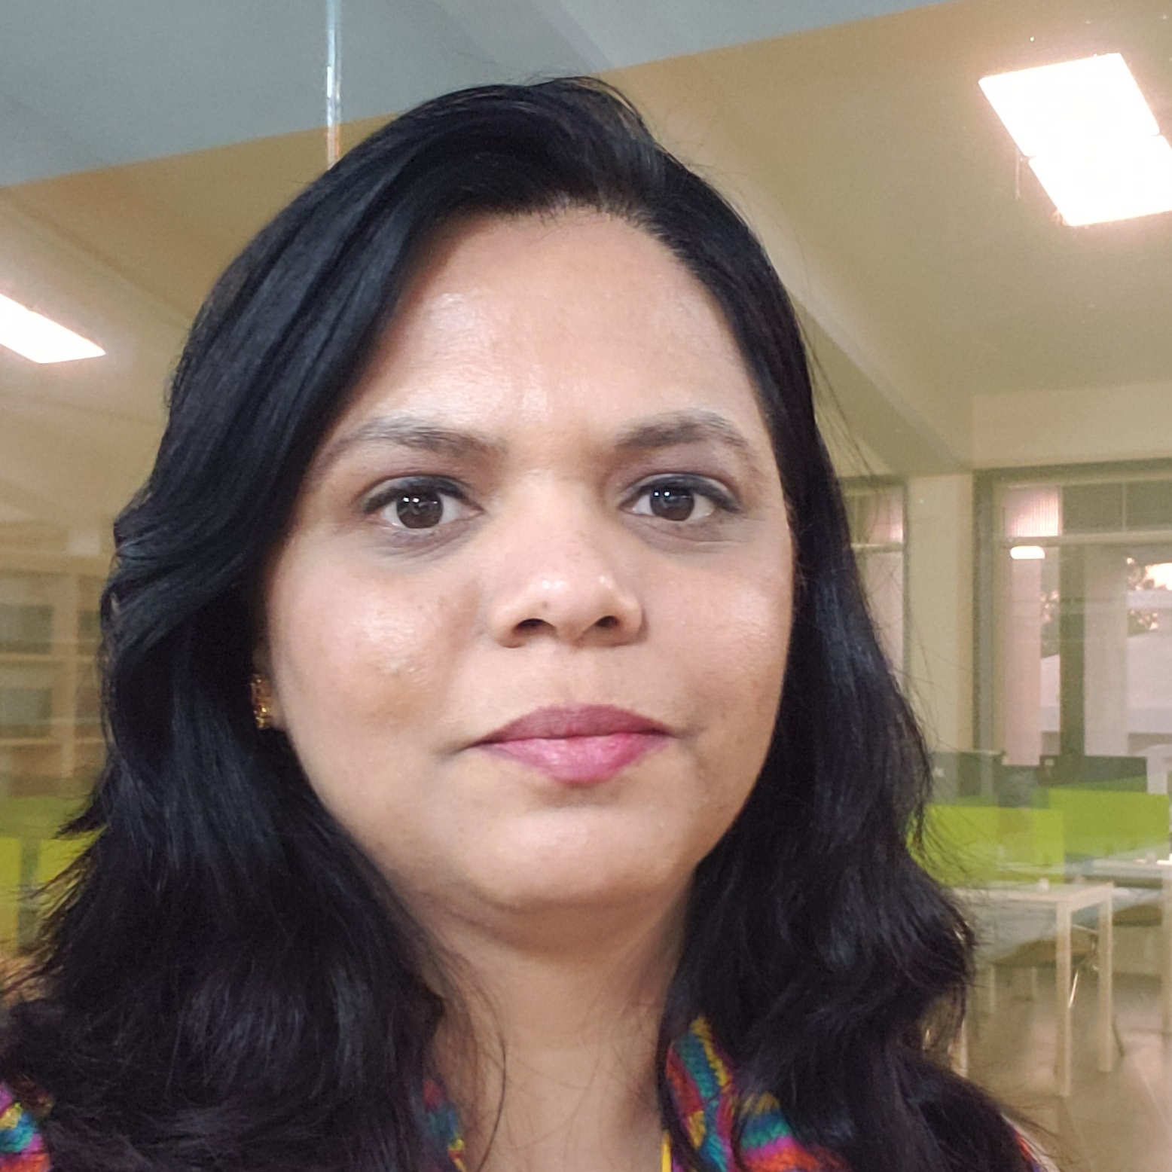 | CAMed/  Infectious Diseases | Clinician Scientist
Lilani Perera,  MD | 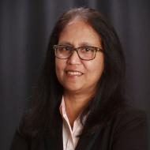 | CAMed/ Medicine & Gastro-enterology | Clinician Administrator
Maura Walker,  PhD | 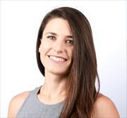 | Sargent College;  CAMed/ Preventive Medicine & Epidemiology | Population Scientist
Megan Leo,  MD | 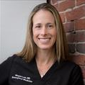 | CAMed/  Department of Emergency Medicine | Clinical Educator
Miriam Harris,  MD MS | 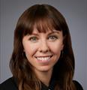 | CAMed/ Division of General Internal Medicine | Clinical Innovator
Nicole Campion  Dialo,  MD MPH | 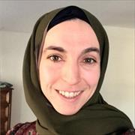 | CAMed/  General Internal Medicine | Clinician Educator
Nicole Spartano,  PhD | 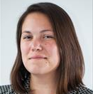 | CAMed/ Endocrinology, Diabetes, Nutrition, & Weight Management | Population Scientist
Sheree Boulet,  MPH DrPhD | 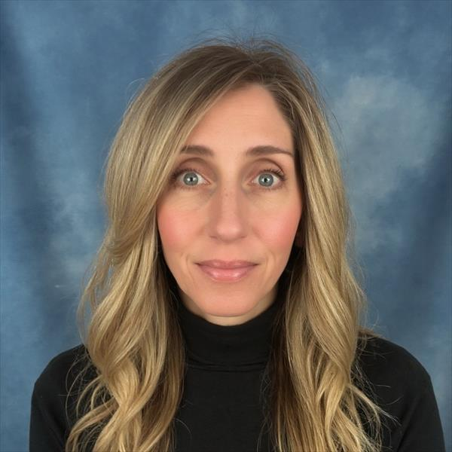 | CAMed/  OBGYN | Population Scientist
Vanessa Xanthakis,  PhD MS | 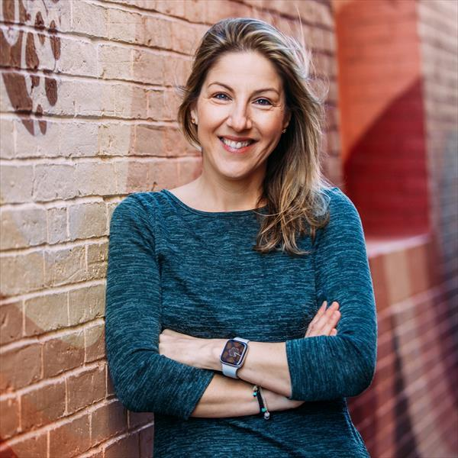 | CAMed/ Medicine, PM&E | Population Scientist
Venetia Zachariou,  PhD | 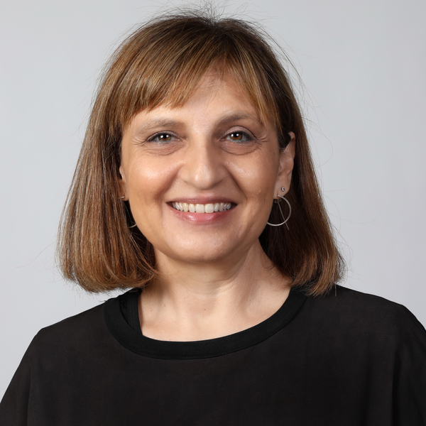 | CAMed/ Pharmacology Physiology Biophysics | Basic Scientist/  Translational Scientist

