Headshot | Name | Sch: Dept | Track
 | Audrey Provenzano,  MD MPH | BUMG: Medicine/GIM | Clinician Administrator
 | Brian Carmine, MD | BUMG: Surgery | Clinician Administrator
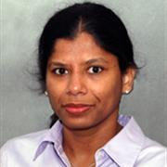 | Devaki Sundararajan, BDS CAGS | GSDM: Division of Oral and Maxillofacial Pathology/  Department of Oral and Maxillofacial Surgery | Clinician Educator
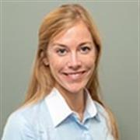 | Lauren Tracy, MD | BUMG: Otolaryngology | Clinician Scientist
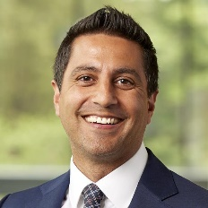 | Nathan Cardoos, MD CAQSM | BUMG: Family Medicine/  Sports Medicine | Clinician Educator
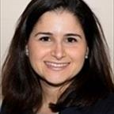 | Nicole Siegel, MD | BUMG: Ophthalmology | Clinician Educator
 | Rosha Forman, MSN | BUMG: Obstetrics and Gynecology/  Midwifery | Clinician Administrator
 | Sarah Kimball, MD | BUMG: Medicine/GIM | Clinician Educator
 | Sarah Valentine, PhD | BUMG: Psychiatry | Clinician Scientist
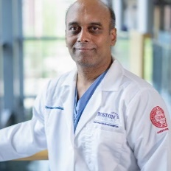 | Sundara Rengasamy,  MD | BUMG: Anesthesiology | Clinician Educator
 | Titilayo Ilori,  MD MSc | BUMG: Medicine/  Nephrology | Clinician Scientist
 | Urvashi Upadhyay, MD | BUMG: Neurosurgery | Clinician Educator
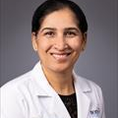 | Vishakha Sabharwal, MBBS | BUMG: Pediatrics/  Division of Pediatrics Infectious Diseases | Clinician Scientist
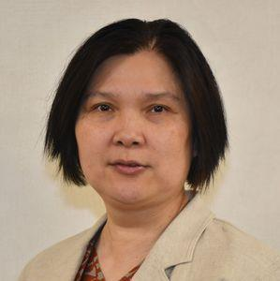 | Xueling Wu, PhD | BAMed: Medicine/ID | Basic Scientist/Translational Scientist

