Headshot | Name | Department | Academic Rank
 | Ariel Marks, MD | Neurology | Assistant Professor
 | Audrey Christiansen, MD | Pediatrics/  Developmental and Behavioral | Assistant Professor
 | Danby Kang, MD | Surgery | Assistant Professor
 | Denise Wong, MD | Medicine/Endocrinology | Assistant Professor
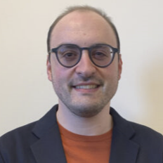 | Seth Tobolsky, MD | Medicine/Endocrinology | Assistant Professor

