Name/  Degree | Headshot | Department/  Section | Phenotype/ Track
Alexandria Miller, PhD | 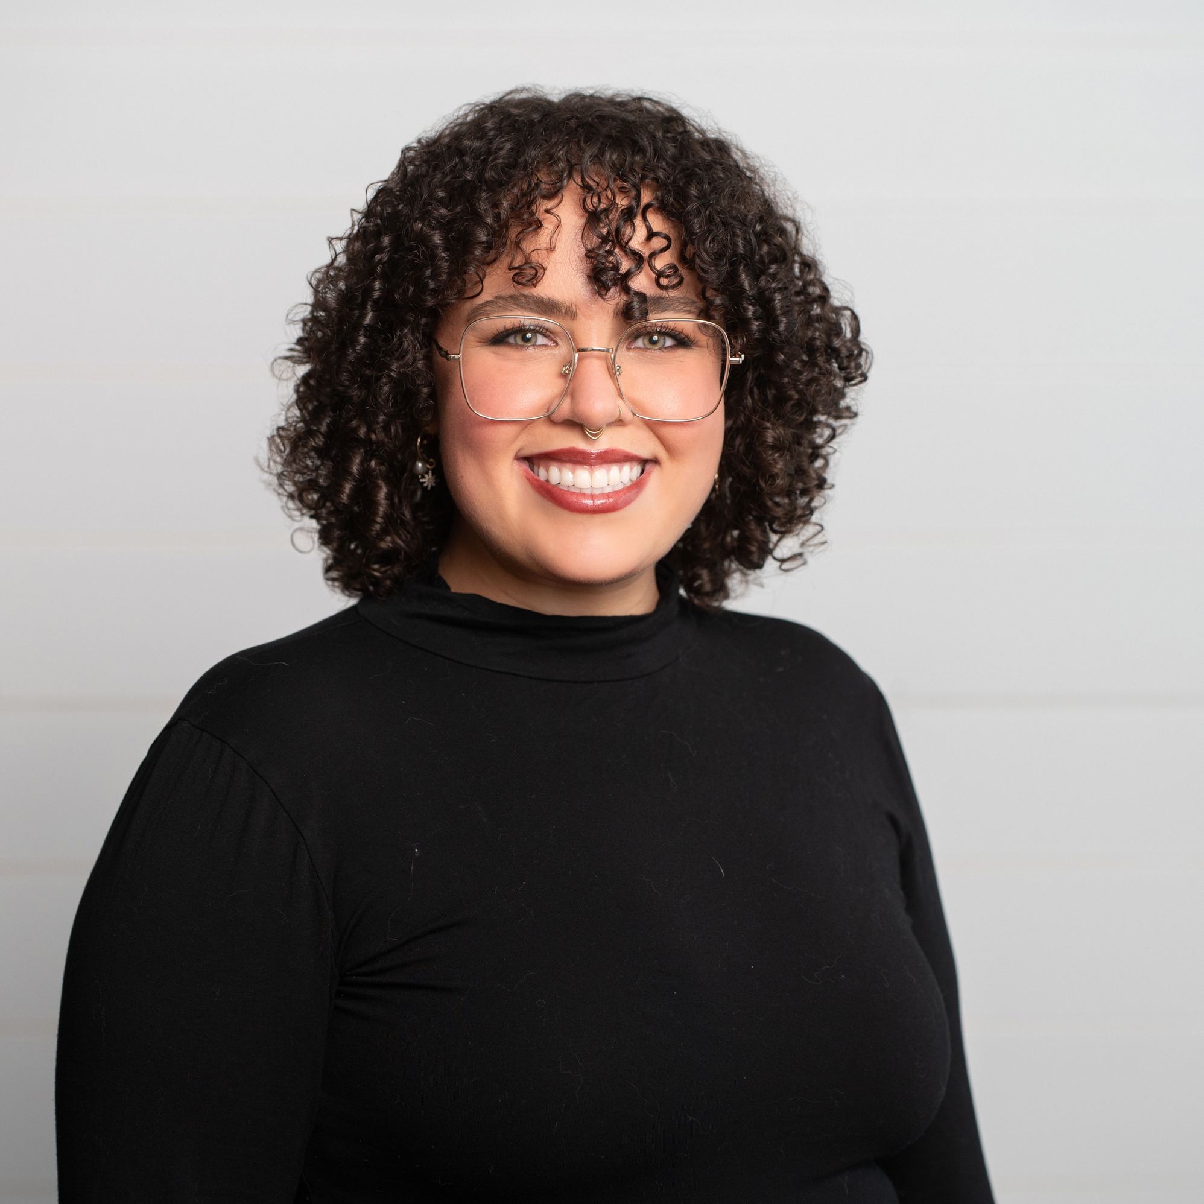 | Psychiatry | Clinician Scientist
Arielle Spellun, MD | 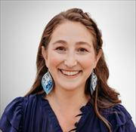 | Pediatrics/Developmental & Behavioral Pediatrics | Clinician Scientist
Cara Connors, BSN MS | 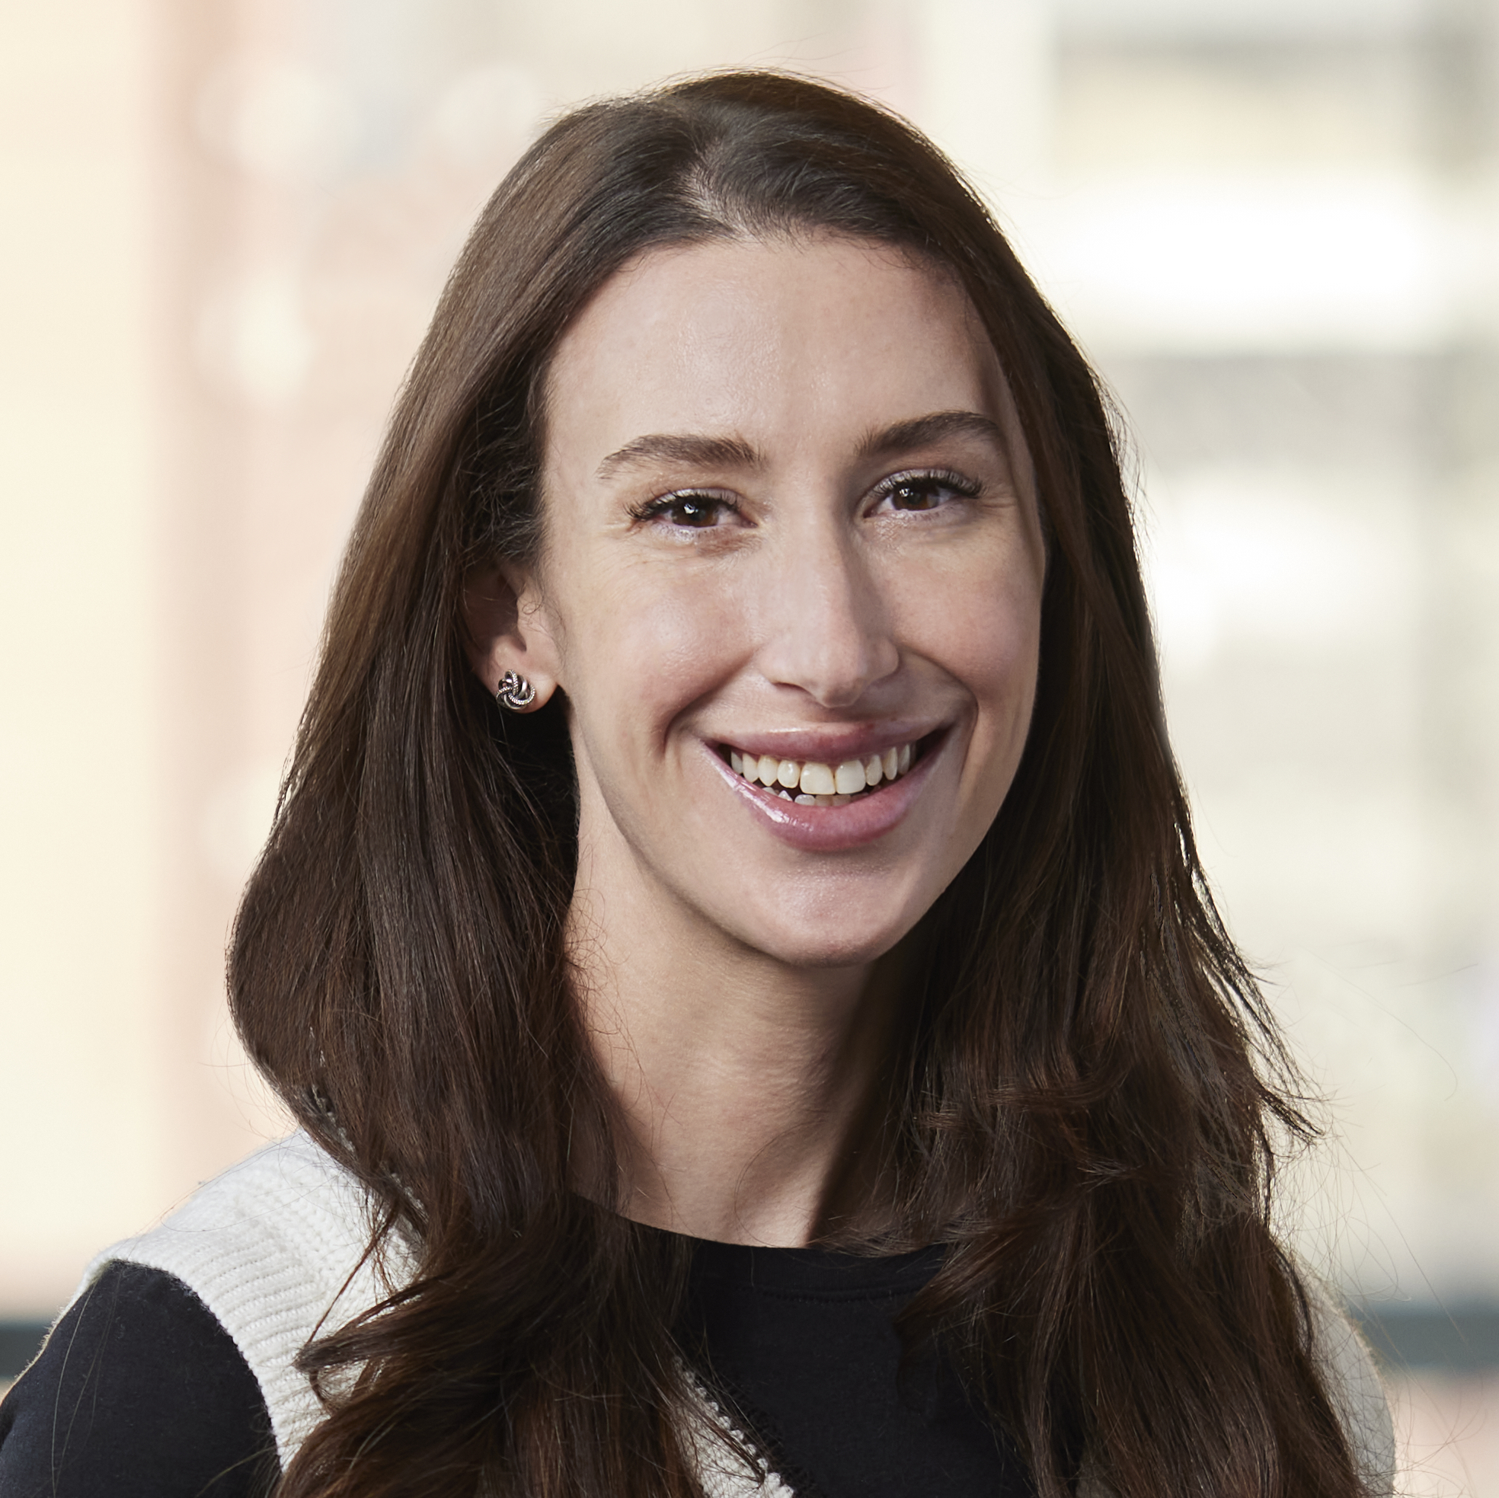 | Obstetrics & Gynecology / Urogynecology | Clinician Educator
Carolyn Arnold, MD MPH | 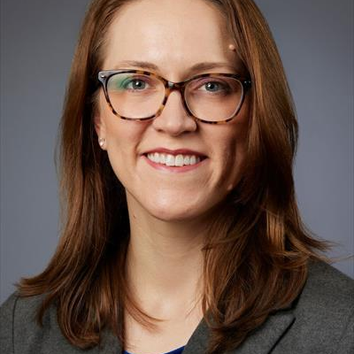 | Family Medicine | Clinical Administrator
Cynthia Gaudet, DO MPH | 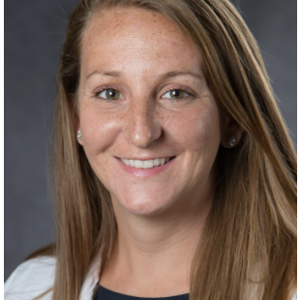 | Emergency Medicine | Clinician Educator
Elizabeth Sanders, DPM | 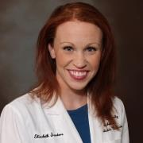 | Surgery/Podiatry | Clinician Educator
Jennifer Farraye, MSN BSN | 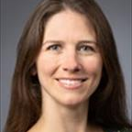 | OB/GYN | Clinician Educator
Jennifer Hao, MD | 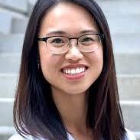 | Medicine/GIM | Clinician Educator
Kelsey Egan, MD MsC | 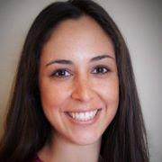 | Pediatrics/Health Services Research | Clinician Scientist
Kwaku Twum, PhD | 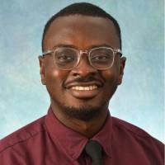 | Pathology and Laboratory Medicine | Clinician Educator
Lynsie Ranker, PhD MPH | 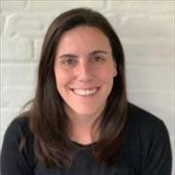 | Community Health Sciences | Population Scientist
Mark Castera, MD | 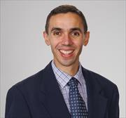 | Pediatrics | Clinician Scientist
Marva Foster, PhD | 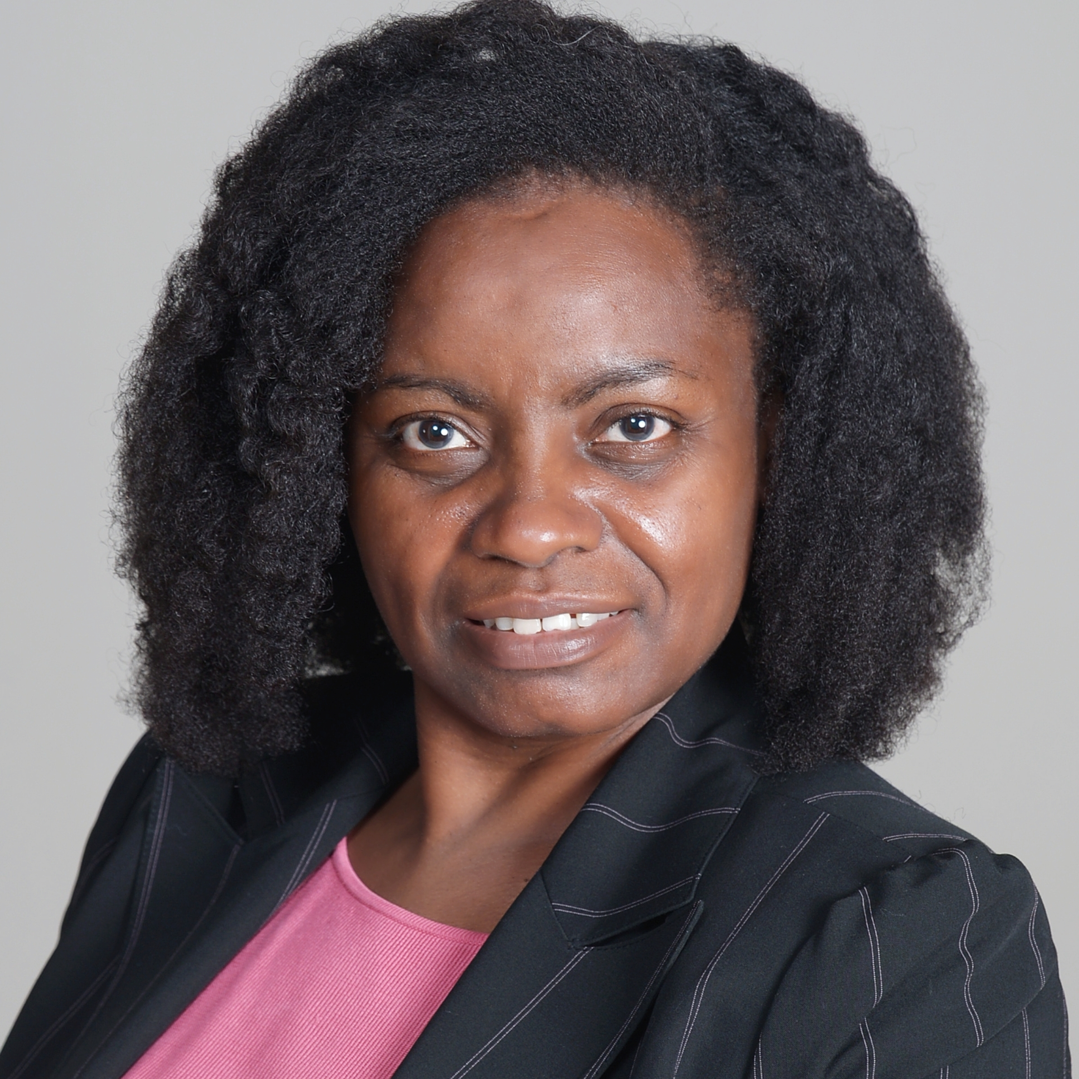 | Medicine/GIM | Clinician Scientist
Megan Janeway, MD | 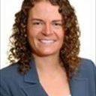 | Surgery | Clinician Scientist
Mirian Barrientos, MSN MPH | 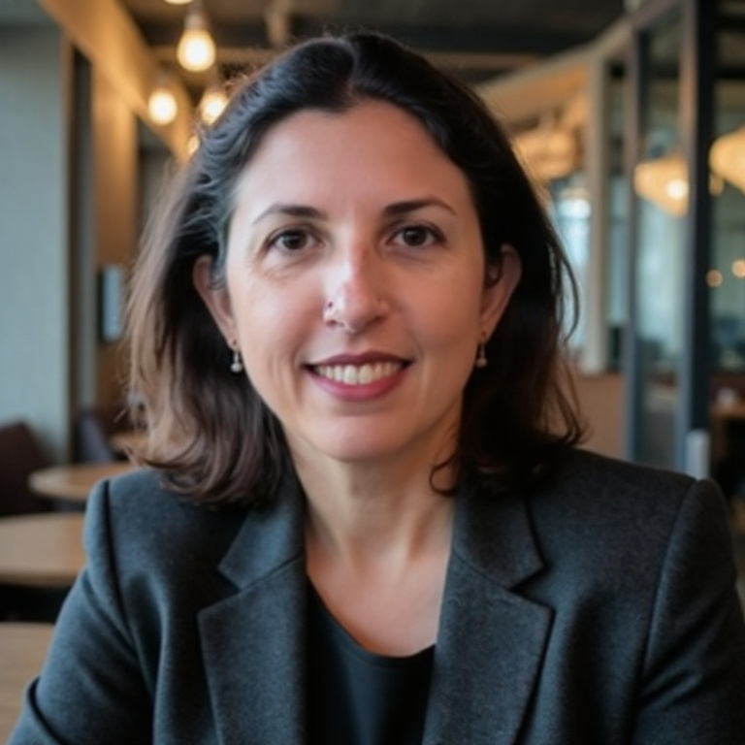 | Medicine/Endocrinology | Clinician Educator
Sabetta Singh, MD | 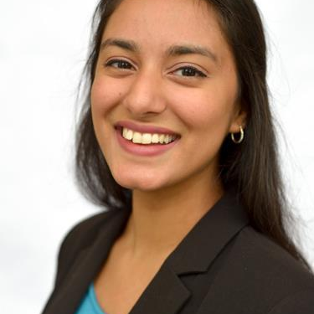 | Medicine/GIM | Clinical Administrator
Samantha Truong, MD | 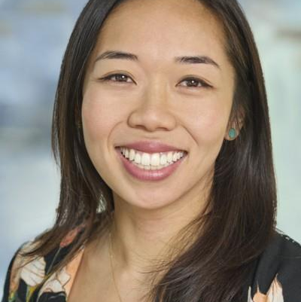 | OBGYN | Clinician Scientist
Samuel Luk, PhD |  | Radiation Oncology | Clinician Scientist
Yasmine Elhefnawy, MD | 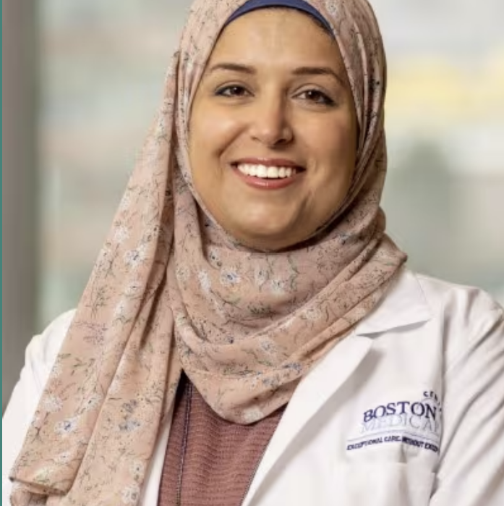 | Pediatric/Neurology | Clinician Educator

