Name/  Pronouns | Headshot | School/  Dept | Track | Email
Alysse Wurcel,  MD |  | School of Medicine/GIM | Clinician Scientist | alysse.wurcel@bmc.org
Julia Bond,  MPH MD |  | SPH/Epidemiology | Population Scientist | jcbond@bu.edu
Kathleen Swenson,  EdD MPH MS |  | CAMed/GMS; Genetic Counseling Program | Clinician Educator | kbb2010@bu.edu
Kendra D. Sims,  PhD MPH |  | SPH/Epidemiology | Population Scientist | ksims17@bu.edu
Rodolfo Villarreal-Calderon,  MD MS | 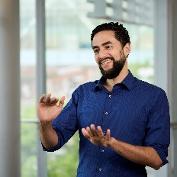 | School of Medicine/Hospital Medicine | Clinician Educator | rodolfo.villarreal-calderon@bmc.org
Samuel Slavin,  MD |  | CAMed/Cardiology | Clinician Educator | samuel.slavin@bmc.org
Scarlett Bellamy,  ScD |  | SPH/Biostatistics | Population Scientist | bellamys@bu.edu
Wei Zhao,  PhD | 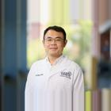 | CAMed/Radiation Oncology | N/A | wei.zhao@bmc.org
Xanthia Tucker,  MD |  | CAMed/Internal Medicine (General) | Clinician Educator | xanthia.tucker@bmc.org

