**Respiratory Viruses: a focus on COVID-19 ARC**

**Special Seminar**

**Tuesday, December 14, 2021 | 3:00 – 4:00pm**

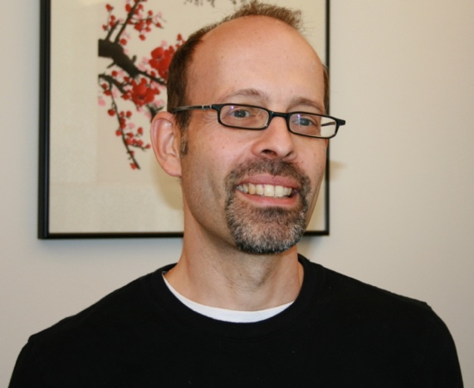

[**Michael S. Diamond, MD, PhD**](https://infectiousdiseases.wustl.edu/faculty-staff/michael-s-diamond/)

**Herbert S. Gasser Professor, Departments of Medicine, Molecular Microbiology, Pathology & Immunology**

**Washington University School of Medicine, St. Louis**

*“****Antibody and vaccine mediated protection to emerging***

***SARS-CoV-2 variants****”*

**Zoom Meeting**

https://bostonu.zoom.us/j/94320738605?pwd=d25EV0RmaVJqK0dkUDlEYWw0UXRCQT09

**Meeting ID: 943 2073 8605**

**Passcode: 678053**



***IBRO*BU Interdisciplinary Biomedical Research Office**