MedHub Ready – Final Evaluations Resource
https://view-su2.highspot.com/viewer/649db6d21b931941ac0e7f89
Note: 36:01 on the clip above starts approximately where the review and release tutorial webinar begins.
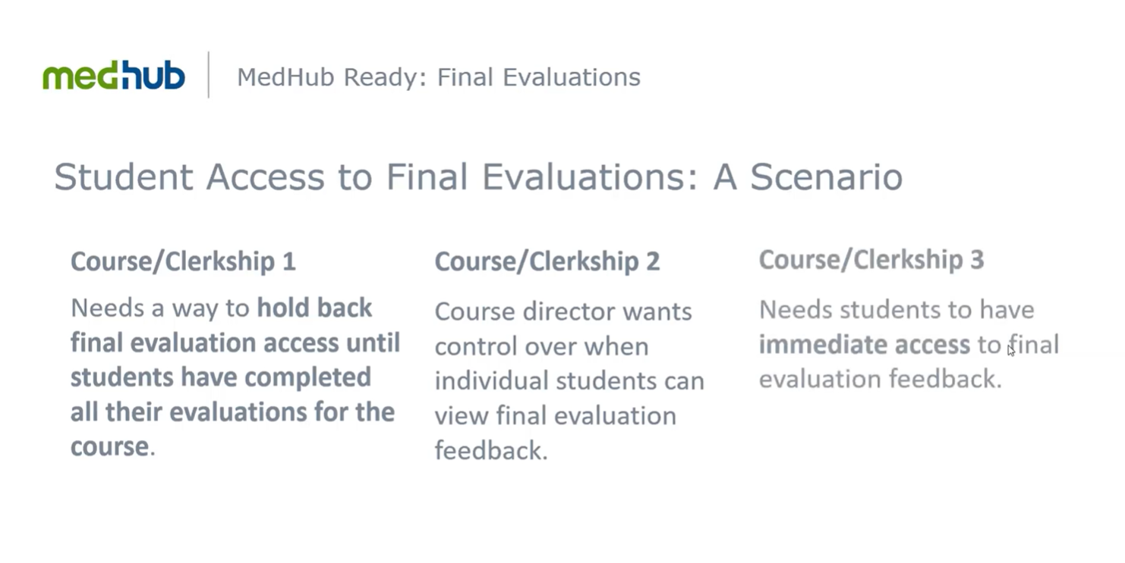
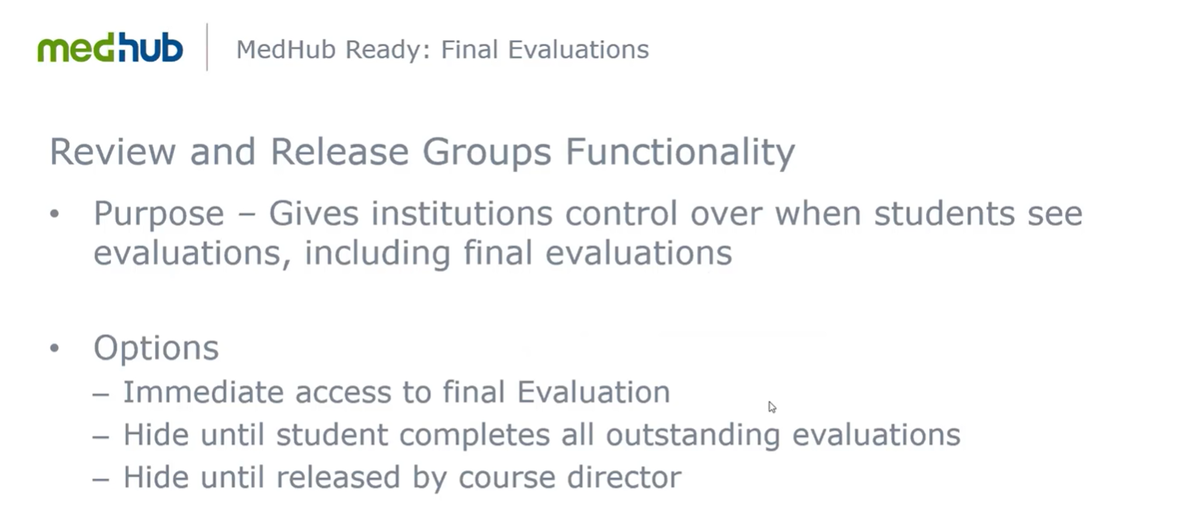

For Faculty (Course/Clerkship Directors) to Release Evaluations:
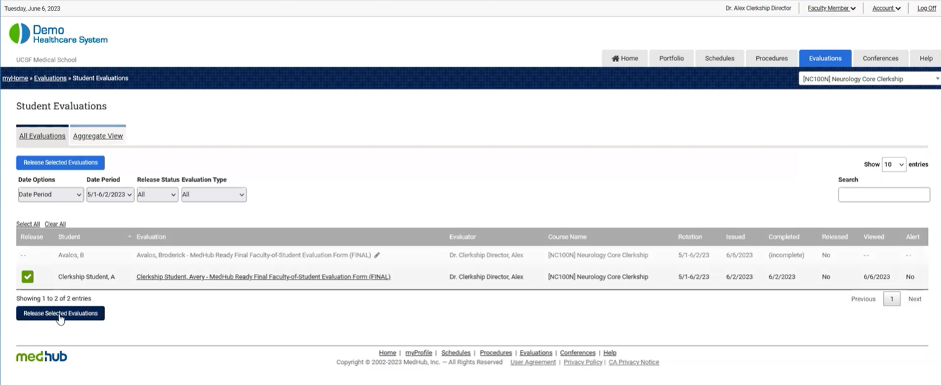

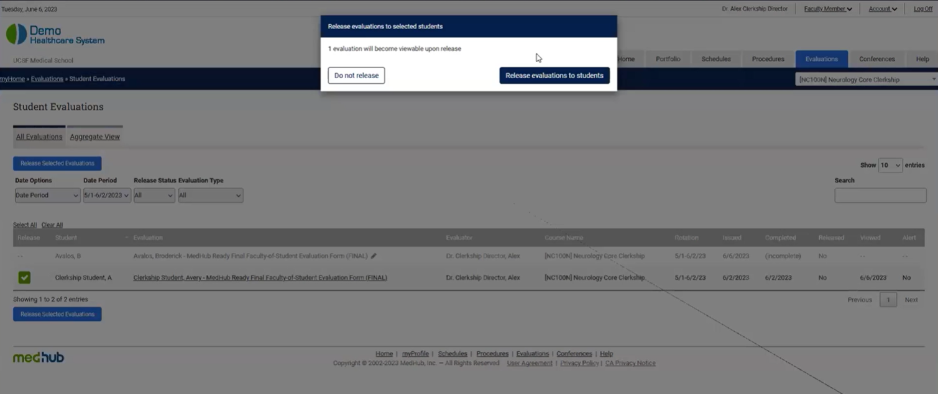

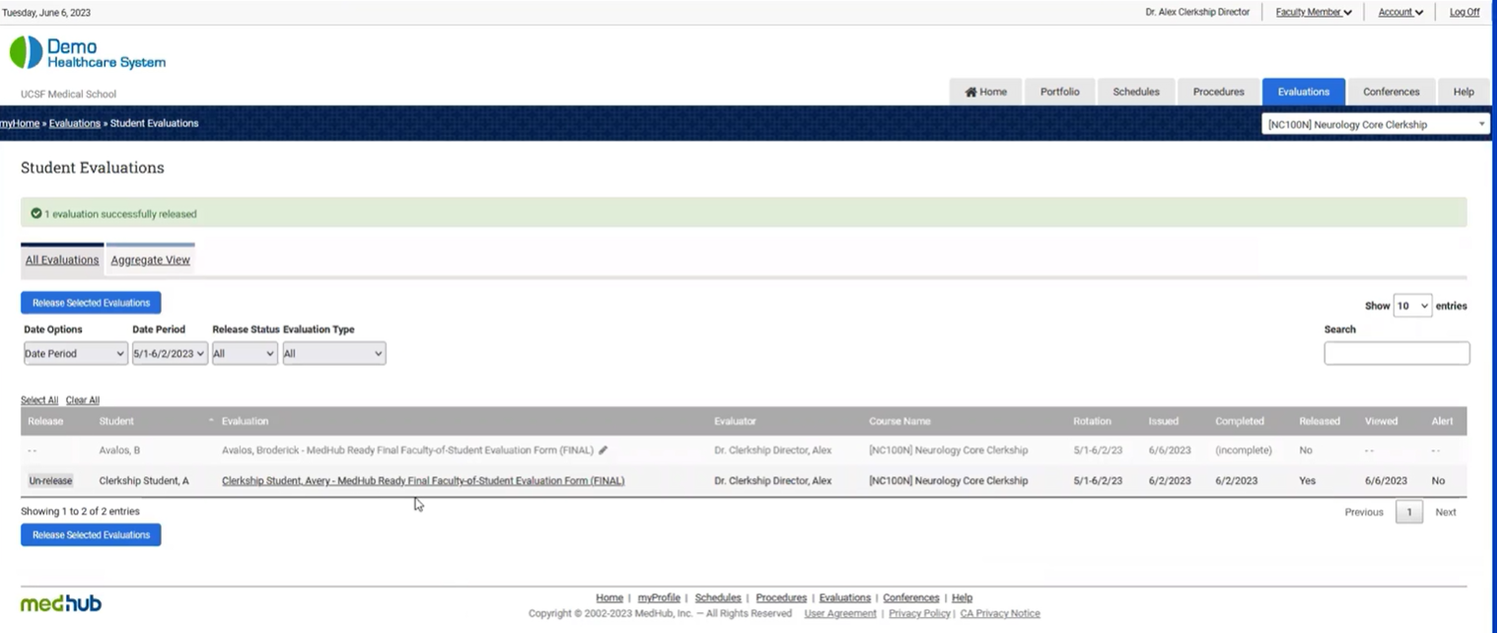

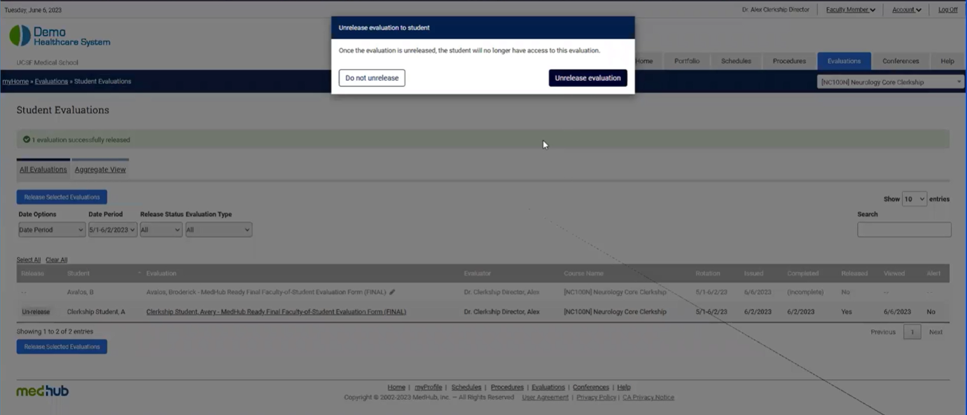

For Course Coordinators to Release:

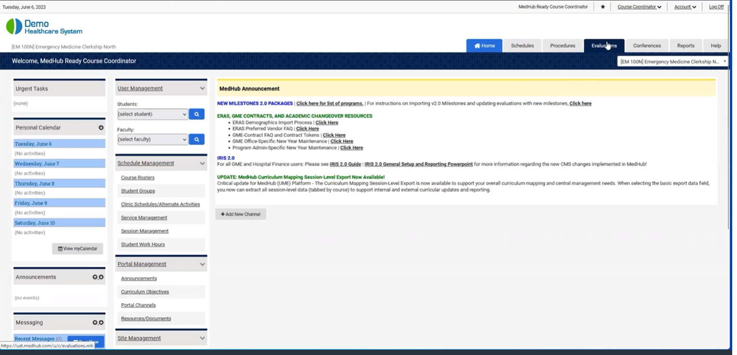
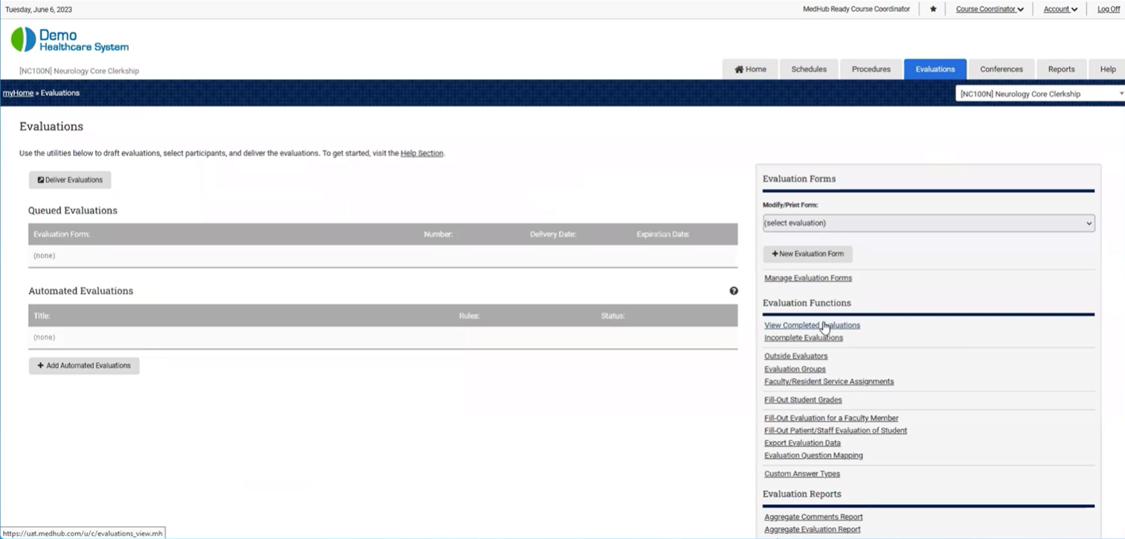
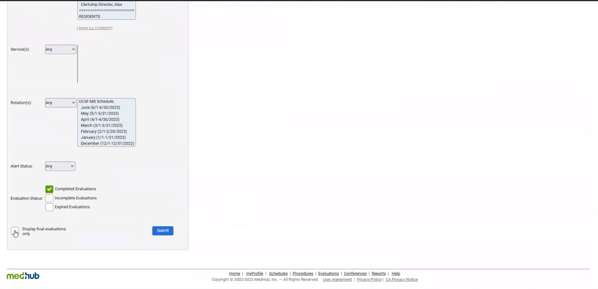
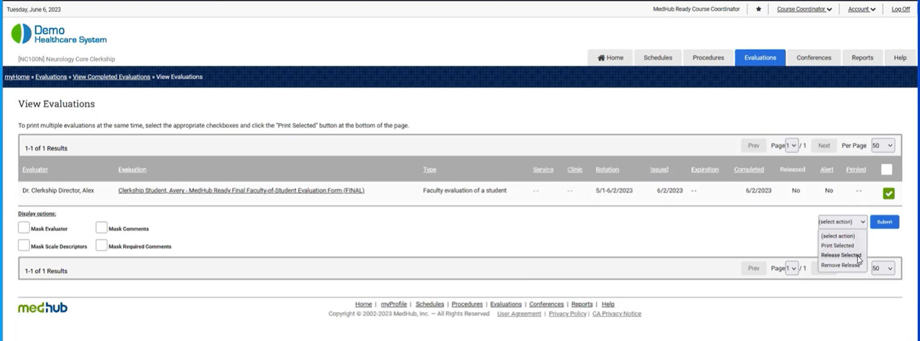
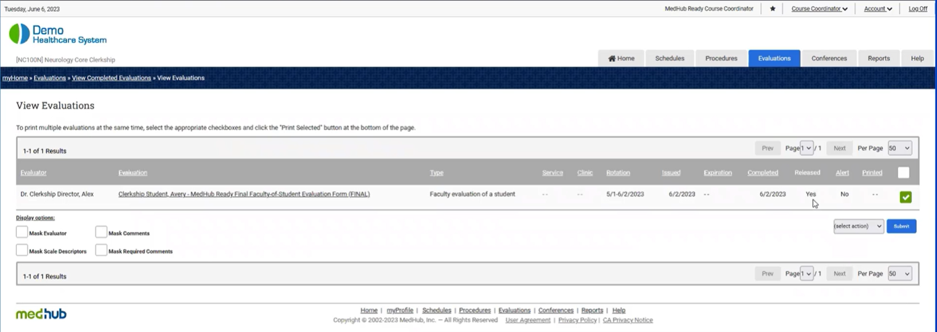

Brief Summary from Learning Portal Module On Review and Release Groups.
The Review & Release Groups feature provides Student Administrators with the ability to create groups of individual courses, and to apply different evaluation settings for each group of courses. These groups and settings are applicable to evaluations completed on students, or "... of a Student" evaluation type, which also include Final Evaluations. Creating release groups allows the school to manage if and when students receive their evaluation results.
The Review & Release Groups link is only available to a Student Administrator that has been granted security access and is available within the security section of the homepage.

Review & Release Groups have no interaction with or connection to Course Groups.

Most Common Use Case and General Information
The Review & Release Groups functionality allows the school to manage evaluation settings for different groups of courses. For example, if all offsite courses or electives have stricter or more lenient evaluation settings, the school can use the review and release groups feature to set the evaluation settings for those particular groups of courses.
For Student Access to Resident Evaluations and for Student Access to Faculty Evaluations, the access options mean the following:
- Always hide from students - Students cannot view any evaluations completed by a Resident/Faculty with the Student as the target.
- Immediate access to resident/faculty evaluations - Students can view Resident/Faculty evaluations as soon as they are completed.
- Hide until reciprocal evaluation is submitted - Students must submit a reciprocal evaluation of the target Resident/Faculty prior to having the ability to view Resident/Faculty evaluation(s).
- Hide until grade is posted by Course Director - Students cannot view Resident/Faculty evaluations until the Course Director posts the Student’s final grade.
- Hide until reciprocal evaluation is submitted and grade is posted - Students must complete a reciprocal evaluation of the target Resident/Faculty as well as wait for their final grade to be posted by the Course Director prior to having the ability to view Resident/Faculty evaluation(s).
- Hide until released by Course Director - Students cannot view completed Resident/Faculty evaluations until the Course Director releases those evaluations to the Student (if the workflow to have Course Directors release evaluations is used).

Reciprocal Time Window Days
The reciprocal time window box is only available for selection if one of the Hide until reciprocal… evaluation access options is selected. You may select from a 0 to 365-day reciprocal window. The reciprocal time window of 0 (zero) will expire at the end of the current date. It may be used when delivery of performance evaluations and corresponding reciprocal evaluations occurs at the same time. Doing so could make evaluations available to students in a more expedient manner.
If using any of the Hide until reciprocal evaluation is submitted… settings, a reciprocal evaluation must be delivered to the student within the allotted time window to meet the reciprocal evaluation submission requirement. If a reciprocal evaluation is required but that evaluation is not delivered to the student within the set reciprocal time window, the student will be able to view the evaluation response data after the set time window has expired. And lastly, if a reciprocal evaluation is delivered to the student within the set time window, the student will not be able to view evaluation response data until that evaluation is completed and submitted.

Steps to create a Review & Release Group:
- Logged in as Student Administrator, navigate to the Security section and click the Review & Release Groups link.
- Click the Create New Group button.
- Enter the new group name.
- Select the courses to add to the group and click the Add Selected button.
- Click the Save Group button.
Steps to manage Release Group Settings:
- Click the Access/Hide dropdown to select the type of evaluation access.
- Click the Update Settings button.

Tips:
- The Default group cannot be removed.
- If you have courses in your default review group, make sure to set the release settings for the default group.
- Each group must have a unique name and must contain at least one course, or the group cannot be saved.
- If an institution is utilizing the course hierarchical feature, any core course moved into a course group will also include all site courses listed within and underneath the core course by default. Core and site courses must remain together in any Review & Release Groups.
- Changes made to Review & Release Groups will be archived and available to view in the audit trail query report. Navigate to the Reports tab and select the Audit Trail Query report under Site Statistics and select the audit trail query to run a report against.
  - The following audit query reports for Review & Release Groups are available:
    - Review and Release: Group Created
    - Review and Release: Group Deleted
    - Review and Release: Group Membership Modified
    - Review and Release: Group Name Changed
    - Review and Release: Group Settings Changed

Watch the video below to learn more then give it a try with the simulation.

