Self Service Password Instructions

New user will need to access: https://passwordhelp.bmc.org and set their password

- Enter your new BMC email as the username.
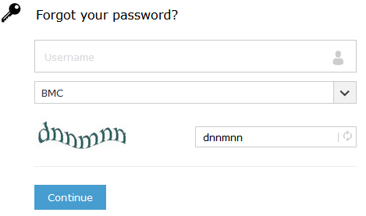

- Complete the captcha

- Right Mouse click the blue continue.

- Select email Verification.
- Right Mouse click the blue continue.
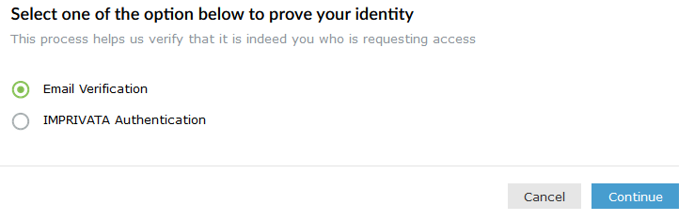

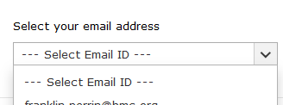
- Right Mouse click the down arrow and select your personal/work non bmc email address by right mouse clicking it.

- Right Mouse click the blue continue.
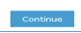

- You will receive at that address an email subject line Password Reset Confirmation this will contain you verification PIN.
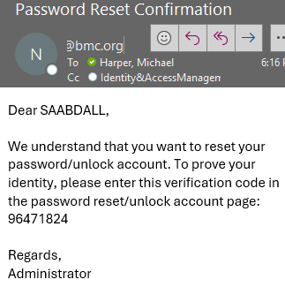

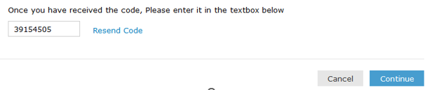
- You will then need to enter the PIN from your email into the blank box.
- Right Mouse click the blue continue

Password Generation Advice: 22-22 Method two capitals, two names, two numbers and two special characters. Example any combination “John2#smitH5#” ,“John##Smith25”,etc……

Set your password by entering your new password twice and then right mouse click the blue Reset Password

