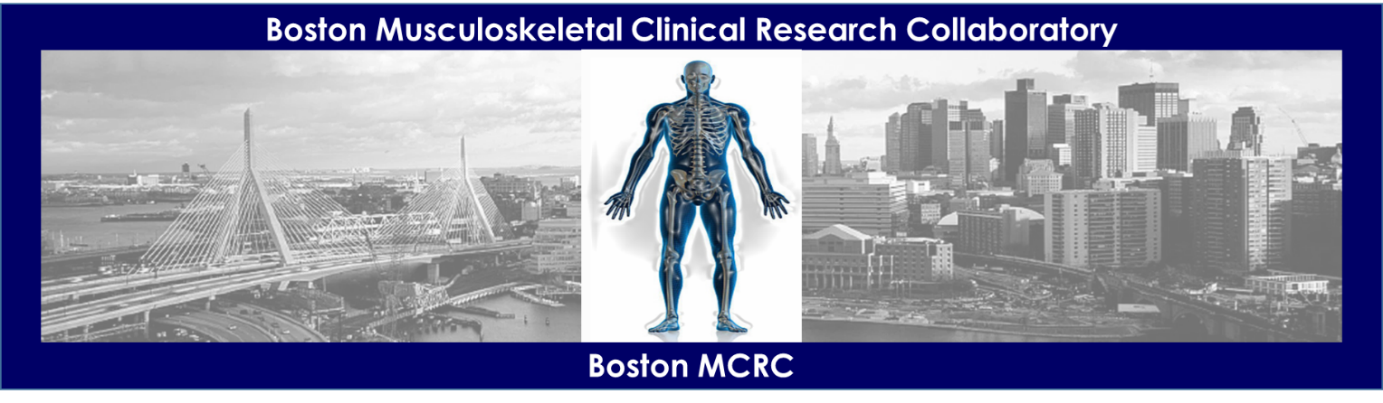

BOSTON MCRC PILOT & FEASIBILITY RESEARCH AWARD COVER PAGE

- Primary Investigator (applicant) (name, degree(s), academic rank)

_________________________________________________________________________

- Collaborator(s)

_________________________________________________________________________

- Primary Institution

_________________________________________________________________________

- Pilot Project Title

_________________________________________________________________________

_________________________________________________________________________

- Other Support.

- IRB Status. The project receiving the Boston MCRC Award must be IRB approved by July 1, 2021. The IRB approval letter is required before funding.

- Detailed Budget Form and Budget Justification.

Submit the application as a single pdf by email to Sharon Tomlinson at mcrc@bu.edu

