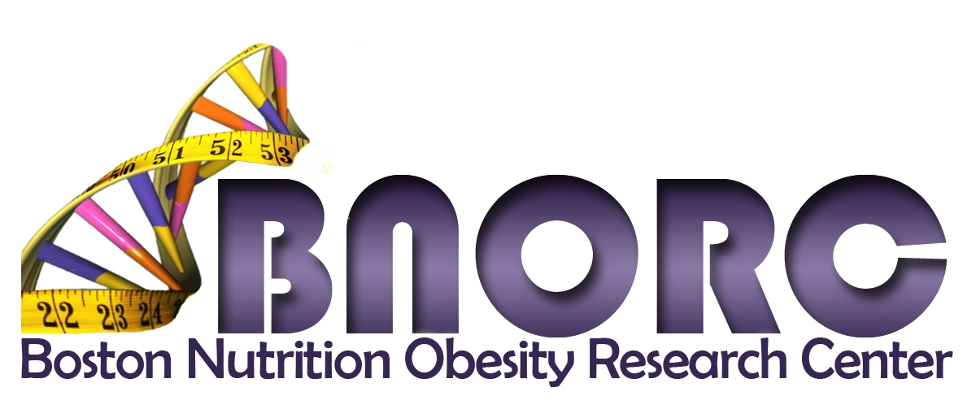

Pilot and Feasibility Program 2020-2021
LETTER OF INTENT (LOI) – DUE September 1 at 10:00PM
Applicant Information:
Name
Degree(s)
Academic Title
If MD or PhD Fellow or Senior Postdoc, please confirm that you have completed a minimum of 24 months of a fellowship. | Yes
Institution
Project Title
Email
Mentor (if applicable)

Check Category of Eligibility:
New investigator without current or past independent research support (i.e., NIH R01, P01). MD and PhD fellows and senior postdoctoral fellows who have completed a minimum of 24 months of a fellowship who have formal mentors are eligible in this category.
Established Funded Investigator without previous or current research in the area of nutrition or obesity, proposing to study a problem in these areas.
Established Investigator in nutrition or obesity proposing an innovative project that is a substantial departure from previous areas of study.

Check BNORC theme(s) that your project addresses (please refer to the website for a description of themes):
Nutrient Metabolism in Health and Disease
Brain Control of Feeding Behavior and Metabolism
Environmental and Genetic Influences on Obesity and Related Chronic Diseases

Attach the following and submit as one PDF file using this form as the cover page:
- NIH Biosketch (with an appropriate personal statement and current other support)
- Letter of support (2-page maximum) from mentor (required only for MD and PhD fellows and senior post-doctoral fellows) that includes the following components:
- Description of trainee’s path to independence;
- Evidence that the proposed project belongs to the trainee;
- Statement of departmental support available to the trainee during the 1-2 year period of the proposed project.

- One page summary of proposal that includes the following components:
- Description of how the applicant fits into one of the eligibility categories;
- Brief description of the background, gap in knowledge to be addressed, and objectives of the proposed project; and
- Description of how the P&F project will provide critical preliminary data for a planned proposal to the NIH or other funding agencies.

Additional details of the eligibility requirements and instructions for submitting your Letter of Intent (LOI) may be found on the Center’s website. Please contact Andrew Greenberg, Associate Director or Donna Gibson, Center Administrator with any questions about the requested information or the submission process. LOIs will be reviewed in September. Full proposals (invitation only) will be due October 22. We anticipate that Year 1 funding will begin as early as December 1, 2020.

