Dear Colleague,

Accounts Payable is going green! Given the frequency of reimbursement checks that you have received recently, please consider registering for the Paymode for Reimbursements direct deposit program. These expense reimbursements are completely separate from Payroll direct deposits and can be made to the same bank account as your paycheck, or to a different bank account, based on your own preference. We already have over 1,000 employees signed up and successfully receiving reimbursements via this new program.

If you are interested in signing up for the direct deposit program, please follow the directions below to add your bank information for expense reimbursements in the **‘Benefits and Pay’** section of Employee Self-Service (accessed through the BUworks Portal). *Please make note of the browsers recommended for best results below.

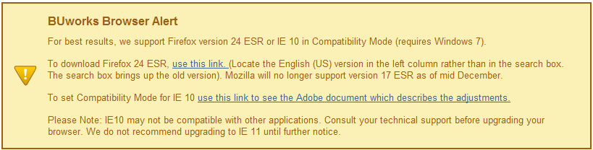

|  |
| --- |
| 1.   Click on the **‘Direct Deposit’** section. |
| cid:image005.png@01CEF1C3.DAB1B880 |
| 2.   Then click on **‘Add’** and select ‘**Expense Reimbursement bank’**. |
| cid:image006.png@01CEF1C3.DAB1B880 |
| 3.   Enter your **routing** and **bank account number** and specify the type of account (**checking/saving**). For ‘Payment Method’, select **‘Bank Transfer (ACH PPD)’**. Please do not fill in any information in the “Note to Payee”, “Percentage of Net” or “Flat Amount” fields. |
| cid:image003.png@01CEF1C4.C178B340 |
|  |
| 4.   Hit **‘Save’**. Please allow up to 3 business days for the change to go into effect. |

If you need to change your bank information in the future, or want to discontinue the use of direct deposit, this information can be edited in ESS or removed at any time, via these same screens in Employee-Self Service. If you have any questions regarding the Paymode direct deposit program, please send an email to [payment@bu.edu](mailto:payment@bu.edu).

Thank you for your cooperation.