PROMETHEAN SMARTBOARD MANUAL

BU 802.1X WIFI:
bumcemcw
Wireless4You!

- To Power On:
Press power button on front of panel
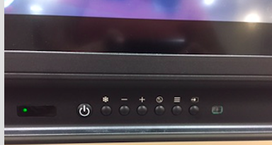

- Promethean Activ Board is on Source HDMI2 or HDMI3 – To switch source view, press the source button on the front of the panel and touch the desired source directly on the screen

- To return to the Home Screen at anytime:
Press the pink circular menu button in the center of the screen and select the home button
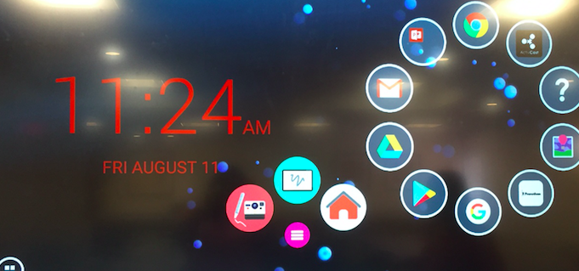

- To access a blank whiteboard:
Press the pink circular menu button in the center of the screen and select the whiteboard button

- To freeze a screen/image and draw over it:
Press the pink circular menu button in the center of the screen and select the pen with camera button.

- To save said image, press the save (floppy disk) button. Images will be saved in the Picture Gallery. To access, click on gallery and select your image. Once selected email to yourself or save on an unencrypted flash drive.
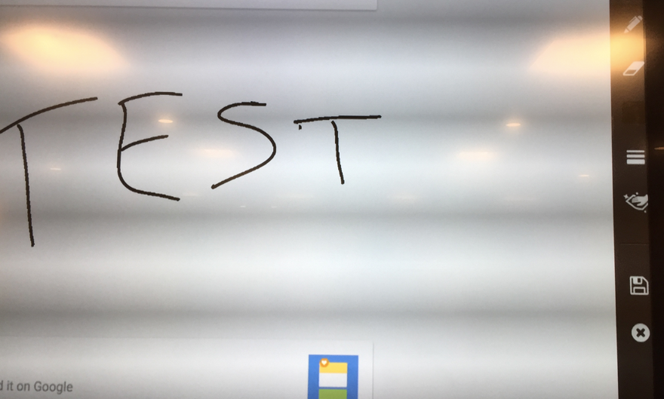

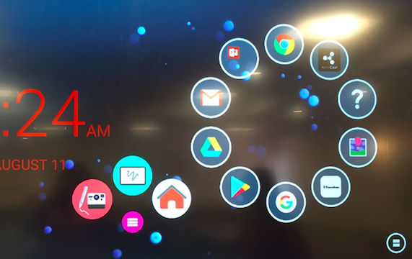

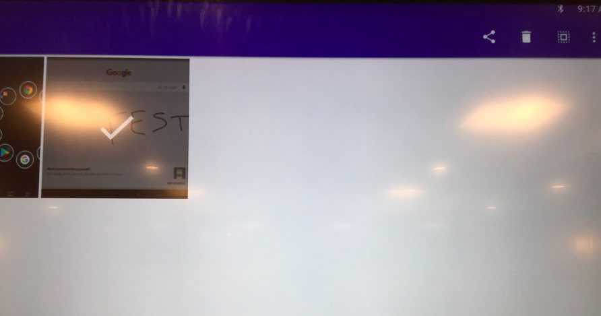

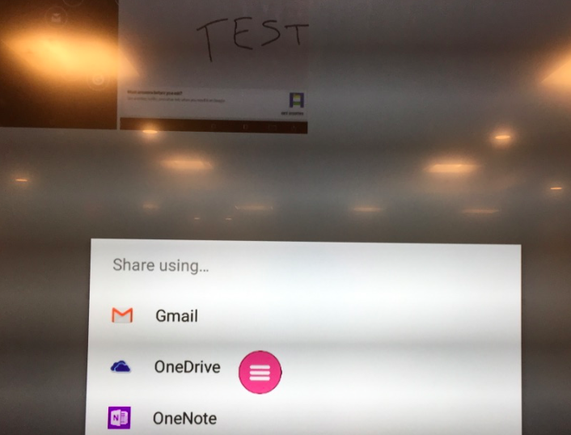

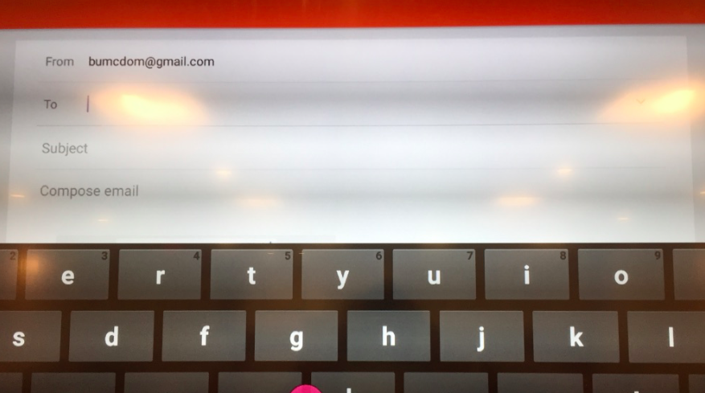

- Applications like Microsoft Office apps, Google search, and Youtube are already installed. Many are located on the home screen bubble wheel. To access a full list: Select the applications button on the bottom corner of the screen, then select utilities from the menu bar to see a list of pre-installed apps.

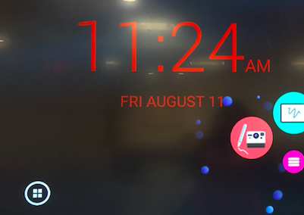

- BMC email can be accessed by selecting an internet browser and logging into mybmc.org. All other websites can also be accessed.

- Unencrypted USB flash drives can be inserted directly into the front of the panel. To access your files if your flash drive is not recognized right away: Select the applications button on the bottom left hand corner of the screen. Select Media – select Explorer – Select your flash/thumb drive.
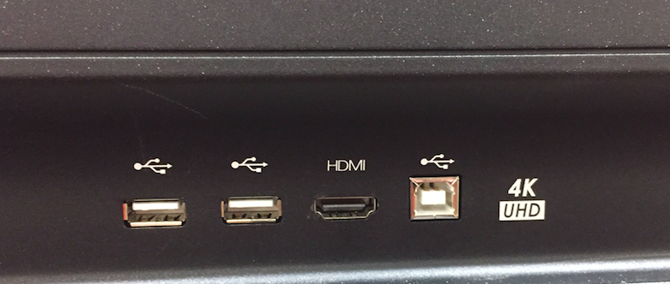

- To Connect a Laptop:
Use the provided HDMI cable to plug one end into your laptop and one end into the front of the panel. Once connected, switch the source view in order to mirror what is on your laptop onto the screen. Sound played on your laptop will come out of the panel.

- If your laptop has touch capabilities, one end of the touch cord can be inserted into the panel and one end into your laptop. The touch feature may then be used on the screen.

- To connect Mac laptops in Wilkins, E115, and E118 no HDMI cables are needed. Select the “Activ Connect” application. Generate pin code. Press the Air Play icon on the top right hand corner of you menu bar, on your laptop. Enter the pin code that is displayed on the panel. Your laptop home screen should be mirrored on the panel.

- The airplay feature can be used on iPhones as well. Just be sure that your cellphone is connected to the same WIFI network as the panel (BU 802.1x)
