Mapping the BUMC “Y” Drive on Mac OS X

- At the top of the desktop window from the Finder, select Go> Connect to Server (Or use the keyboard shortcut Command +K)
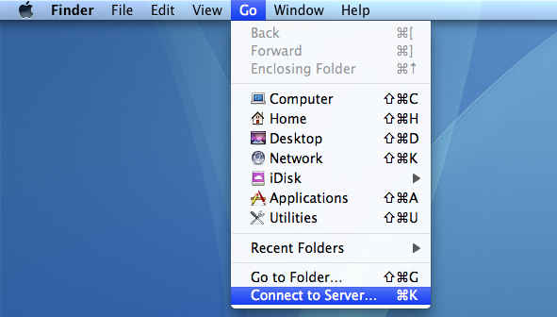

- Enter the Server Address of the network drive: smb://filesrvs.bumc.bu.edu
- Click the + to add the Server Address to your Favorite Servers. Click Connect.
- An Authentication Window will open, select Registered User and enter your BU username and password with “AD” before your username (ad\username) and Kerberos password and click Connect (older Mac OS- click OK)
- The drive is now mounted

