Map Grants.Gov in Mac OSX
- At the top of the desktop window from the Finder, select Go> Connect to Server (Or use the keyboard shortcut Command +K)
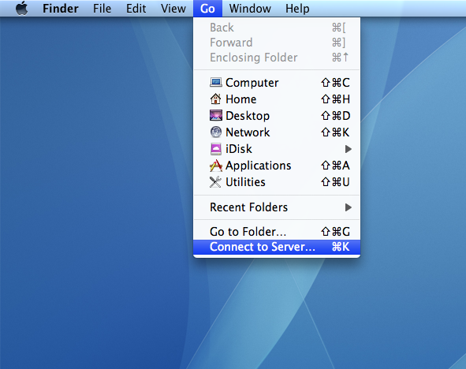

- Enter the path to the network drive: smb://bumc.bu.edu/grants.gov

- Click the + to add the Server Address to your Favorite Servers (if you want your computer to remember this network drive). Click Connect.
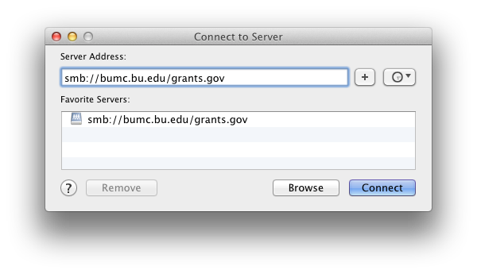
- An Authentication Window will open
- In the Authentication Window, select Registered User and enter your BU username and password with “ad” before your username (ad\username) and Kerberos password and click Connect (older Mac OS- click OK)
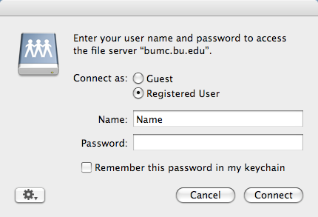

- The drive is now mounted.

