Map Grants.Gov in Windows 7

The following assumes that you are connected to the BUMC network, either directly or using VPN. If you are at home or on a non-configured BU machine, you MUST connect via VPN. In general we recommend using VPN while connected from ANY location, regardless of your configuration. Most importantly, if you are having any difficulties mapping the drive below we recommend trying VPN before contacting us.

- Click Windows Start Button, and open Computer

- Click Map network drive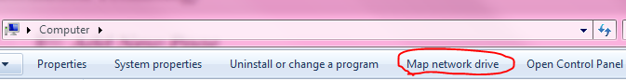

- Select the Drive Letter (I choose X in my example), Type \\bumc.bu.edu\grants.gov, Check Reconnect at Logon box if you want the Mapping to be persistent (remain after a reboot). CheckConnect using different credentials box, Click Finished when finished.
﻿﻿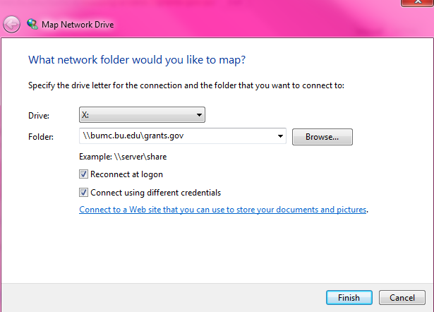

- When prompted, enter your BU username (ad\username) and Kerberos password and click OK.
﻿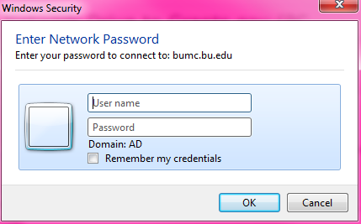

- You should now able to see the new drive in Computer under Network Location. Unless you changed it, the name of the drive should be ‘grants.gov (\\bumc.bu.edu)(X:)’

