Using your iOS Device on the BUMC 802.1x Wireless Network
Use of the VPN for connecting to BU’s wireless network is no longer necessary. The easiest way to connect is via the BU 802.1x wireless network and is recommended over use of the VPN. If you would still like to connect to the BUMC VPN, see the configuration directions below.
If you do not need to connect to the BUMC wireless network from your iPhone, we recommend that you switch this feature off in order to preserve battery life.
Apple iOS devices permit connectivity to the BUMC Microsoft Exchange server and to the BUMC campus network. You can have your Exchange e-mail, contacts, and calendar pushed to your iOS device via ActiveSync. You can also access other campus resources via the wireless campus network using the BU 802.1x wireless network or the built-in Cisco VPN client.

Configuring your iOS Device for Outlook/Exchange
The settings outlined on this page may vary slightly across devices and versions, but these instructions should be generally applicable to all users of the iOS.
Configuring the Mail client
You can connect your device to an Exchange server by following these steps.
Before you begin, you will need to know whether your account is in the AD or AD2 domain. If you are unsure, please consult with your local computer support staff or submit a Help request. If you need to guess, try AD first.
1. Tap Settings.
2. Tap Mail, Contacts, Calendars.
3. Tap Add Account.
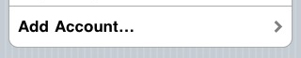
4. Tap Microsoft Exchange.
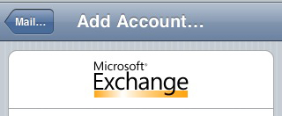
5. Fill in your
- complete e-mail address as login@bu.edu (where login is your BU login name)
- the name of your Exchange server is xmail.bu.edu
- AD or AD2 will be the domain
- your e-mail username (login) and
- your e-mail password (either Kerberos for AD, or the AD2 password)
- What you type in the Description field is the name your Exchange account will have on your device, and will be displayed in a list if you have more than one e-mail account configured. (Devices with iOS 4 or newer can have multiple Exchange accounts. However, devices with older operating systems can have only one.)

6. Tap Next to continue.
Your device will attempt to connect to the Exchange server with the information you have entered. If it’s successful, it will take a few minutes to synchronize your device and the Exchange server. When it’s done, your most recent e-mail, calendar items, and your Exchange Contacts will be viewable on your device.

7. The next step is to adjust a few settings for your Exchange account.
Tap Settings, Mail, Contacts Calendars, then tap the account you just created to see the Exchange ActiveSync page. Make sure the switches for Mail, Contacts, and Calendars are all switched ONor OFF, depending on your preference.
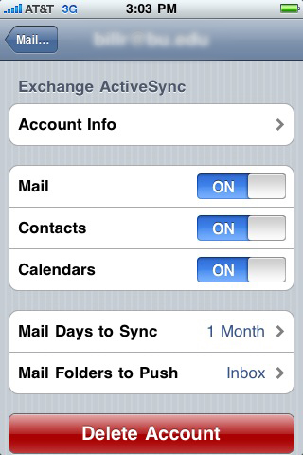
8. Then click the Mail Days to Sync button. Tap one of the options, depending on your preferences. Choosing No Limit is not recommended and 1 Month is the maximum.
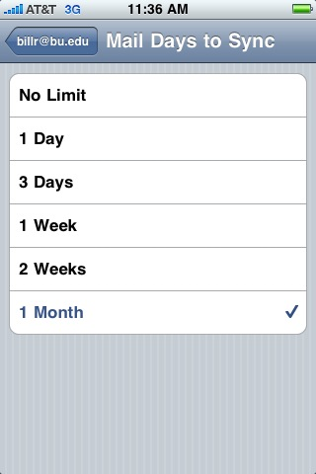
If you do not have a BUMC Outlook/Exchange account, but rather a BU ACS e-mail account (if you check your e-mail using Horde), please visit http://www.bu.edu/tech/comm/email/handheld-devices/iphone/.

Configuring VPN on the iPhone
1. From the home screen on your iPhone, select Settings.
2. Select General at the bottom of the screen
.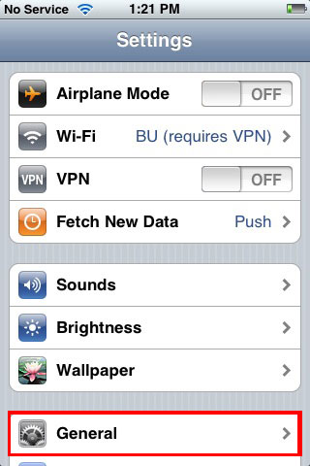
3. Select Network.
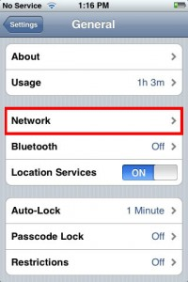

4. From the Network screen, select VPN.
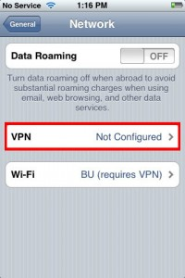
5. Select Add VPN Configuration.
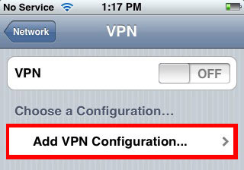
6. Select IPSec (at the top, right of the screen).
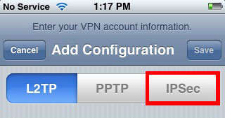
7. Fill in the following configuration information
- For Description enter: BUMC
- For Server enter: work2.bumc.bu.edu
- In the Account field enter: your_bu_username
- For Password enter: your_BU_Kerberos_password
- Use Certificate should be set to OFF.
- For Group Name enter: BUMC (CaSe SeNSiTiVe)
- For Secret enter: BUMC (also case sensitive)

14. Select Save at the upper right corner when you are done.
The VPN is now configured. You will only have to do this setup once; from now on you should simply follow the steps below to connect via the VPN

Connecting the VPN
1. Open the Settings application and select Wi-Fi.
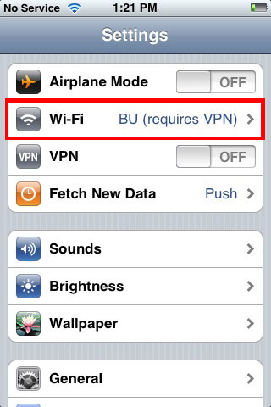
2. Connect to the BU (requires VPN) wireless network.
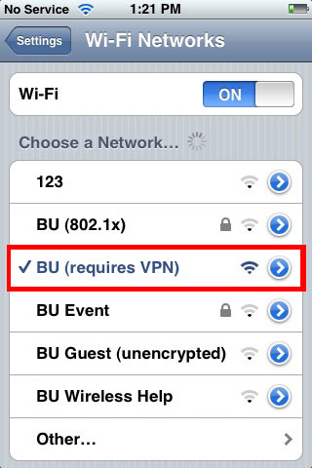
3. Go back to the Settings application and turn the VPN switch to the On position
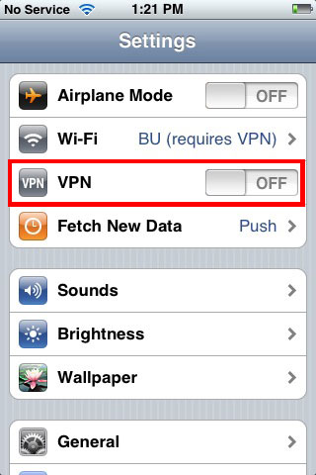

4. After the VPN gets connected, you will be prompted to enter your BU login name and Kerberos password.
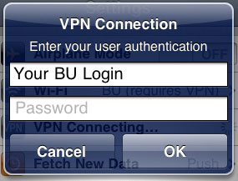
5. You can now use the Internet as you would over any other WiFi network, or through EDGE or 3G. The iPhone will indicate it is on VPN with an icon in the title bar.

