Mapping the Y Drive on Windows XP
11/01/2010

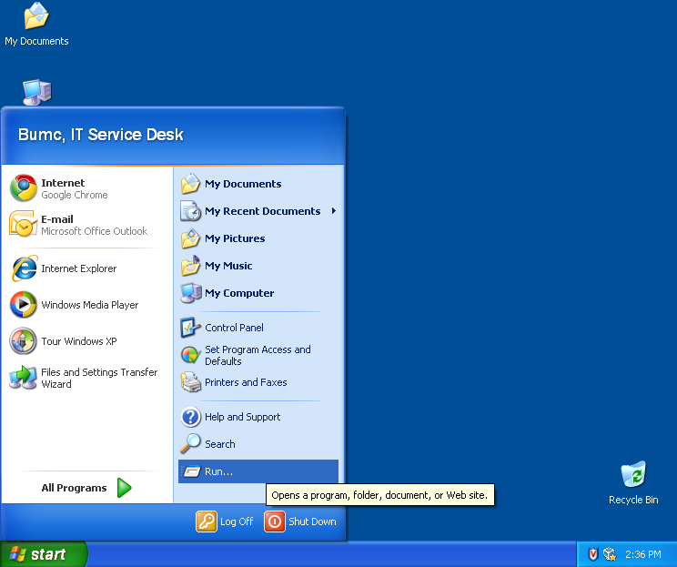

1. Press Start and then Run.

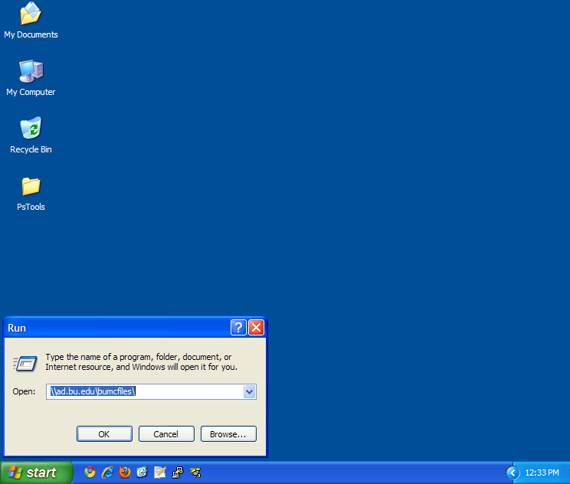

2. In the Run box, type \\ad.bu.edu\bumcfiles\ (If you are on a hospital computer or if \\ad.bu.edu\bumcfiles ) Press OK.

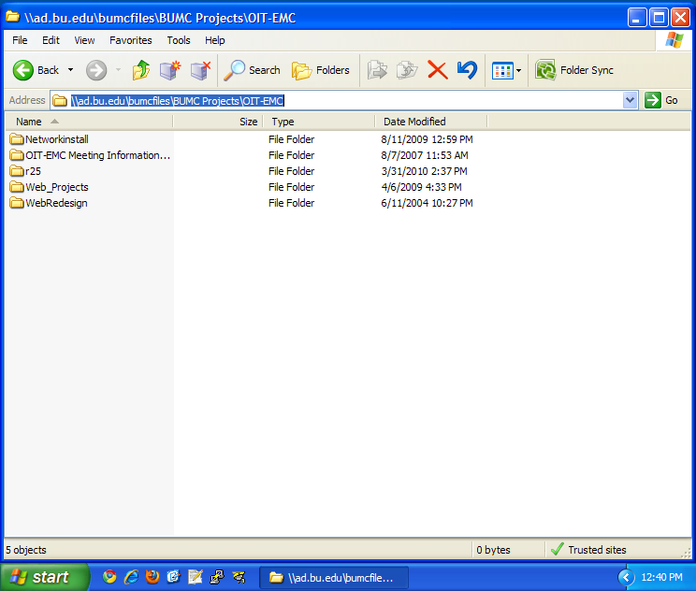

3. Navigate to the inside of the folder you wish to map.

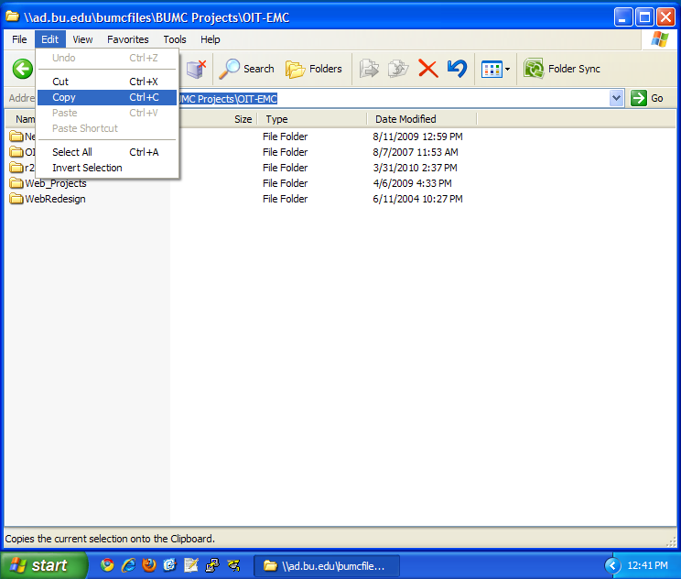

4. Select the address so it is blue, then on the Edit menu choose Copy.

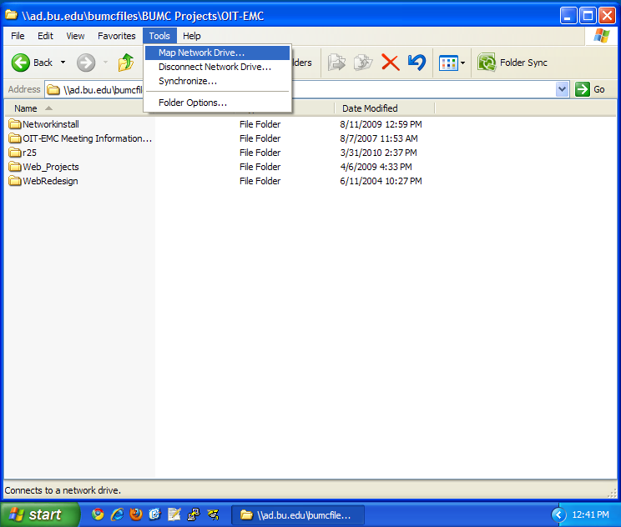

5. On the Tools menu choose Map Network Drive.

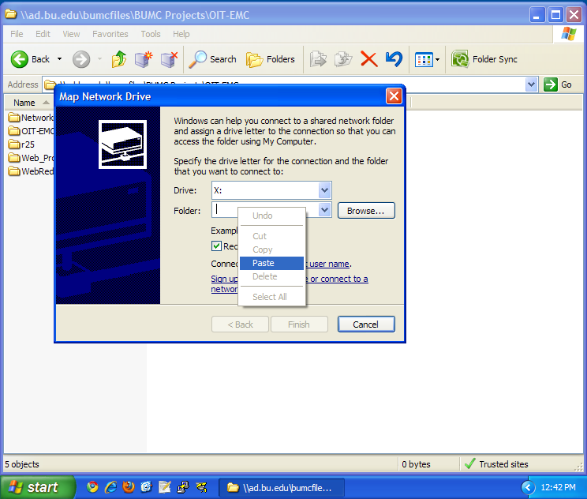

6. Right click in the Folder field and choose Paste to insert the address from before. Select a different drive letter if you do not like the one provided. If you want to map the drive as someone other than the user logged into Windows, press "Connect using a different user name" and proceed to step 7. Otherwise click Finish.

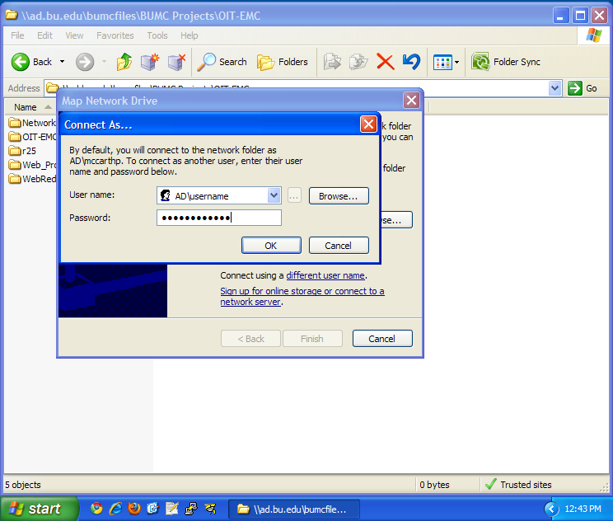

7. Enter the BU login name you wish to map the drive as, preceeded by AD\ as shown. Press OK and then Finish.

