Mapping the Y Drive on Windows 7/ Vista
12/21/2011

- Click on the Start button in the lower left and then click Computer
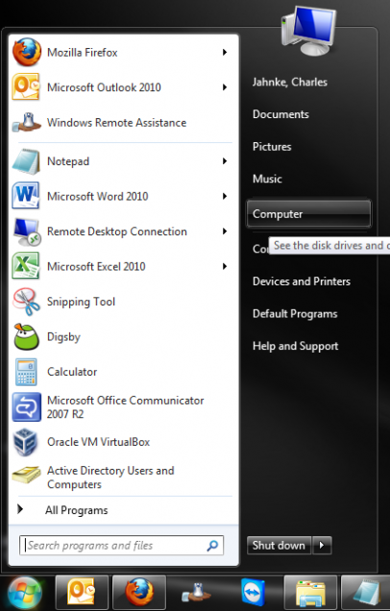
- Click Map network drive from the title bar
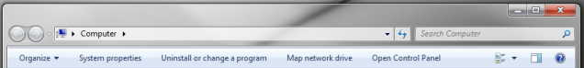
- Specify the drive letter (Y for Personal and Z for Department) and map the appropriate addresses.
- Ensure Reconnect at logon is checked and click Finish.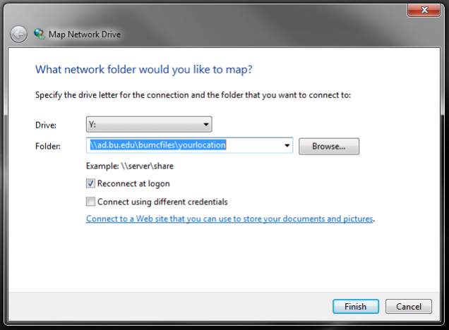
- A Map Network Drive box may appear as the folder is located connects. If this box hangs, cancel the attempt and ensure network connectivity and folder location is typed correctly. The Browsebutton may simplify the location process.
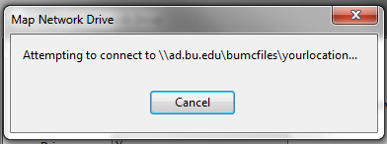
- Once the network folders are mapped, shortcuts can be added to the desktop by clicking on the drives and dragging them to the desktop.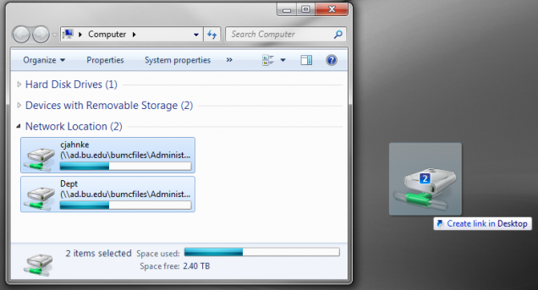
- The network drives will appear with their full folder location and will need to be renamed. Right-click on the drive and rename it to its appropriate description (“Y Drive” or “Dept”) 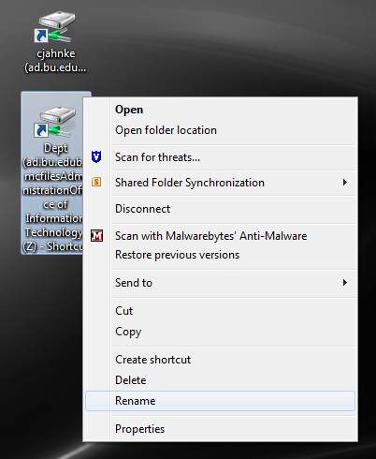
- When finished, the shortcuts should appear as shown below.
