Mapping the Y Drive on Mac OS X
11/01/2010

- At the top of the desktop window from the Finder, select Go> Connect to Server (Or use the keyboard shortcut Command +K)
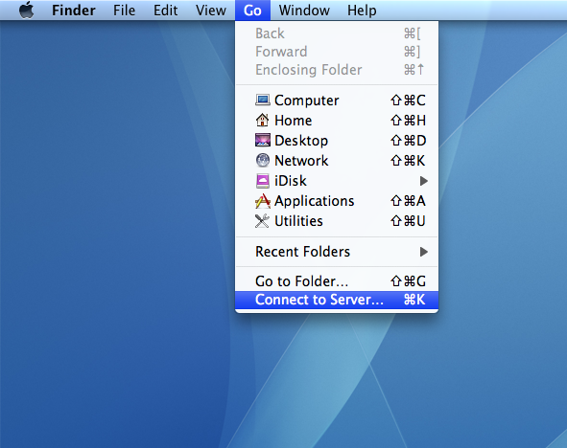

- Enter the Server Address of the network drive: smb://bumc.bu.edu/bumc
- Click the + to add the Server Address to your Favorite Servers. Click Connect.
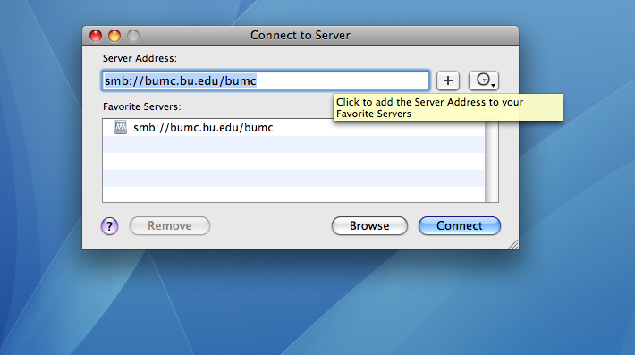
- An Authentication Window will open
- In the Authentication Window, select Registered User and enter your BU username and password with “ad” before your username (ad\username) and Kerberos password and click Connect (older Mac OS- click OK)
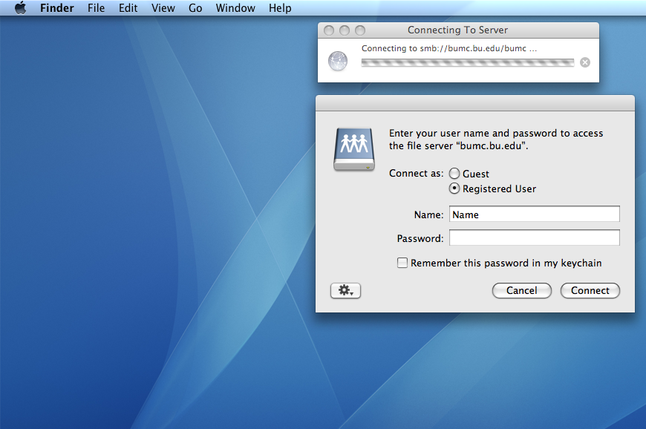

- The drive is now mounted

