


What is Acupuncture?
Acupuncture is a form of traditional Chinese medicine that dates back more than 2,500 years. It is based on the belief that the body contains energy called Qi (sounds like chee). This energy flows throughout the body on pathways called meridians. When a person is healthy, the energy flows freely. When a person is ill, the energy may be weak or blocked. During acupuncture, the therapist tries to improve the energy flow along the meridians.
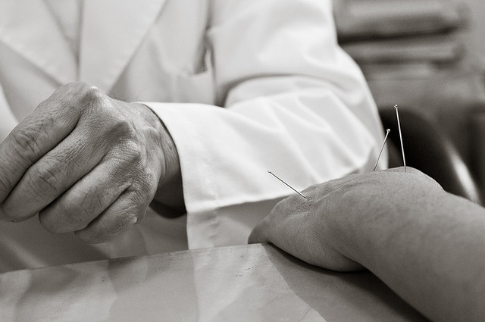
Who performs acupuncture?
A professionally trained acupuncturist, medical doctor or acupuncture student in training may perform acupuncture. In the state of Massachusetts all acupuncturists must be licensed.

What happens before the treatment?
The acupuncturist talks with the patient about their health history, including medications, diets and daily habits. The acupuncturist examines the patient's tongue and checks the pulse carefully in both wrists.

How is acupuncture performed?
The patient is placed in a comfortable position. Patients do not need to remove clothing. The acupuncturist stimulates the pathways where the energy flow is weak or blocked. If needles are used, they are as thin as fine hair and are not painful. Some patients get a tingling feeling where the needle is placed. Many say that they feel comfortable and relaxed. Often they fall asleep during the treatment.

How long does a course of treatment last?
The length of treatment depends on the condition being treated. Each individual treatment usually takes about 30-60 minutes.

What conditions can it help?
Acupuncture has been shown to be helpful for many conditions, including addiction, pain and nausea. Acupuncture is also used to treat many other conditions, but this has not been fully tested by scientific studies. What is known is that acupuncture is a safe, relaxing treatment.
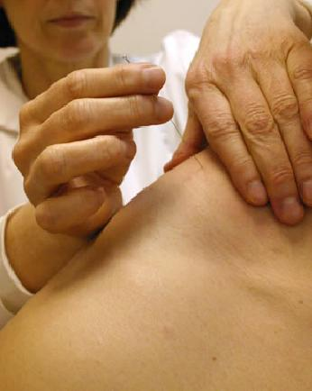
Is it safe?
Acupuncture is very safe when performed by a licensed acupuncturist or under the supervision of a licensed acupuncturist. All needles are sterile, and are used only once. They are then disposed of like any other used medical equipment.

Are there side effects?
Any time a needle is inserted through the skin there is a slight possibility for infection or small bruising at the site of insertion.

Should I talk with my doctor/ my child's doctor about acupuncture?
Yes, it is important to talk about all therapies you use with your doctor. For any serious medical complaint or condition, please see your doctor before trying a new therapy.

