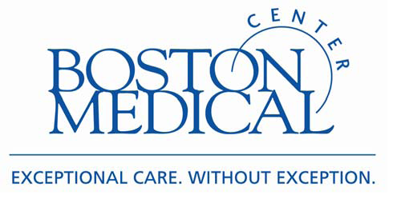
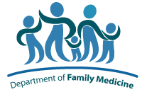
RESOURCE LIST
Acupuncture Clinics in the Boston-area

Due to high demand for acupuncture in Family Medicine, you may want to seek out acupuncture in the community. Here’s a list to help you:

PATHWAYS TO WELLNESS
1601 Washington Street, 3rd Floor
South End, Boston, MA 02118
(617) 859-3036 www.pathwaysboston.org
$20-40/session student intern clinic

ACUPUNCTURE TOGETHER
2464 Mass Ave, Suite 420
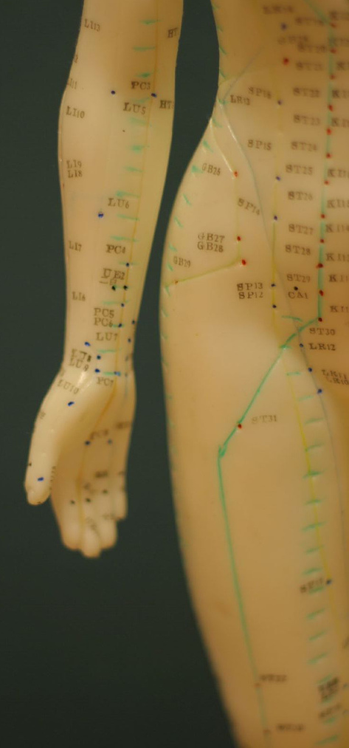
Cambridge, MA 02140
(617) 499-9993 www.acupuncturetogether.com
$20-40 sliding scale per session, plus extra $15 for first visit

ACUPUNCTURE FOR EVERYONE
581 Boylston St., Suite 407
Boston, MA 02115
Anne: (617) 875-1143
Midgie: (617) 645-0073
Joyce: (617) 510-0559
www.everyonesacupuncture.com
$15-40 sliding scale

BROOKLINE COMMUNITY ACUPUNCTURE
318 Harvard St., Suite 24
Brookline, MA 02446
(617) 879-9992
brookline-community-acupuncture.lattiss.com
1st session $35-50; after $25-40

NEW ENGLAND SCHOOL OF ACUPUNCTURE (NESA) STUDENT CLINIC
150 California St., 1st Floor
Newton, MA 02458
(617) 558-1788 x117 www.nesa.edu/nesa_satellites.html
$30-40/session

OPEN SPACE COMMUNITY ACUPUNCTURE
66-70 Union Square, Suite 102
Somerville, MA 02143
(617)627-6900
$15-40 sliding scale plus one-time fee of $10

CAMBRIDGE HEALTH ALLIANCE
NESA Clinic open Wednesday 2pm-7pm, Thursday 8am – 1pm
Malden Family Medicine Center
195 Canal Street
Malden, MA 02148
(781) 338-0500 *Call to confirm fee and any possible discounts

ROXBURY COMPREHENSIVE COMMUNITY CENTER
NESA Clinic open Wednesday 9am – 2 pm
435 Warren St.
Roxbury, MA 02119
(617) 541-3790 *Appointments are free of charge. Donations accepted and appreciated.

*NOTE* The information above is subject to change. Please call each site directly for complete details.

