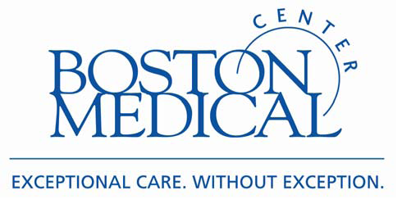
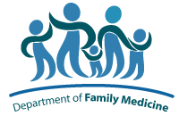
RESOURCE LIST
Acupuncture Clinics in the Boston-area

Due to high demand for acupuncture in Family Medicine, you may want to seek out acupuncture in the community. Here’s a list to help you:

PATHWAYS TO WELLNESS
1601 Washington Street, 3rd Floor
South End, Boston, MA 02118
(617) 859-3036 www.pathwaysboston.org
$30/session student intern clinic, sliding scale based on income

ACUPUNCTURE TOGETHER
2464 Mass Ave, Suite 420
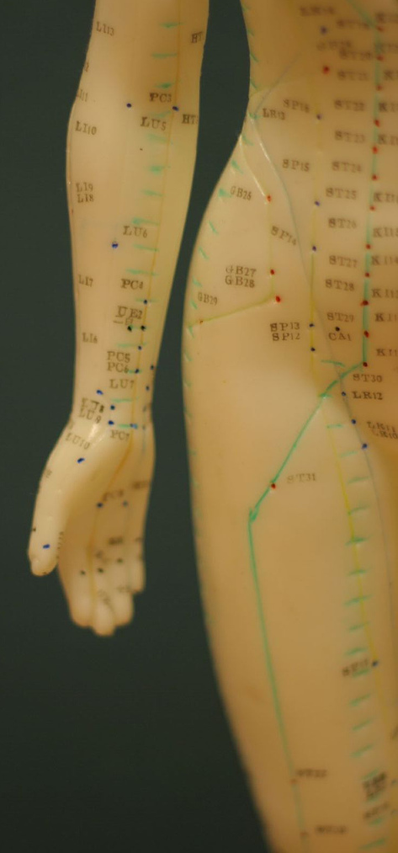
Cambridge, MA 02140
(617) 499-9993 www.acupuncturetogether.com
$20-40 sliding scale per session, plus extra $15 for first visit

ACUPUNCTURE FOR EVERYONE
581 Boylston St., Suite 407
Boston, MA 02116
Anne: (617) 875-1143, Jess: (617) 833-7187 www.everyonesacupuncture.com
$15-35 sliding scale

NEW ENGLAND SCHOOL OF ACUPUNCTURE (NESA)
Main Teaching Clinic open Mon-Fri 8am – 8pm, Sat 8am – 4pm
150 California St., 1st Floor
Newton, MA 02458
(617) 558-6372 www.nesa.edu/nesa_satellites.html
$40/session, discounts for students/seniors/military, financial aid application

CAMBRIDGE HEALTH ALLIANCE
NESA Clinic open Wednesday 8am – 1 pm, Thursday 9am – 2pm
Malden Family Medicine Center
195 Canal Street
Malden, MA 02148
(781) 338-0500 *Call to confirm fee and any possible discounts

ROXBURY COMPREHENSIVE COMMUNITY CENTER
NESA Clinic open Wednesday 9am – 2 pm
435 Warren St.
Roxbury, MA 02119
(617) 541-3790 *Appointments are free of charge. Donations accepted and appreciated.

*NOTE* The information above is subject to change. Please call each site directly for complete details.

