Name/  Pronouns | Headshot | School/  Dept | Track | Email | NWP Project Description | Academic Interests | Skills
Alcy Torres  He/Him/His | 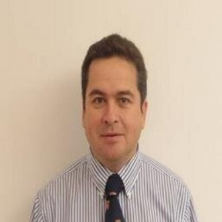 | Pediatrics/CASOM | Clinician Scientist | atorres@bu.edu |  | Traumatic Brain Injury, Global Health | Patient care, research, editing, curriculum design, mentoring, teaching, leadership, advising, resilience, education
Amanda DeLoureiro  She/her | 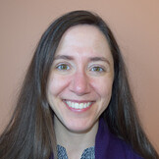 | Family Medicine/  CASOM | Clinician Educator | delourea@bu.edu | My clinical practice is as a family physician at a community health center, where I mainly care for patients from Central and South America. I plan to explore my experiences in primary care over the past few years in a series of essays and/or op-eds. | Primary care, immigrant health, maternal and child health, medical student education | Primary care, mentoring/advising students and residents, education curriculum development
Chris Muratore  He/Him | 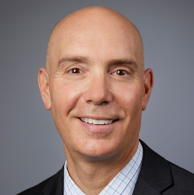 | Surgery, Pediatric Surgery/  CASOM | Clinician Educator | christopher.muratore@bmc.org | My goal is to bring to light the importance of advocating for Children's health care service, (including Surgery) and the impact of not prioritizing access to children's surgery as a population health measure. | (Pediatric) Surgical Outcomes, Leadership, Trauma & Critical Care | Patient care, leadership, collaboration, mentoring, listening.
Gabrielle VanSpeybroeck  She/her/hers | 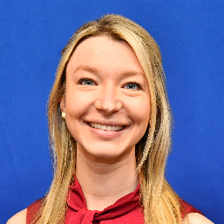 | GIM/VA | Academic Hospitalist | Gabrielle.  vanspeybroeck@va.gov &  gvanspey@bu.edu | I’d like to compose a project which highlights the experience of the veteran as well as the experience of the medical trainee caring for the veteran | VA medicine, women’s health, care of the veteran, narrative medicine, medical student education | Experienced in patient care of the hospitalized veteran, women’s health within internal medicine clinical interest, experience and exposure to medical trainees including medical students and residents
Inha Jo  She/her/hers |  | Pediatrics  /Pediatric Endo  /CASOM | Assistant Professor/Clinician | inha.jo@bmc.org | To develop narrative writing skills and to practice expressing my voice and perspective on different issues relating to patient care, challenges surrounding health care disparities. | Diabetes, obesity, health care disparities, quality improvement, health policy | Patient care, teaching, listening, education
Karen Cullen  She/Her | 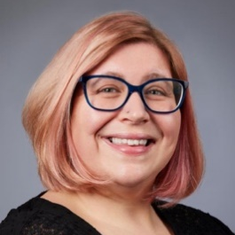 | Midwifery, OB/GYN/  CASOM | Clinician Educator | Karen.Cullen@Bmc.org | Explore moral injury of working as a midwife in an academic medical institution. How do you strive for patient first care in a medical industrial complex? How do you support and educate future clinicians with concurrent dismantling/rebuilding of systems of care. | Evidence based/trauma informed care, antiracism, promoting patient autonomy, body liberation, culturally humble care, promoting physiologic birth, interdisciplinary medical and nursing education | Trauma informed patient care, editing, clinical simulations, listening, education, critical systems design
Salah Abdelgadir  He/Him | 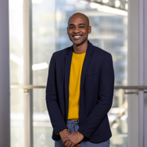 | Medicine/  ID/CASOM | Clinician Educator | Salah.abdelgadir@bmc.org | That is not clear now, but it my focus will be directed towards health equity pertaining immigrant and refugee health | Infectious Disease  Biosocial Medicine | Patient care, mentoring, teaching, and education, in addition to listening, advising, resilience, and education. What I would like to improve are my writing skills and my story telling narratives.
Tara Adyanthaya  She/Her | 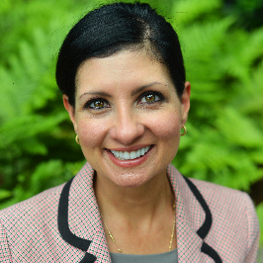 | Psychiatry/CASOM | Mental Health Counselor | tara.adyanthaya@bmc.org | I am interested in exploring the oversimplification and lack of nuance that permeates social media treatment of mental-health concepts. Superficially appealing sound bites or tough-talk packaged into slick content are not one-size-fits-all prescriptions. I would like to highlight areas that require deeper consideration, like leaning in to conflict or tolerating differences in service of maintaining long-term relationships and learning to tolerate distress in service of longer-term goals. | Complex Trauma, Intersection of Law and Medical Ethics, Identity Formation and Maintenance | Editing, Listening, Positive and Strengths-Based Mindset
Theresa Kim  She/her | 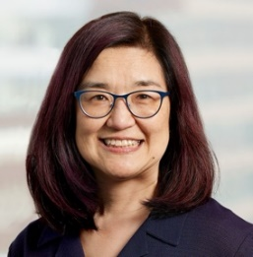 | Medicine/GIM/ CASOM | Clinician Scientist | theresa.kim@bmc.org | I would like to write an essay based upon a patient interaction or (or composite of several patients) to describe i) misconceptions about addictions (and homelessness) ii) and/or what it is like to take care of people with addictions and/or iii) reasons I do this kind of work | Management of addictions in primary care and other general medical settings  Examining the impact of alcohol and other drug use on bone health, falls, and frailty among people with and at- risk of HIV | Identify journals, blogs, etc. for publishing my narrative writing  Become more comfortable and  confident about receiving feedback  Learn how to write about patients while respecting privacy, confidentiality.  Develop a clear focus (“objectives”)  of an essay and improve the “flow” between ideas, paragraphs, sentences
Zayir Malik  He/him | 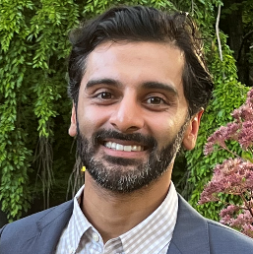 | Emergency Medicine | Clinician Educator | zayir.malik@bmc.org | I’ve been interested in writing something to express to the “outside world” the pervasive sense of moral injury and resulting cynicism that exists amongst my colleagues. | Burnout, Wellness, Moral injury, Medical culture, Medical history, Disparities, Cognitive Structures, and medical decision making | Non-scientific writing  Op-ed style writing  Close reading skills

