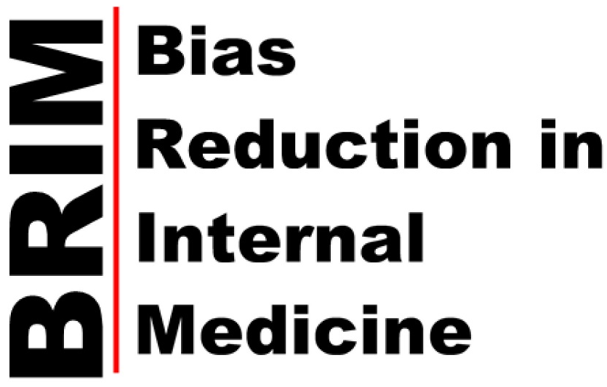
About the BRIM Initiative
Cultural stereotypes can influence our judgments, decision-making, and behaviors in unwanted and unintended ways. The BRIM Initiative offers the opportunity to help your faculty “break the bias habit” and align their judgments and behaviors with their explicit commitments to be fair and objective.

How does the BRIM Initiative do this?
Over the course of 2 years, all divisions in your department that align with ACGME/ABIM subspecialties (and GIM) will be offered a 3-hour interactive workshop with 3 modules:
- Implicit bias as a habit
- Becoming bias literate: If you name it, you can tame it
- Evidence-based strategies to break the bias habit
What is the goal of the BRIM Initiative?
The overall goal is to study and facilitate the implementation of an effective pro-diversity intervention throughout academic medicine. To achieve this, a team from the University of Wisconsin-Madison (UW-Madison) will present the workshop to ~half of your divisions. UW BRIM Team will then train 8-10 individuals at your site to deliver the workshop to the remaining divisions.

Background
Professional interactions, performance evaluations, and hiring decisions can be inadvertently influenced by cultural stereotypes about race, gender, age, sexual preference, and weight. As a result, faculty from some groups experience a more positive and supportive work environment than faculty from other groups.¹⁻⁷ These same stereotypes can unwittingly affect physicians’ perceptions and decisions about their patients. The Association of American Medical Colleges (AAMC), National Academies of Sciences (NAS), and National Institutes of Health (NIH) affirm that reducing stereotype-based bias will benefit medical education, patient care, population health, and scientific discovery.

Unlike most diversity trainings that can be time consuming and ineffective, the BRIM Initiative draws on decades of research on behavioral change in approaching stereotype-based bias as a “habit of mind” that can be changed like any other unwanted habit by increasing awareness, motivation, and self-efficacy to practice evidence-based strategies.^{8,9} The BRIM Initiative also incorporates principles of implementation science to build capacity for continuing this approach at collaborating institutions and to help ensure sustainability.

There are 3 phases of activities in the BRIM Initiative:
Phase I:
- Preliminary telephone discussions between the BRIM PI (Molly Carnes) and department chair to determine whether to proceed with the collaboration.
- The chair identifies Local BRIM Leads who will work with the UW BRIM Team over the 2 years of the study.
- Launch Visit: An initial 1-day visit from Dr. Carnes and 2 BRIM team members at no cost to the institution (ideally timed to a chair’s regular meeting of division chiefs). This group will meet with the department chair, the Local BRIM Leads, and any other groups deemed important by the chair for a successful collaboration. Dr. Carnes will present the BRIM study to the division chiefs. If desired, Dr. Carnes can provide a lecture during this Launch Visit (e.g., Medical Grand Rounds).
- Following the Launch Visit, the Local BRIM Leads meet with each division (that aligns with ACGME/ABIM subspecialties and GIM) in their regularly scheduled meeting to present the BRIM study and ask the division to consider which faculty might be good candidates to become local workshop presenters (Local BRIM Implementers) (materials and training for presentation will be provided).
- The first of 3 online surveys is sent to faculty in a given division after the Local BRIM Lead meets with that division (are scheduled to go out same day; division head sent IRB-approved text for reminder to distribute to faculty).
- Once the Local BRIM Leads have met with all participating divisions and surveys have been completed, divisions are randomized to receive the Breaking the Bias Habit workshop from the UW BRIM Team or the Local BRIM Implementers, and workshops can then be scheduled. (To allow time for re-scheduling clinics, workshops will likely be given 3-4 months later).
Phase II
- Two members of the UW BRIM Team come to your site for ~3-4 days and deliver a 3-hour workshop to each division randomized to the UW BRIM Team.
- The second of the 3 online surveys is sent to faculty in all participating divisions 3 months later.
Phase III
- The 3-10 faculty/staff selected to become Local BRIM Implementers participate in a structured curriculum facilitated via online videoconferencing to develop mastery of content and workshop presentation skills. They receive all workshop materials and a Certificate of Completion of training to deliver the workshop, Breaking the Bias Habit®: Bias Reduction in Internal Medicine, at your campus.
- The Local BRIM Implementers deliver the 3-hour workshop to the remaining participating divisions. (Local BRIM Leads ensure that participants’ evaluation forms and commitment to action forms are sent to UW BRIM Team).
- The last of the 3 online surveys is given to faculty in all participating divisions.
- A summary report, including 2 years of department climate measures, is given to the department.

Each collaborating BRIM institution will contribute $12,500 per year, plus travel and lodging for ~3-4 days when the two presenters from UW-Madison come to deliver a workshop to each division allocated to receive workshops from the UW BRIM Team. This amount can be invoiced at the end of each year.

References

1. Chapman EN, Kaatz A, Carnes M. Physicians and implicit bias: how doctors may unwittingly perpetuate health care disparities. J Gen Intern Med. Nov 2013;28(11):1504-1510.
2. Phelan SM, Burgess DJ, Yeazel MW, Hellerstedt WL, Griffin JM, van Ryn M. Impact of weight bias and stigma on quality of care and outcomes for patients with obesity. Obesity Review. Apr 2015;16(4):319-326.
3. Sabin JA, Greenwald AG. The influence of implicit bias on treatment recommendations for 4 common pediatric conditions: pain, urinary tract infection, attention deficit hyperactivity disorder, and asthma. American Journal of Public Health. May 2012;102(5):988-995.
4. van Ryn M, Burke J. The effect of patient race and socio-economic status on physicians' perceptions of patients. Social Science in Medicine. Mar 2000;50(6):813-828.
5. Sabin J, Riskind R, Nosek B. Health care providers' implicit and explicit attitudes toward lesbain women and gay men. American Journal of Public Health. 2015;105:1831-1841.
6. Williams R, Romney C, Kano M, et al. Racial, gender, and socialeconomic status bias in senior medical student clinical decision-making: A national survey. J Gen Intern Med. 2015;6:758-767.
7. Ruiz J, Andrade A, Anam R, et al. Group-based differences in anti-aging bias among medical students. Gerontology and Geriatrics Education. 2015;36:58-78.
8. Carnes M, Devine PG, Baier Manwell L, et al. The effect of an intervention to break the gender bias habit for faculty at one institution: a cluster randomized, controlled trial. Academic Medicine. Feb 2015;90(2):221-230.
9. Carnes M, Devine PG, Isaac C, et al. Promoting institutional change through bias literacy. Journal of diversity in higher education. Jun 2012;5(2):63-77.

