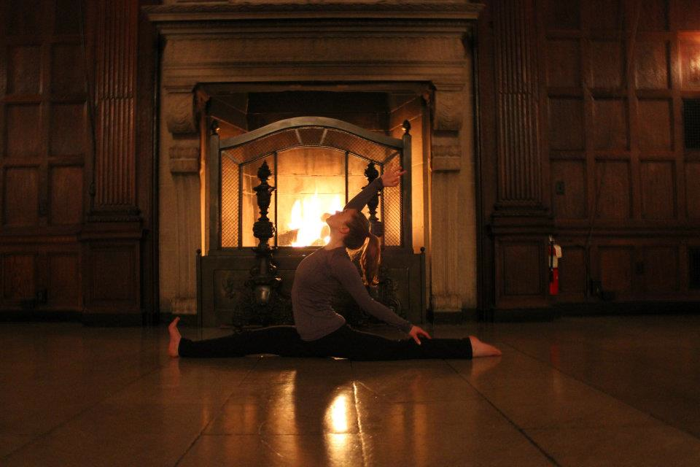

|  |  |  |
| --- | --- | --- |
| Date | Location | Time |
| Tuesday, September 17 | Hiebert Lounge | 5:00-6:00 PM |
| Tuesday, September 24 | Hiebert Lounge | 5:00-6:00 PM |
| Monday, September 30 | Hiebert Lounge | 5:00-6:00 PM |
| Monday, October 7 | Hiebert Lounge | 5:00 – 6:00 PM |
| Friday, October 11 | Hiebert Lounge | 5:00-6:00 PM |
| Monday, October 28 | Hiebert Lounge | 5:00 – 6:00 PM |
| Tuesday, November 12 | Hiebert Lounge | 5:00 – 6:00 PM |
| Tuesday, November 26 | Hiebert Lounge | 5:00-6:00 PM |
| Monday, December 9 | Hiebert Lounge | 5:00-6:00 PM |
| Monday, December 16 | Hiebert Lounge | 5:00-6:00 PM |
| Wednesday, December 18 | Hiebert Lounge | 5:00-6:00 PM |

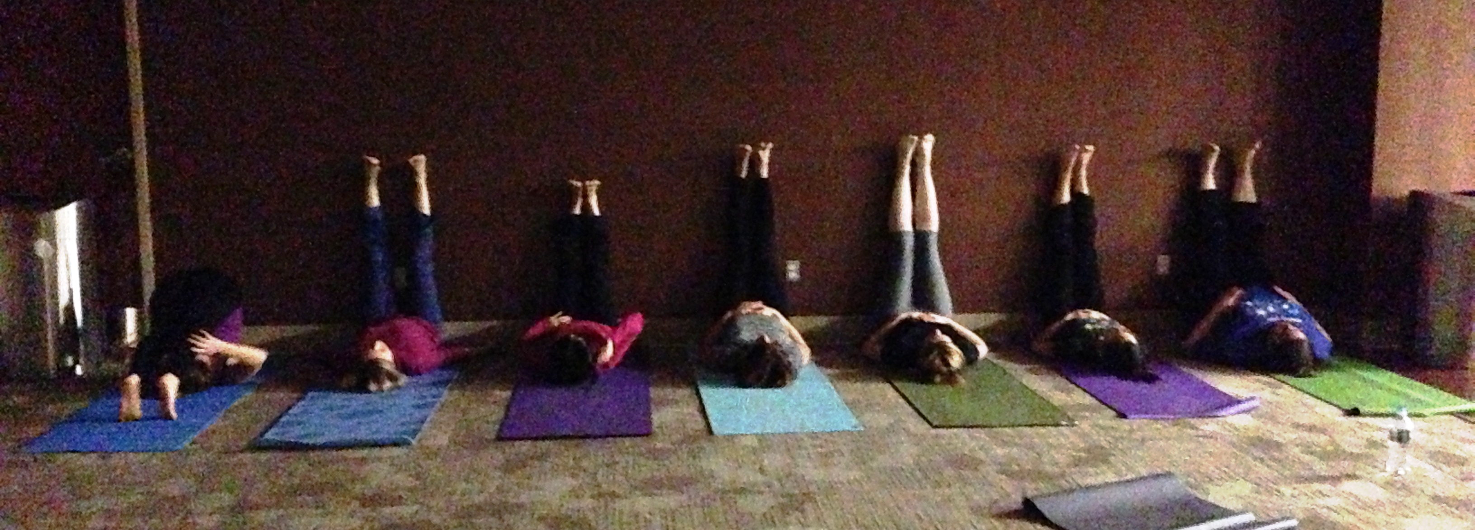

+

Leave the pipettes and textbooks behind and join us on the mat for an hour of movement, stress release, and relaxation. This is a chance to learn and experience first-hand the beneficial effects of yoga on your mental and physical health. Sessions will include breathing exercises and poses that are adaptable to all skill levels. No previous yoga experience is necessary. Taught by a BU MD/PhD student and certified yoga instructor who has an interest in how yoga can be used to prevent disease and heal illness. Please bring a mat if you own one, if not, we will provide one. Email: [Yolanta@bu.edu](mailto:Yolanta@bu.edu) to register

BU GMS Yoga Fall/Winter 2013

Breathe Relax and Empower