Writing Course

Boston University School of Medicine Department of Medicine
12:00 to 1:00 p.m. Evans 118 (and Evans 115)
Emelia J. Benjamin, MD, ScM Peter S. Cahn, PhD
emelia@bu.edu pcahn@bu.edu

At the end of this course, participants will be able to…
- Present evidence to advance an intellectual argument
- Adopt work habits that facilitate the completion of writing projects
- Submit a manuscript for review at an academic journal

Resources for academic writers:
http://www.bumc.bu.edu/facdev-medicine/for-researchers/manuscript-publishing/
Top of Form
Bottom of Form

September 8, 2011: Writing mechanics
- Introductions
- Overcoming writer’s block
- Establishing a writing routine
- GIPSY rubric for peer review
- Meet with writing team
- Set a realistic goal and stretch goal

September 22, 2011: From data to argument
- Group check-in
- Organizing data
- Tables and figures
- Honing the argument
- Review manuscripts
- Set a realistic goal and stretch goal

October 6, 2011: Editing and rewriting
- Group check-in
- One idea per paragraph
- Using clear, concise language
- Establishing flow, making transitions
- Review manuscripts
- Set a realistic goal and stretch goal

October 20, 2011: Publishing
- Group check-in
- Knowing when to stop editing
- Choosing a journal
- Responding to reviewers
- Holding each other accountable
- Review manuscripts
- Program evaluation
Peer review rubric:
Grabber
I argue that
Prove it
So what
Yes, but

Amy | Baranoski | amy.baranoski@bmc.org | Infectious Disease
Myrdell | Belizaire | mbelizairebla@yahoo.com | Preventive Medicine and Epidemiology
Renee | Boynton-Jarrett | renee.boyntonjarrett@bmc.org | Pediatrics |  |  |  | 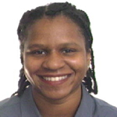
Serguei A. | Castaneda | serguei@bu.edu | Hematology and Medical Oncology |  |  |  | 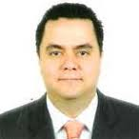
Zhihong | Chen | szchen@bu.edu | Hematology and Medical Oncology
Christina | Cove | christina.cove@bmc.org | Cardiovascular Medicine
Isabel | Dominguez | isdoming@bu.edu | Hematology and Medical Oncology |  |  |  | 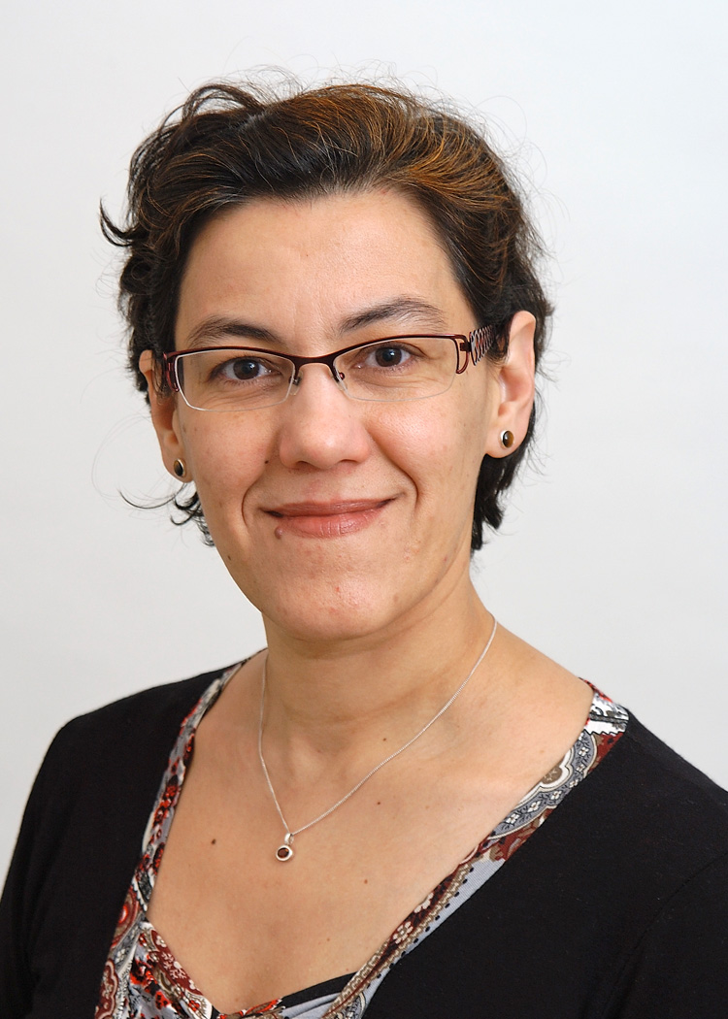
Matthew | Fox | mfox@bu.edu | International Health |  |  |  | 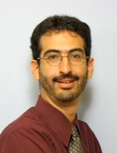
Sandeep | Ghai | Sandeep.ghai@bmc.org | Nephrology
Nicole | Glazer | nlglazer@bu.edu | Preventive Medicine |  |  |  | 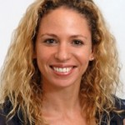
Angela | Jackson | angela.jackson@bmc.org | General Internal Medicine
Natalie | Joseph | napierre@bu.edu | Pediatrics |  |  |  | 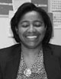
Gyungah | Jun | gyungah@bu.edu | Genetics |  |  |  | 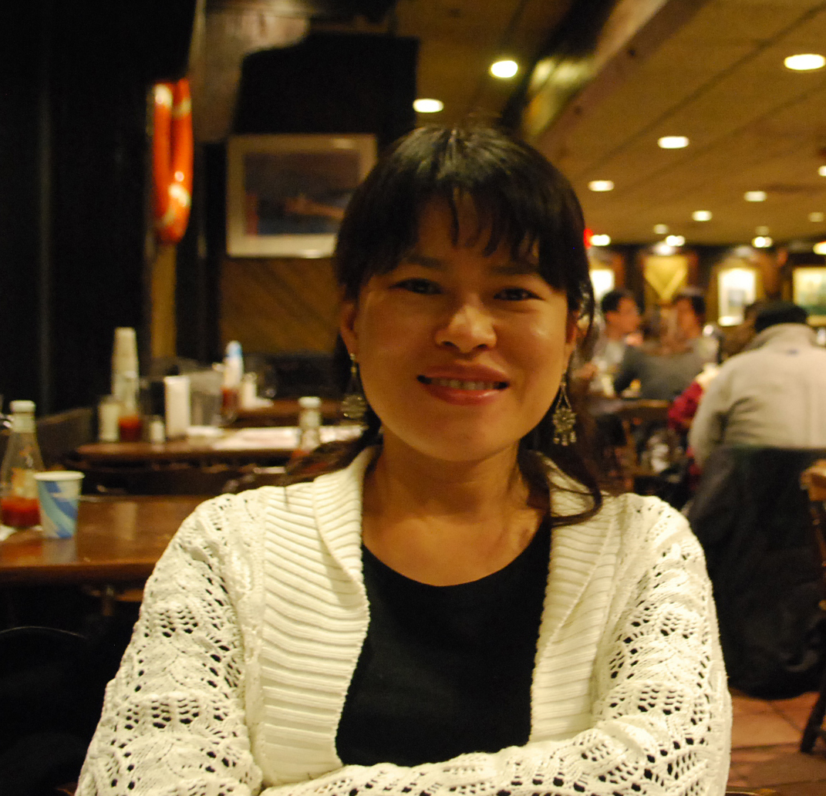
Laura | Kaufman | laura.kaufman@bmc.org | Geriatrics
Andrea | Kronman | andrea.kronman@bmc.org | General Internal Medicine |  |  |  | 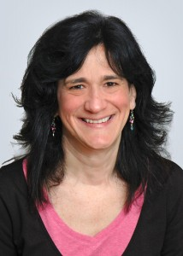
Kimberly | Leite-Morris | kleitemo@bu.edu | Psychiatry
Weining | Lu | wlu@bu.edu | Nephrology |  |  |  | 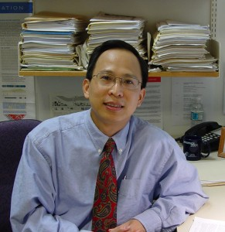
Jared | Magnani | jmagnani@bu.edu | Cardiovascular Medicine
Duyen | Ngo | duyen.ngo@bmc.org | Hematology and Medical Oncology
Uyen-Sa | Nguyen | unguyen@bu.edu | Clinical Epidemiology |  |  |  | 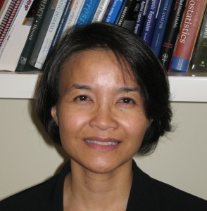
Felicia | Patch | fepatch@bmc.org | General Internal Medicine |  |  |  | 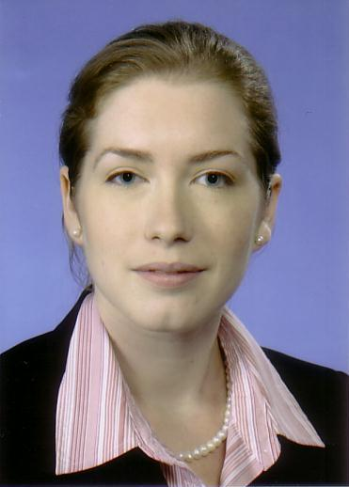
Maria | Ramirez | mramirez@bu.edu | Pulmonary, Critical Care, and Allergy Medicine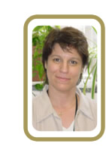
Mark | Sloan | mark.sloan@bmc.org | Hematology and Medical Oncology
Winnie | Suen | winnie.suen@bmc.org | Geriatrics
Kei | Yasuda | kyasuda@bu.edu | Nephrology

