**ARC Proposal for ‘Thrombosis & Homeostasis in Health and Disease’ (TNH)**

**ARC Co-directors:**

-Vipul Chitalia, MD PhD, Assistant Prof of Medicine, Renal Section, Department of Medicine

## -Elaine Hylek, MD, MPH, Prof. of Medicine, Department of Medicine

## -Katya Ravid*,* Ph.D., Professor of Medicine and Biochemistry;

## Director, Evans Center for Interdisciplinary Biomedical Research

**Announcement**

Vipul Chitalia, ElaineHylekand Katya Ravid will co-direct ‘Thrombosis and Homeostasis in Health and Disease’ (TNH) ARC. The overarching goal of TNH ARC is to provide a common platform for investigators from different disciplines interested in vascular thrombosis to develop projects spanning from pure basic science or clinical medicine to the intersection of them. This collaborative effort will ensure development of core analytic tools addressing different aspects of thrombotic disorders and eventually cross-pollinate ideas to develop fertile ground for innovative projects that can help individual investigators for RO1 or a group of collaborative investigators for PO1 grant support.

Please contact Vipul Chitalia ([vichital@bu.edu](mailto:vichital@bu.edu)) ElaineHylek ([Elaine.hylek@bmc.org](mailto:Elaine.hylek@bmc.org)) and Katya Ravid (kravid@bu.edu)

TNH ARC will meet once a month to discuss the development of programs within the TNH ARC and will have monthly presentations by involved laboratories. The first meeting of ARC will be on September 12th 11.30-2 pm at Building W-502 at BMC.

**Mission statement.**

TNH ARC will be a collaborative group of interested investigators in vascular thrombosis, which will provide resources for cutting-edge thrombotic research to encourage interdisciplinary projects in this area.

**Significance**:

Thrombosis is a highly complex and dynamic process involving multiple factors and several cell types. Clinically it ranges from spontaneous thromboembolic disorders such as deep vein thrombosis to induced thrombosis in the setting of endovascular intervention or pro-thrombotic medications. Thrombosis can be local caused by vessel injury or blood stasis or systemic caused by generalized endothelial damage in diseases such as disseminated intravascular coagulation or HUS/TTP, etc. Be it familial, genetic or acquired factors, thrombosis is a uniformly devastating complication also contributing to top two causes of death in the world and therefore remains an area of intense research. With the emergence of novel mediators and drug targets and explosion of new information, TNH ARC intends to provide a collaborative platform by reaching investigators across several specialties and expertise to join forces in this rapidly changing field to maximize success.

**Organizational plan**:

Thrombotic disorder epitomizes multi-specialty problem. TNH ARC will have investigators and experts from the following disciplines to crystalize the active problems from their areas of focus and define common infrastructure needed for their projects.

**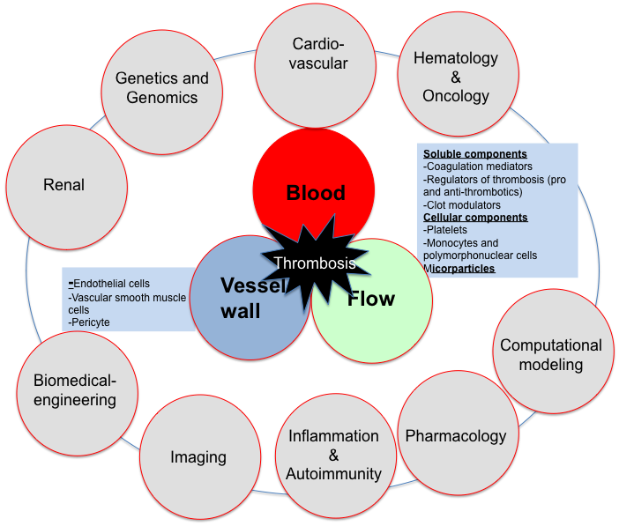**

**Goals**

The immediate goal of the TNH pre-ARC is to gather team of investigators with active interest and expertise in the field of thrombosis. We will begin to identify following key questions.

1. Prioritize the area of focus for TNH ARC
2. Describe expectations/contributions to TNH ARC
3. Crystallize short term and long term plans
4. Define core resources needed for ARC members- for e.g. animal model of thrombosis and related equipments,
5. Explore interdisciplinary projects

**Multidisciplinary group:**

**Thrombosis in different disciplines & potential members:**

Renal: Vipul Chitalia, Jean Francis, Shashar Moshe

Cardiovascular: Elaine Hylek, Richard Cohen, Adam Rose

Hematology & Oncology: Mark Sloan, Quillen, Karen

Platelet biology: Katya Ravid

iPS technology: George Murphy

Genetics and Genomics: Clinton Baldwin

MRI imaging of thrombosis: James Hamilton

Inflammation: Daniel G. Remick Jr.

Biomedical Engineering: Joyce Wong

Infectious diseases: Caroline Genco

Machine learning and Computational modeling: Kumaran Kolindavelu and Vijaya Kolchalma (MIT)

**Thrombosis studied with different tools:**

Clinical, Imaging, Biochemical, Computational Modeling; iPS

**Potential resource core for BU:**

Aggregometer

Doppler for In vivo imaging of animal model of thrombosis (ferric chloride)

MRI imaging

Automated thrombogram assay

**Current/potential Members**

|  |  |  |  |
| --- | --- | --- | --- |
| **Members** | **Rank** | **Departments/school affiliation** | **Email** |
| Katya Ravid | Director, Evans Center for Interdisciplinary Biomedical Research | Department of Medicine | [kravid@bu.edu](http://mail.bmc.org/owa/redir.aspx?C=-w4IFruCOkqpzB1CS34YnuiBprGYcNAIx29D2uD6nCniy-hMRZf6yppoNa9Do3xbPN33GxvOgd8.&URL=mailto%3akravid%40bu.edu" \t "_blank) |
| Elaine Hylek | Professor of Medicine | General Internal Medicine | [ehylek@bu.edu](http://mail.bmc.org/owa/redir.aspx?C=-w4IFruCOkqpzB1CS34YnuiBprGYcNAIx29D2uD6nCniy-hMRZf6yppoNa9Do3xbPN33GxvOgd8.&URL=mailto%3aehylek%40bu.edu" \t "_blank) |
| Vipul Chitalia | Assistant Prof of Medicine | Internal Medicine/Renal section | [vichital@bu.edu](http://mail.bmc.org/owa/redir.aspx?C=-w4IFruCOkqpzB1CS34YnuiBprGYcNAIx29D2uD6nCniy-hMRZf6yppoNa9Do3xbPN33GxvOgd8.&URL=mailto%3avichital%40bu.edu" \t "_blank) |
| Joyce Wong | Associate Professor, Biomedical Engineering | Biomedical Engineering | [jywong@bu.edu](http://mail.bmc.org/owa/redir.aspx?C=-w4IFruCOkqpzB1CS34YnuiBprGYcNAIx29D2uD6nCniy-hMRZf6yppoNa9Do3xbPN33GxvOgd8.&URL=mailto%3ajywong%40bu.edu" \t "_blank) |
| James Hamilton | Professor of Physiology and Biophysics | Physiology & Biophysics | [jhamilt@bu.edu](http://mail.bmc.org/owa/redir.aspx?C=-w4IFruCOkqpzB1CS34YnuiBprGYcNAIx29D2uD6nCniy-hMRZf6yppoNa9Do3xbPN33GxvOgd8.&URL=mailto%3ajhamilt%40bu.edu" \t "_blank) |
| Jean Francis | Assistant Professor of Medicine | Internal Medicine/Renal section | [Jean.Francis@bmc.org](http://mail.bmc.org/owa/redir.aspx?C=-w4IFruCOkqpzB1CS34YnuiBprGYcNAIx29D2uD6nCniy-hMRZf6yppoNa9Do3xbPN33GxvOgd8.&URL=mailto%3aJean.Francis%40bmc.org" \t "_blank) |
| Mark Sloan | Assistant Professor of Medicine | Internal Medicine/Hematology-Oncology | [Mark.Sloan@bmc.org](http://mail.bmc.org/owa/redir.aspx?C=-w4IFruCOkqpzB1CS34YnuiBprGYcNAIx29D2uD6nCniy-hMRZf6yppoNa9Do3xbPN33GxvOgd8.&URL=mailto%3aMark.Sloan%40bmc.org" \t "_blank) |
| Richard Cohen | Professor of Medicine | Internal Medicine/Cardiovascular Division | [racohen@bu.edu](http://mail.bmc.org/owa/redir.aspx?C=-w4IFruCOkqpzB1CS34YnuiBprGYcNAIx29D2uD6nCniy-hMRZf6yppoNa9Do3xbPN33GxvOgd8.&URL=mailto%3aracohen%40bu.edu" \t "_blank) |
| Quillen, Karen | Associate Professor of Pathology and Laboratory Medicine/Associate Professor of Medicine | Internal Medicine/Hematology-Oncology | [Karen.Quillen@bmc.org](http://mail.bmc.org/owa/redir.aspx?C=-w4IFruCOkqpzB1CS34YnuiBprGYcNAIx29D2uD6nCniy-hMRZf6yppoNa9Do3xbPN33GxvOgd8.&URL=mailto%3aKaren.Quillen%40bmc.org" \t "_blank) |
| Daniel G. Remick Jr. | Chairman and Professor of Pathology and Laboratory Medicine | Department of Pathology | [remickd@bu.edu](http://mail.bmc.org/owa/redir.aspx?C=-w4IFruCOkqpzB1CS34YnuiBprGYcNAIx29D2uD6nCniy-hMRZf6yppoNa9Do3xbPN33GxvOgd8.&URL=mailto%3aremickd%40bu.edu" \t "_blank) |
| Caroline Genco | Professor of Medicine and Microbiology | Internal Medicine/Infectious Diseases | [cgenco@bu.edu](http://mail.bmc.org/owa/redir.aspx?C=-w4IFruCOkqpzB1CS34YnuiBprGYcNAIx29D2uD6nCniy-hMRZf6yppoNa9Do3xbPN33GxvOgd8.&URL=mailto%3acgenco%40bu.edu" \t "_blank) |
| George Murphy | Assistant Professor of Medicine | Internal Medicine/Hematology-Oncology | [gjmurphy@bu.edu](http://mail.bmc.org/owa/redir.aspx?C=-w4IFruCOkqpzB1CS34YnuiBprGYcNAIx29D2uD6nCniy-hMRZf6yppoNa9Do3xbPN33GxvOgd8.&URL=mailto%3agjmurphy%40bu.edu" \t "_blank) |
| Kumaran Kolindavelu | Director, Clinical Research Center | Harvard-MIT Division of Science and Technology, MIT | [kkolandaivelu@partners.org](http://mail.bmc.org/owa/redir.aspx?C=-w4IFruCOkqpzB1CS34YnuiBprGYcNAIx29D2uD6nCniy-hMRZf6yppoNa9Do3xbPN33GxvOgd8.&URL=mailto%3akkolandaivelu%40partners.org" \t "_blank) |
| Vijaya Kolchalama | Principle Member of Technical Staff | Machine Learning and Computational Modeling Division, Draper Laboratory, MIT | [vbk@mit.edu](http://mail.bmc.org/owa/redir.aspx?C=-w4IFruCOkqpzB1CS34YnuiBprGYcNAIx29D2uD6nCniy-hMRZf6yppoNa9Do3xbPN33GxvOgd8.&URL=mailto%3avbk%40mit.edu" \t "_blank) |
| Clinton Baldwin | Professor of Pediatric Medicine | Biomedical genetics | [cbaldwin@bu.edu](http://mail.bmc.org/owa/redir.aspx?C=-w4IFruCOkqpzB1CS34YnuiBprGYcNAIx29D2uD6nCniy-hMRZf6yppoNa9Do3xbPN33GxvOgd8.&URL=mailto%3acbaldwin%40bu.edu" \t "_blank) |
| Arthur Stucchi | Director, Surgical Research | Department of Surgery | [arthur.stucchi@bmc.org](mailto:arthur.stucchi@bmc.org) |
| Deborah Stearns-Kurosawa | Associate Professor of Pathology and Laboratory | Department of Pathology | [dstearns@bu.edu](mailto:dstearns@bu.edu) |
| Shinichiro Kurosawa | Associate Professor of Pathology and Laboratory Medicine | Department of Pathology | [kurosawa@bu.edu](mailto:kurosawa@bu.edu) |