College Dean: Gabrielle Jacquet, MD, MPH
Assistant College Dean: Elissa Schechter-Perkins, MD, MPH

PARTICIPANTS: Residents who seek to develop an area of expertise in the principles of Public and Global Health and relate these principles to the development and management of sustainable projects in marginalized populations and resource-limited settings.

This college will enable residents to:
- Develop the knowledge, skills and experience necessary to succeed in public and global health activities and careers.
- Become competitive candidates for fellowships and faculty positions in academic emergency medicine programs

OBJECTIVES: To develop knowledge and expertise in the essential areas of public and global health, including developing an understanding of the following competencies and skills:

Population-Based Health: Learn how to care for the population as a whole.

Global Burden of Disease:
- Obtain a basic understanding of major causes of morbidity and mortality and their variations between high-, middle- and low-income regions, and with major public health efforts to reduce health disparities globally.

Social and Environmental Determinants of Health
- Understanding that social, economic and environmental factors are important determinants of health, and that health is more than the absence of disease.

Capacity Strengthening
- Sharing knowledge, skills, and resources for enhancing global public health programs, infrastructure and system development, and workforce to address current and future global public health needs.
Globalization of Health and Healthcare
- Basic understanding of major causes of morbidity and mortality and their variations between high-, middle- and low-income regions, and with major public health efforts to reduce health disparities globally.

Collaboration, Partnering, and Communication
- Cultivating the ability to select, recruit, and work with a diverse range of global health stakeholders to advance research, policy, and practice goals, and to foster open dialogue and effective communication with partners and within a team.
- Working with the resources already in place in a given environment, i.e. working with non-physician partners such as community-based health workers.

Ethical Reasoning
- Developing the ability to identify and respond with integrity to ethical issues in diverse economic, political, and cultural contexts, and promote accountability for the impact of policy decisions upon public health practice at local, national, and international levels.

Health Equity and Social Justice
- The framework for analyzing strategies to address health disparities across socially, demographically, or geographically defined populations.

Program Management
- Ability to design, implement, and evaluate global health programs to maximize contributions to effective policy, enhanced practice, and improved and sustainable health outcomes.

Social-Cultural and Political Awareness
- Socio-cultural and political awareness is the conceptual basis with which to work effectively within diverse cultural settings and across local, regional, national, and international political landscapes.
- Patient-centered communication when dealing with marginalized populations.

Strategic Analysis
- Strategic analysis is the ability to use systems thinking to analyze a diverse range of complex and interrelated factors shaping health trends to formulate programs at the local, national, and international levels.

REQUIREMENTS (See Appendix II):
1. Meetings: All residents in the PGH College will be expected to attend the following meetings (unless working clinically, on away elective, on vacation, or if attendance would violate duty hours). Attendance will be taken.
- PGH Section meetings
  - 6/10/14 12:00-13:00
  - 9/17/14 12:30-13:30
  - 11/19/14 12:30-13:30
  - 3 OTHER DATES TBD
- PGH College sessions during Wednesday conference (outside/inside speakers, journal clubs)
  - 9/3/14 9:30-10:30
  - 12/3/14 9:30-10:30
  - 6/3/15 9:30-10:30
- PGH Small groups during Wed conference
  - 10/15/14 7:30-12:30
  - 4/8/15 7:30-12:30
  - Ideas include: Journal Article Review, Postpartum Hemorrhage, Global Dentistry, GH Sim cases

2. Elective: All PGH College residents will be required to complete at least 1 of their elective blocks in the field of Public or Global Health with one of the PGH faculty mentors. This may include clinical work, research, or training the trainers.

3. Scholarly Work: All PGH College residents will be required to complete 1 piece of scholarly work in the field of Public and/or Global Health. Possibilities include book chapters, case report, clinical research, systematic review, curriculum design, simulation cases, didactic lectures, oral and poster presentations at conferences.

4. PGH Newsletter: All PGH College residents will be expected to actively participate in the Resident Advisory Panel of the PGH Newsletter and contribute at least 1 article before graduation.

ACGME MILESTONES:
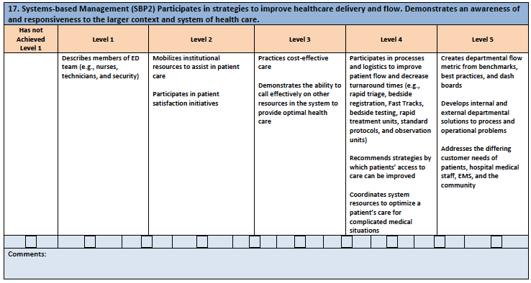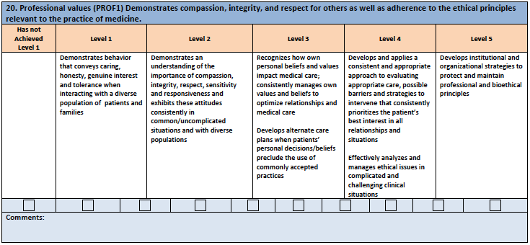
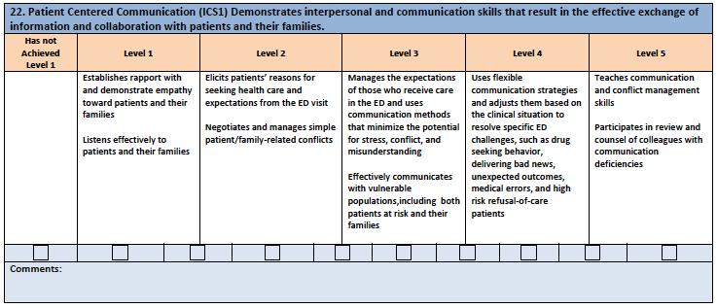

MENTORS:
Each resident will be expected to identify and meet with one or more faculty mentors who guide the resident through his/her research project and offer advice for career development. (see Appendix I)

WORKING WITH OTHER COLLEGES:
Projects can be in collaboration with other colleges, e.g.:
- Ultrasound project that develops a “train the trainer” model in another country
- Curricula development for providers in developing countries in collaboration with the Education College.

Permission from both college Deans must be obtained.

Appendix I: PGH College Mentors at BMC

Faculty Name | Public or Global Health | Research Interests/Experience | Email
Ed Bernstein | PH | Substance Abuse; Project Assert, Naloxone kits | ebernste@bu.edu
Bill Fernandez | GH |  | william.fernandez@bmc.org
Camilo Gutierrez | GH | Pediatric Global EM | camilo.gutierrez@bmc.org
Jon Howland | PH | Injury Prevention Center | jhowl@bu.edu
Gabrielle Jacquet | GH | Global EM; EM Education development in Haiti and India | gjacquet@bu.edu
Judy Linden | PH | Domestic Violence | Judith.Linden@bmc.org
Kalpana Narayan | PH | Falls in the Elderly | kns1@bu.edu
Ward Myers | PH | Pediatric Public Health; violence | ward.myers@bmc.org
Elissa Schechter-Perkins | PH/GH | Infectious Disease | elissa.schechter@bmc.org
Emily Rothman | PH | Injury Prevention Center; trafficking; dating violence | erothman@bu.edu
Thea James | PH/GH | Violence Intervention (VIAP) | thea.james@bmc.org

APPENDIX II: PGH COLLEGE REQUIREMENTS CHECKLIST

_____ Meeting attendance (unless post-nights or on vacation or away elective)
_____ 1 elective in Public or Global Health
_____ 1 piece scholarly work in Public or Global Health
_____ 1 PGH Newsletter article

Suggested relevant readings can be found on the internal BMC EM Residency PGH website.

