**Completing the ABIM Self-Directed PIM**

To access and order the ABIM Self-Directed PIM visit: <http://www.abim.org/moc/earning-points/productinfo-demo-ordering.aspx?self-directed#58A>

**Part A: Orientation**

This section provides information on the 5 components of the PIM with information on how to complete each component as well as relevant disclosure information and how to claim CME credit.

**Part B: Measures and Data**

**Step 1:** Provide information about your practice setting (i.e., Inpatient or Outpatient setting). This selection will provide you with measures that are appropriate for that setting.

**Step 2:** Enter the period of time that your baseline data covers. Baseline data must be less than 12 months old.

**Step 3:** Enter description of where you obtained your data from the following options:

* Medical society
* Report on the health system or hospital where I practice
* Physician pay-for-performance or recognition program
* Health plan / managed care plan / preferred provider network (PPO)
* Report from our EHR/EMR system
* State Quality Improvement Organization (QIO)
* I or my team manually abstracted and aggregated individual patient data from our charts or surveys
* None of the above

**Step 4:** You will now enter the Measures Library. ***You must provide performance data for at least three measures with a minimum of 25 patients in the sample for each measure***.

First, search the library by measure sets within a grouping (e.g., Hematologic/Oncologic). Individual measures are organized into sets by disease, condition or other relevant topics. Sets are then placed into groups to help narrow your search.



You can now search by sub-topic (i.e., QOPI).



Next, search for individual measures within the set you selected. You do not have to find a corresponding measure for every measure selected on your report, but you must be able to select at least three. The following figure depicts the individual measures within the Breast Cancer measure set.



If the measures library does not have the measure you need, click on the link on the bottom that reads, “Submit your measures for approval.”

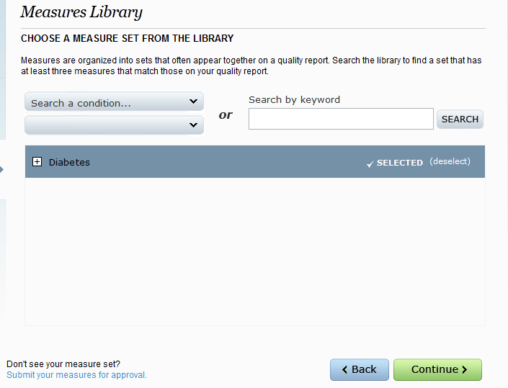

You will have to fill out another form describing your measure. If it is a measure from a nationally recognized organization like the NQF or NCQA, you only need to site the source of the measure. If your measure is something you have created, you will need to provide references to show that it is an evidence-based measure. Here are four examples of the forms for approval of other measures. These forms are reviewed with the entire module after all elements of the project are complete.

* + All NQF-Endorsed or AQA-, NCQA-, or PCPI-Developed Measures
    - (<https://moc.abim.org/content/ABIM-MOC/NPM_1.pdf> )
  + All Measures Derived from a Single Clinical Practice Guideline
    - (<https://moc.abim.org/content/ABIM-MOC/NPM_2.pdf> )
  + Measures Derived from More than One Clinical Practice Guideline
    - (<https://moc.abim.org/content/ABIM-MOC/NPM_3.pdf> )
  + One or More Measures Not Derived from a Clinical Practice Guideline
    - (<https://moc.abim.org/content/ABIM-MOC/NPM_4.pdf> )

**Please note that you will still need to include a minimum of 3 measures and 25 patients in the sample for each measure even if you use your own measures.**

Last, you will provide performance data for at least three measures. ***Only one*** of these will be your target for improvement.



**Part C: Action Plan**

**Step 1:** You will be asked about the nature of your improvement plan.

**Step 2:** You will be asked to identify the resources you plan to use as part of your improvement activity.



**Step 3:** You will be asked to choose a single measure that you would like to improve. The PIM will provide you with tips on how to select the best measure, some of which include:

* Look at the performance measure with the lowest performance. You can have the greatest impact on a measure on which you don’t already perform well.
* Think about measures that are likely to respond to changes in your practice.
* Clinical outcome measures often need the most improvement. Consider focusing on one of these measures if your performance is not what you would like to see.
* Choose a measure for which improvement would reach the most patients.

**Step 4:** You will then be asked to provide a brief description on why you choose a particular measure as well as a brief problem statement related to the measure.

**Step 5:** You will now set a performance goal for you selected measure. Guidelines will be provided in the PIM to help you set a realistic performance goal.



**Step 6:** You will then be asked about the care setting in which you will implement your improvement plan.

**Step 7:** You will now have the opportunity to identify individuals in your care setting that can assist you with your improvement plan.

**Step 8:** You will now be provided with a step-by-step guide within the PIM on how to complete your action plan. This should be shared with each member of the project improvement team.

**Step 9:** Once the action plan is completed, you will enter the root cause(s) of your measured performance. You will then complete a survey related to your action plan. This will assess your practice operations, communication between team members, etc. Lastly, you will propose a change in your practice system and develop a timeline for completion.

**Part D: Re-measurement**

**Step 1:** You will be asked to enter the date of the re-measurement collection data.

**Step 2:** Next, you will report if your re-measurement data was obtained from the same source as the original data.

**Step 3:** Now, you will enter your re-measurement data.



**Part E: Completion & Credits**

**Step 1:** You will be asked a series of questions that allow you to reflect on your improvement activity.

**Step 2:** Next, you will be asked if you plan to continue to improve your practice with future quality improvement projects.

**Step 3:** Now, you will complete a brief survey about your improvement activity.

**Step 4:** At this time, you can now claim CME credit.

**Congratulations! MOC and CME credit will now appear on your ABIM home page**