**Completing the ABIM Project Completed PIM**

To access and order the ABIM Self-Directed PIM visit: <http://www.abim.org/moc/earning-points/productinfo-demo-ordering.aspx>

**Part A: Orientation**

This section provides information on the requirements for the module and other basic information.

* Your project must have been completed in the last two years
* Each measure for which you provide data must include a sample of at least 25 patients
* You only need to focus on one measure for improvement
* Physician must have “meaningful and substantive role” in the activity to submit for credit. ABIM defines “meaningful and substantive role” as:

*Physician participation in QI is considered meaningful and substantive when:*

* + *The QI effort is intended to provide clear benefit to the physician's patients and is directly related to the physician's clinical practice.*
  + *The physician is actively involved in the QI effort, including, at a minimum:* 
    - *Working with care team members to plan and implement interventions,*
    - *Interpreting performance data to assess the impact of the interventions,*
    - *Making appropriate course corrections in the improvement effort;*
  + *The physician is able to reflect personally on the QI effort, describing the change that was performed in his/her practice and how it affected the way care is delivered.*
* Your project needs to include an assessment of baseline data, implementation of a plan for improvement, and remeasurement using follow-up data collected after the implementation of your action plan.

**Step 1:** Enter your activity completion date.

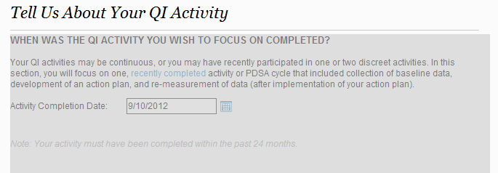

**Part B: Measures and Data**

**Step 1:** Provide information on how you conducted the needs assessment for the program. The suggested options include:

* I looked at my performance on multiple measures and identified one in need of improvement.
* My health system or employer directed me toward this priority.
* Another organization directed me toward this priority (e.g., medical society, regional collaborative).
* I identified this measure as a common concern through an article or conference.
* A needs assessment was not conducted for this activity.

**Step 2:** Enter the period of time that your baseline and follow-up data covers. If your project has multiple data collection periods, you only need to enter one value for baseline and one for follow-up

**Step 3:** Enter description of where you obtained your data from the following options:

* Medical society
* Report on the health system or hospital where I practice
* Physician pay-for-performance or recognition program
* Health plan / managed care plan / preferred provider network (PPO)
* Report from our EHR/EMR system
* State Quality Improvement Organization (QIO)
* I or my team manually abstracted and aggregated individual patient data from our charts or surveys
* None of the above

**Step 4:** Indicate the setting of your QI project (Inpatient or Outpatient)

**Step 5:** You will now enter the Measures Library. ***You must provide performance data for at least three measures with a minimum of 25 patients in the sample for each measure***. You can preview the Measures Library at <https://www.abim.org/measures-library.aspx>

First, search the library by measure sets within a grouping (e.g., Hematologic/Oncologic). Individual measures are organized into sets by disease, condition or other relevant topics. Sets are then placed into groups to help narrow your search.



You can now search by sub-topic (i.e., QOPI).



Next, search for individual measures within the set you selected. You do not have to find a corresponding measure for every measure selected on your report, but you must be able to select at least three. The following figure depicts the individual measures within the Breast Cancer measure set.



**If the measures library does not have the measure you need, click on the link on the bottom that reads, “Submit your measures for approval.”**

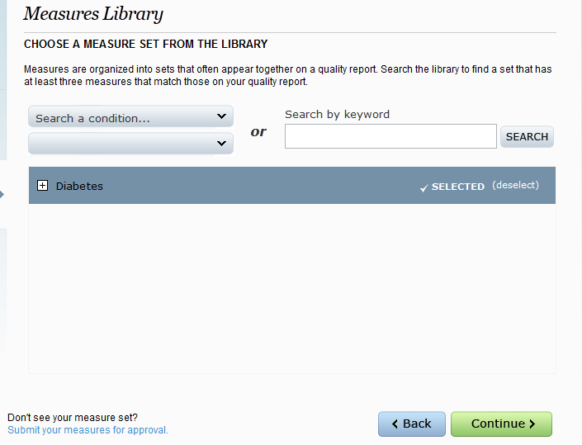

You will have to fill out another form describing your measure. If it is a measure from a nationally recognized organization like the NQF or NCQA, you only need to site the source of the measure. If your measure is something you have created, you will need to provide references to show that it is an evidence-based measure. Here are four examples of the forms for approval of other measures. These forms are reviewed with the entire module after all elements of the project are complete.

* + All NQF-Endorsed or AQA-, NCQA-, or PCPI-Developed Measures
    - (<https://moc.abim.org/content/ABIM-MOC/NPM_1.pdf> )
  + All Measures Derived from a Single Clinical Practice Guideline
    - (<https://moc.abim.org/content/ABIM-MOC/NPM_2.pdf> )
  + Measures Derived from More than One Clinical Practice Guideline
    - (<https://moc.abim.org/content/ABIM-MOC/NPM_3.pdf> )
  + One or More Measures Not Derived from a Clinical Practice Guideline
    - (<https://moc.abim.org/content/ABIM-MOC/NPM_4.pdf> )

**Please note that you will still need to include a minimum of 3 measures and 25 patients in the sample for each measure even if you use your own measures. The module outlines special cases where sample sizes of less than 25 patients are accepted.**

Last, you will provide performance data for at least three measures.

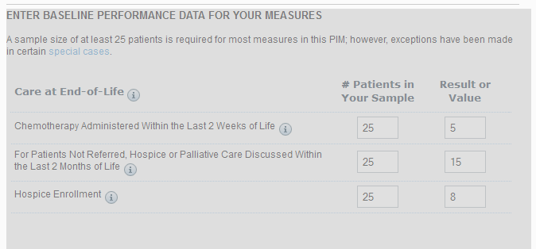

**Part C: Intervention**

**Step 1:** Select the measure on which you focused your improvement efforts.

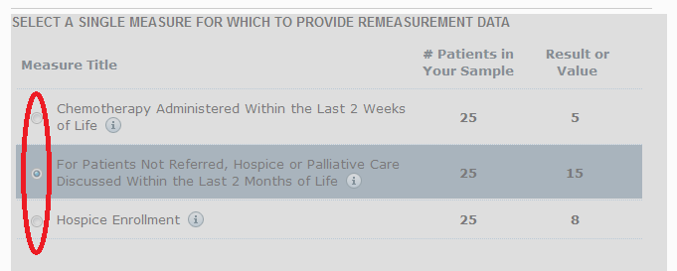

**Step 2:** You will need to give details about your project by answering the following questions:

* Briefly describe the problem(s) you were trying to address with this improvement activity
* Describe the nature of the improvement activity
* Describe the setting of your project
* Describe your project team
* Describe your intervention with details of a Root Cause Analysis process, and then provide a description about at least 3 causes of sub-optimal performance
* Detail how you choose interventions
* Detail about your practice systems and what aspects you examined for this project
* Describe the intervention in detail

**Part D: Re-measurement**

**Step 1:** You will be asked to enter the date of the re-measurement collection data.

**Step 2:** Next, you will report if your re-measurement data was obtained from the same source as the original data.

**Step 3:** Now, you will enter your re-measurement data.



**Part E: Completion & Credits**

**Step 1:** You will answer reflection questions about your project.

**Step 2:** Next, you will be asked if you plan to continue to improve your practice with future quality improvement projects.

**Step 3:** Now, you will complete a brief survey about your improvement activity.

**Step 4:** At this time, you can now claim CME credit.

**Congratulations! MOC and CME credit will now appear on your ABIM home page**