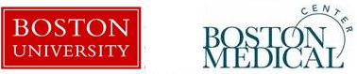
BU-BMC Cancer Center Travel Award Program 2019
Applicant Information
Name:
Degree:
Current Position:
Email:
Mentor:
Abstract Title and Author(s):
Poster or Talk

Briefly state (1-2 sentences) your “career stage” (e.g. 3rd year post-doctoral fellow working with Dr. Smith).

What is the importance of this meeting to your career/training?
Describe your research and its relevance to the Cancer Center.

