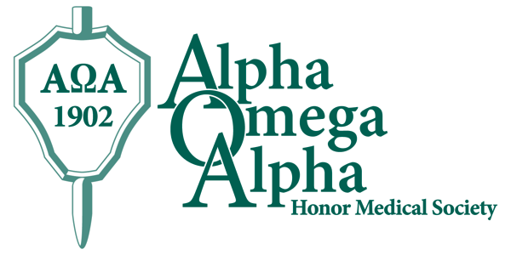

Alpha Omega Alpha is the national honor medical society. Founded in 1902, it is dedicated to improving care for all by recognizing educational achievement and gifted teaching, encouraging the development of leaders, supporting the ideals of humanism, and promoting service to others. Its motto is: “Be worthy to serve the suffering.” Election to AΩA is a distinction that accompanies you throughout your professional life.

Boston University’s chapter, Gamma Massachusetts, was chartered in 1948. Students at BUSM are eligible for selection to AΩA during their fourth year. At BUSM, selection is based on academic performance in BUSM-III clerkships and USMLE exams, as well as evidence of leadership, professionalism, and commitment to service and to the medical profession. In addition, AΩA offers several opportunities for awards and scholarships for both members and nonmembers.

The BUSM Alpha Omega Alpha Executive Committee:

Katelin Blackburn, President
James Trussler, Vice President
David McAneny, MD, Councilor
Robert Lowe, MD, Secretary-Treasurer

The Alpha Omega Alpha Chapter of
Boston University School of Medicine
proudly presents

The 2018
Alpha Omega Alpha
Visiting Professorship

Shale Wong MD, MSPH
University of Colorado School of Medicine

April 12, 2018

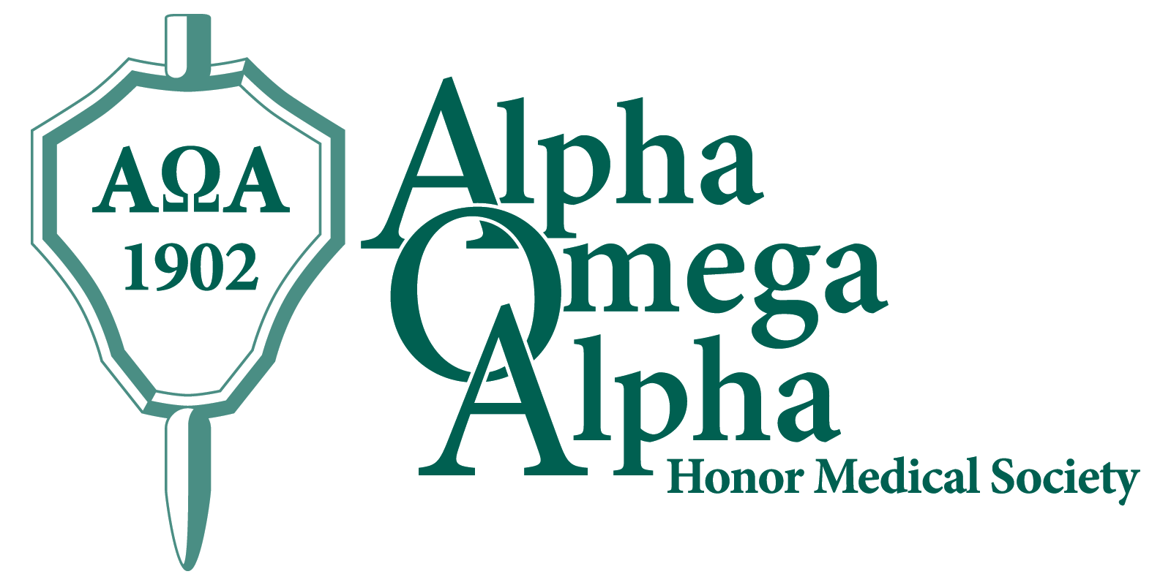
2018 Alpha Omega Alpha Visiting Professorship Schedule

8:00-9:00 am Department of Pediatrics Grand Rounds
“Providers, Parents and Policymakers—Working Together, We Can Make Health Whole”
Boston University School of Medicine, L-112

9:00-10:00 am Tour of BUSM/BMC with Robert J. Vinci, MD
Chief of Pediatrics, Boston Medical Center
Joel and Barbara Alpert Professor of Pediatrics
Chair, Department of Pediatrics
Boston University School of Medicine

10:00-10:30 am Meet & Greet
AOA Leadership &
Visiting Professor Committee
Lobby of BUSM

10:30-11:00 am Break

11:00 am-12:00 pm Medical Student Small Group Session
“Leadership Skill Development Workshop”
Whitelaw Conference Room

12:00-1:00 pm Medical Student Small Group Session & Lunch
“Incorporating Advocacy into Medical
Careers”
Whitelaw Conference Room

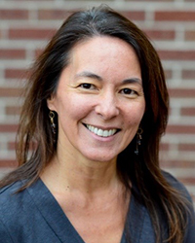
Shale Wong, MD, MSPH is a practicing pediatrician and Professor of Pediatrics at the University of Colorado School of Medicine (CU SOM). She has more than two decades of experience in the intersection of pediatrics, public health, education, advocacy, and policy. Dr. Wong received her BA in modern dance from UCLA in 1987 and graduated from the University of Utah School of Medicine in 1993. She completed a residency in Pediatrics at the CU SOM in 1997 and received a Master degree in their School of Public Health in 1999.

Dr. Wong is well-known for her work in child health, advocacy, policy, and health care reform, with focused interests in integrated care and achieving health equity. She is Director of the Eugene S Farley, Jr. Health Policy Center as well as the Vice Chair for Policy and Advocacy in the University of Colorado Department of Pediatrics. Through her work, she strives to improve children’s health through medical education, health policy and clinical care.

Dr. Wong co-founded CU LEADS- an innovative curriculum designed to promote leadership, education, advocacy, development, and scholarship for medical students. CU LEADS inspires new leadership in health care, focusing on social determinants of health and empowering advocates to improve the health of communities through service, collaboration, civic engagement and public policy.

Dr. Wong also served as health policy advisor to First Lady Michelle Obama from 2009-2011, for the development and implementation of “Let’s Move!”, a national initiative to prevent childhood obesity, as well as “Joining Forces” to improve health and wellness of military families. She also served as a senior program consultant for the Robert Wood Johnson Foundation from 2011-2015. Dr. Wong has received many awards and honors throughout her illustrious career, including the Chancellor’s Diversity Recognition Award for CU LEADS.

