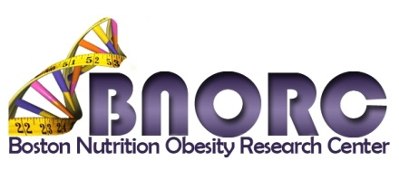
REQUEST FOR APPLICATIONS
TRAVEL SCHOLARSHIP PROGRAM

Scholarship Applications
Due June 1, 2018 at 12:00 midnight
The mission of the NIDDK-funded Boston Nutrition Obesity Research Center (BNORC) is to facilitate and support the conduct of cutting edge basic and translational research in the fields of nutrition and obesity science in the Boston area. BNORC’s travel scholarship program provides partial support ($500 per trainee) for up to five trainees working in the area of nutrition or obesity research to attend a conference or meeting. Eligible applicants (graduate students and post-doctoral fellows, postdoctoral associates) must work in the lab of and/or be mentored by a BNORC member. Please refer to http://www.bumc.bu.edu/bnorc/ for a list of current members.
How to Apply: Complete the Travel Scholarship Program 2018 – 2019 Application Page and submit as a single PDF file via the Center’s website http://www.bumc.bu.edu/bnorc/ no later than June 1, 2018 12:00 midnight.
Additional details of the program and instructions for submitting your application for a travel scholarship may be found at http://bnorc.org/. The link to submit a completed application is http://www.bumc.bu.edu/bnorc/links-and-resources/travel_scholarship/. Please contact Donna Gibson, Center Administrator (dgibson@bu.edu ● 617 358-7042).

Travel Scholarship Program 2018 – 2019
Applicant Information

Name:
Degree(s):
Current Position (select): | ☐Graduate student ☐Postdoctoral fellow
Institution:
Email:
Mentor:
Title of Conference or Meeting:
Conference or Meeting Date(s):
Are you presenting an abstract:
Abstract Title and Authors (if applicable):
Briefly state (1-2 sentences) your “career stage” (e.g. 3rd year post-doctoral associate working with Dr. Smith at BU).

What is the importance of this meeting to your career/training?

Describe your research and its relevance to BNORC.

